Ardagh Glass Packaging achieves 64% CO₂ reduction producing bottles from NextGen Furnace

Luxembourg (5 June 2024) – Ardagh Glass Packaging-Europe (AGP-Europe), an operating business of Ardagh Group, announced today that the glass bottles produced from its world first hybrid NextGen Furnace have reached a consistent 64% CO₂ emissions reduction*, saving approximately 18,000 tonnes of CO₂ since the start of 2024.

Since starting commercial production in October 2023, the NextGen Furnace at AGP-Obernkirchen in Germany has been gradually ramping up direct electrical heating via electrodes, towards a goal of 80% electrical heating and 20% gas. To date in 2024, AGP-Europe has achieved an average rate of 60% electrical heating in the NextGen Furnace; progress achieved in part due to the support and expertise of furnace supplier SORG.

The NextGen Furnace is funded through the BMWK** ‘Decarbonisation of Industry’ programme, which is managed by the KEI, and also from the ‘NextGeneration EU’ European Innovation Fund.

It has pushed the boundaries of electric melting technology with commercial-scale output of up to 350 tonnes of amber glass, using up to 70% recycled glass cullet.

Joris Goossens, R&D Project Manager, AGP-Europe commented:
“Ramping up the electrical heating in the NextGen Furnace has not been an easy journey. In a conventional furnace, the combustion space is hotter than the glass, but in the NextGen Furnace, the glass gets hotter than the combustion space: the furnace is effectively upside down. We have been navigating uncharted territory.”

Sven-Roger Kahl, Manager of Furnace Operations, AGP-Europe added:
“The NextGen design, which features electrodes in the bottom of the furnace, has challenged traditional furnace operating rules. It has been like learning to drive again, but it has been worth the effort to reach our goal of low-carbon glass packaging.”

Many key customers, glass industry peers and suppliers have now visited the furnace to see it in action. Government officials have also been welcomed to Obernkirchen to discuss the need for electrical grid connection to roll-out the technology to other AGP facilities.

AGP-Europe intends to adopt hybrid and other sustainable melting technologies for furnace rebuilds from 2027 onwards, subject to access to the appropriate electrical infrastructure in the relevant markets.

*Based on modelling
**Bundesministerium fur Wirtschaft und Klimaschutz (German Federal Ministry for Economic Affairs and Climate Action) and KEI: Klimaschutz in Energieintensiven Industrien (Competence Centre on Climate Change Mitigation in Energy-Intensive Industries) have provided a grant to qualifying energy-intensive industries in Germany.
Further information
Sharon Todd, Head of Marketing at Ardagh Glass Packaging – Europe, sharon.todd@ardaghgroup.com, +44 1 977 674111 +44 7768 718941

communications@ardaghgroup.com

Download image
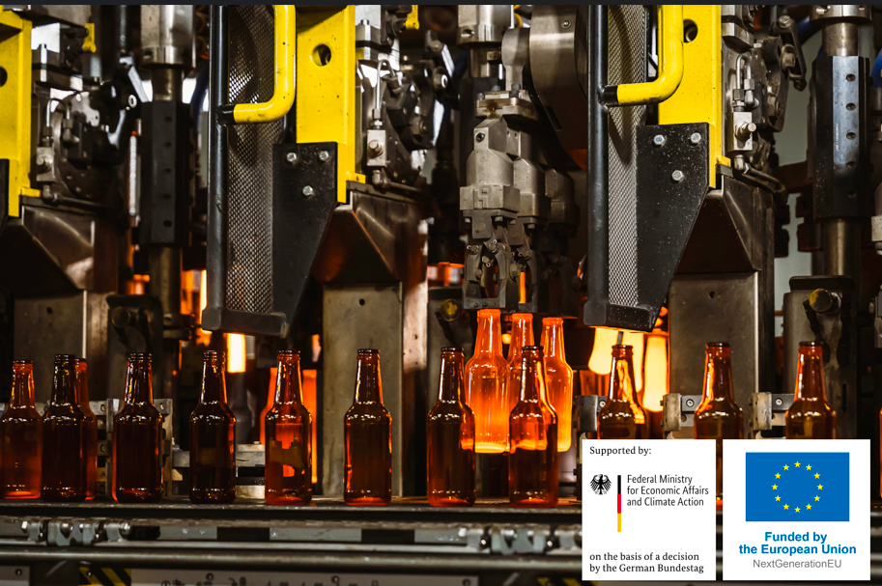
Bottles produced from the NextGen Furnace
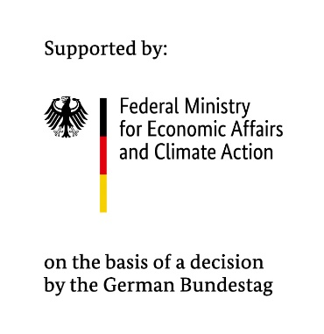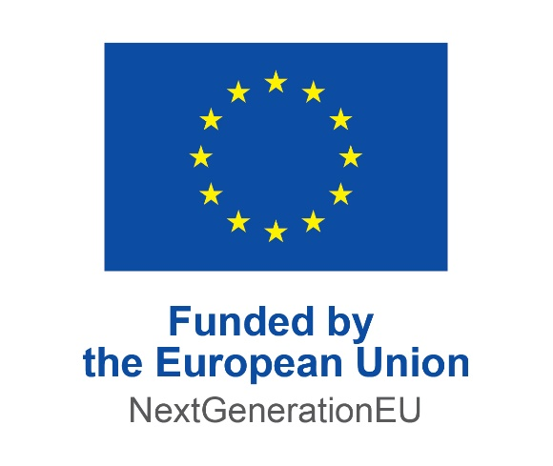

Notes to the editor
Ardagh Glass Packaging is a leading supplier of sustainable and infinitely recyclable glass packaging. Ardagh Glass Packaging operates 39 production facilities in North America, Europe and Africa and employs approximately 14,000 people and has recorded revenues of $4.6bn.

