NO-NAIL BOXES welcomes a new Sales Representative: Christophe Ahuir
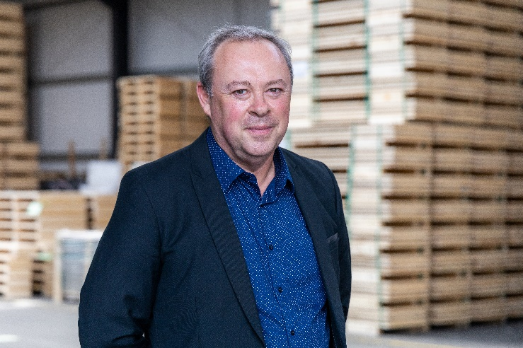
Wiltz, 13/12/2023
NO-NAIL BOXES, manufacturer of foldable plywood boxes, is pleased to announce the arrival of Christophe AHUIR as an external sales representative within the company.
A graduate of the University François Rabelais in Tours with a degree in literature and a diploma in wood and derivatives commerce, Christophe Ahuir brings extensive experience in the field of sales.
He has dedicated a significant portion of his career to developing industrial clientele. Before joining NO-NAIL BOXES, Christophe worked for 10 years at Ets Foussier as a wood and fittings sales representative, then 8 years at Ets Chavigny as a carpentry sales representative, and finally, 12 years at Ets Pakers Mussy as a sales representative.
Within ALIPA Group, Christophe holds the position of sales representative, focusing on expanding the customer base in France. His responsibilities include managing customer relationships, expanding the client portfolio, and promoting NO-NAIL BOXES’ foldable plywood boxes on the French market.
What he particularly appreciates about his work is the human scale of the company and the synergy between technical and commercial aspects. Christophe is passionate about sports, reading, and actively participates in local life and general arts activities. NO-NAIL BOXES is confident that Christophe’s experience and skills will significantly contribute to strengthening the company’s position on the French market and providing innovative solutions to its customers.
NO-NAIL BOXES is located in Wiltz and has been manufacturing folding boxes made of plywood and steel for the industry since 1961. Every year, some 450,000 boxes, 95% of which are custom-made, leave its production workshop. Certified ISO 9001, ISO 14001, ISO 27001, AEO, PEFC, CSR, SuperDrecksKëscht fir Betriber and Sécher a Gesond mat System, NO-NAIL BOXES is integrated in the packaging division of the ALIPA Group, a Luxembourg-based specialist in industrial packaging and lifting, which has a total of about 150 employees.
-----------------------------------------
Note for the editors, not for publication
For more information, please contact:

NO-NAIL BOXES (ALIPA Group)
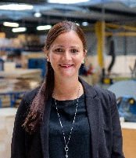
Jenny LENTZ – Project Officer
25, Salzbaach – L-9559 Wiltz
Tel.: +352 81 92 81 259 – Email: jlentz@alipa.lu
Photo: ALIPA Group
Visit our website: www.no-nailboxes.com

