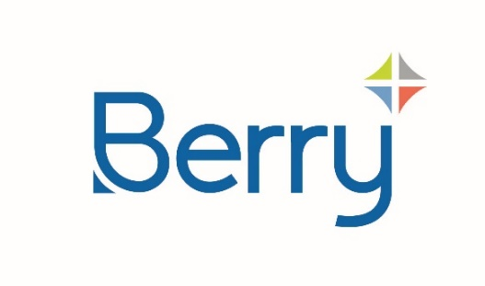
Media Alert

Berry Global’s Pamplona, Spain Site Secures RecyClass and UNE 15343 Certifications
PAMPLONA, Spain, July 23rd 2024 - Berry Global’s factory in Pamplona, Spain has achieved RecyClass and UNE 15343 Certifications, both highly regarded independent markers of the site’s commitment to improving the recyclability of plastic packaging and incorporating recycled content across its products.
RecyClass and UNE 15343 Certifications are awarded after a voluntary audit conducted by third-party recognised certification bodies. The Pamplona factory welcomed auditors over two days, during which various sustainability factors were monitored, including Berry’s capabilities in designing for recyclability and the traceability of recycled plastics used at the site.
These certifications mean that Berry can now offer RecyClass labelling on non-food packaging produced at the Pamplona factory, validating its claims around recyclability and the incorporation of recycled materials for its customers.
Other European Berry factories that have already achieved RecyClass Certification include La Genête and Lubien. Audits at other sites are also underway.
The Certifications, which are valid for three years, were awarded to sales director Ignacio Igea at the Hispack exhibition.
“Berry is committed to helping our customers with circular packaging solutions, and the RecyClass and UNE 15343 Certifications are a commonly-used and widely recognised means of sharing our credentials in recyclability and recycled plastics,” said Ignacio Igea.
Learn more about how Berry is investing in resources to meet its customers sustainability goals at berryglobal.com/supporting-customer-goals

About Berry
At Berry Global Group, Inc. (NYSE: BERY), we create innovative packaging solutions that we believe make life better for people and the planet. We do this every day by leveraging our unmatched global capabilities, sustainability leadership, and deep innovation expertise to serve customers of all sizes around the world. Harnessing the strength in our diversity and industry-leading talent of over 40,000 global employees across more than 250 locations, we partner with customers to develop, design, and manufacture innovative products with an eye toward the circular economy. The challenges we solve and the innovations we pioneer benefit our customers at every stage of their journey. For more information, visit our website, or connect with us on LinkedIn or X.

