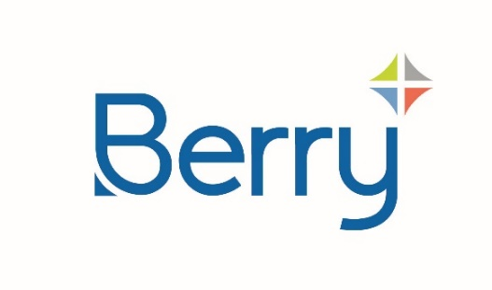
Media Alert

Issue Date: 8th March 2024
For Immediate Release

Berry White Paper Offers Key Considerations for Industrial Stretch Film Solutions
Guidance on selecting the most appropriate film for individual applications

September 6th 2024 – A new white paper from Berry Global offers insights on how to balance the drive towards more sustainable industrial stretch films while delivering the required levels of performance and reliability for every application.

Businesses across all sectors are seeing increasing demand for more sustainable transit packaging. However, while this drive for sustainability is important, it is equally essential to acknowledge that stretch film’s primary function remains to provide load stability and protect against dust, dirt, and moisture.

The Berry white paper Selecting High-Performance, Sustainable Stretch Films – Key Considerations discusses some of the key factors that need to be addressed in the decision-making process and outlines other ways in which the design and production of stretch film can support a business’s sustainability goals.

“True sustainability in any form of packaging requires a comprehensive holistic and product-focused approach,” said Gabriele Ditsch, Sales Director of Berry Global’s European Flexibles Division.

“A so-called sustainable stretch film that fails to protect or transport the product effectively can end up causing greater environmental damage, not to mention serious cost implications, through spilt, lost and wasted product.”

“In addition to our white paper, which has been created to invite companies to approach the subject of sustainability with an open mind, we also offer our customers a comprehensive Stretch Film Analysis as part of our initial sales process to assist them in the making the right decision for their specific application.”

Ends

About Berry
At Berry Global Group, Inc. (NYSE: BERY), we create innovative packaging solutions that we believe make life better for people and the planet. We do this every day by leveraging our unmatched global capabilities, sustainability leadership, and deep innovation expertise to serve customers of all sizes around the world. Harnessing the strength in our diversity and industry-leading talent of over 40,000 global employees across more than 250 locations, we partner with customers to develop, design, and manufacture innovative products with an eye toward the circular economy. The challenges we solve and the innovations we pioneer benefit our customers at every stage of their journey. For more information, visit our website, or connect with us on LinkedIn or X.
Media Contact:
Berry@nmpr.co.uk

