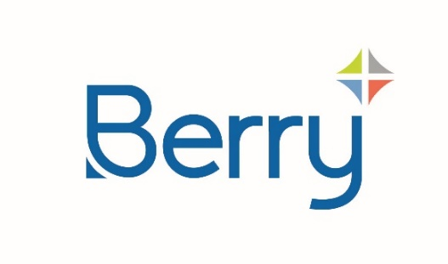
Media Alert

Berry Launches Fully Recyclable*, High-Performance Alternative to Coloured PET Pill Bottles
ClariPPil™ bottles offer enhanced sustainability (reduced carbon footprint and improved recyclability vs a PET container solution) together with excellent functionality, product protection, and aesthetics.

Leading packaging solutions provider Berry Global has launched a range of clarified polypropylene (PP) bottles for healthcare applications, which offer superior sustainability and enhanced product protection compared to traditional coloured PET pill bottles.

Ideal for a wide variety of products including vitamins, nutraceuticals, dietary supplements, beauty supplements and OTC treatments, the new ClariPPil™ bottle has achieved a RecyClass A certification for its recyclability in countries with the appropriate recycling infrastructure in place, when combined with Berry’s PP closures.

“We believe our ClariPPil bottle provides an advanced packaging solution that will transform healthcare packaging,” said Jessica Rodriguez, Sustainability Project Manager at Berry Global.

“As well as its superior sustainability profile, the bottle offers excellent performance and quality.”

ClariPPil bottles are available in green, and light and dark amber, enabling them to meet the requirements of different product types. Custom colours can also be produced on demand. Significantly, whereas similar packs in coloured PET can pose a challenge to the recycling stream, the coloured ClariPPil bottles are all widely recyclable in countries with the appropriate recycling infrastructure in place. Equally important, Berry says that its new manufacturing technology for the bottle delivers a reduction of approximately 71% in carbon dioxide (CO₂) emissions compared to the traditional injection stretch blow moulding process for PET bottles**.

Alongside these enhanced sustainability benefits, ClariPPil bottles also deliver up to 84% improved moisture ingress protection compared to PET, to ensure extended product integrity and effectiveness.

The bottle is available in 100, 120 and 150cc sizes and feature a universal 38mm neck for compatibility with a range of standard closures, including child-resistant options. As well as the choice of colours, the design includes a wide decoration area for individualised branding.

“ClariPPil bottles meet the demand for a sustainable packaging solution without compromising functionality, aesthetics, or barrier performance,” said Ryan Maszton, Director of Sales, Berry Global.

“Equally important, our high-capacity production facilities mean we can offer companies speed of supply and fast response to help them bring products quickly to market, maximising opportunities in growing sectors such as vitamins, minerals and supplements.”

Ends

*Fully recyclable PP bottle and PP closure in countries with the appropriate recycling structure.

** Internal LCA calculation. This has not been externally reviewed for compliance with ISO 14040/44 Standard and Guideline.
ClariPPil™ is a trademark of Berry Global, Inc. or one of its associates.

About Berry
At Berry Global Group, Inc. (NYSE: BERY), we create innovative packaging solutions that we believe make life better for people and the planet. We do this every day by leveraging our unmatched global capabilities, sustainability leadership, and deep innovation expertise to serve customers of all sizes around the world. Harnessing the strength in our diversity and industry-leading talent of over 40,000 global employees across more than 250 locations, we partner with customers to develop, design, and manufacture innovative products with an eye toward the circular economy. The challenges we solve and the innovations we pioneer benefit our customers at every stage of their journey. For more information, visit our website, or connect with us on LinkedIn or X.

