FOR IMMEDIATE RELEASE

CIRT™ and Consumer Brands Announce Partnership to Bring Local Recycling Instructions Directly to Consumers’ Hands

Washington, DC – November 14, 2024 — CIRT™, a comprehensive recycling data and compliance platform, is excited to announce its groundbreaking partnership with the Consumer Brands Association’s SmartLabel®, and its latest product integration, CIRT Check™. SmartLabel is a digital tool that allows consumers to learn more about the product in their hands by scanning a QR code. This strategic collaboration aims to enhance consumer transparency, educate consumers on recycling acceptance locally and increase recycling participation.

CIRT Check merges CIRT's comprehensive recycling database with SmartLabel's established product platform, offering consumers precise, location-based sustainability guidance. This powerful integration helps brands empower consumers with instant access to packaging recyclability data at the zip code level, reducing consumer confusion by helping to navigate recycling systems.

The partnership between CIRT and SmartLabel® reflects a shared commitment to promoting transparency and sustainability in the consumer products sector. CIRT Check will be available as a SmartLabel® integration, allowing brands to seamlessly add accurate, location-specific product recovery data to their labels, which consumers can access instantly via mobile devices. With CIRT Check, brands support sustainability compliance and deepen customer trust by empowering them to participate in the circular economy.

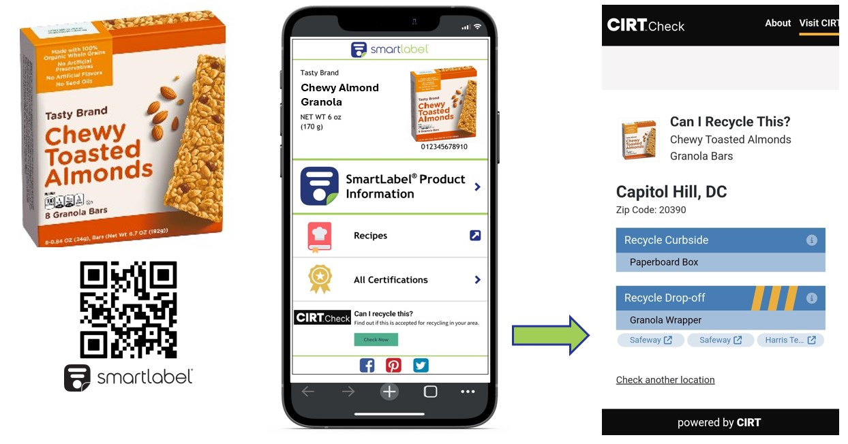

“SmartLabel has carved out a space as the industry standard for transparency,” said Rishi Banerjee, Senior Director of SmartLabel. “Our collaboration with CIRT bolsters our ability to meet consumer demand for sustainable product information, simplifying access to recycling and sustainability details based on local guidelines.” SmartLabel is currently used by 1,000 brands and more than 100,000 products.

Bimbo Bakeries USA will be the first company to integrate CIRT Check within the SmartLabel® platform, bringing this innovative technology to trusted brands like Sara Lee Bread, Thomas’ and Arnold Bread. Bimbo Bakeries USA’s adoption of CIRT Check will highlight the platform's real-world impact, allowing consumers to access geospatially specific recycling information and sustainability data directly from their mobile devices. This partnership not only reflects the company’s commitment to sustainability but also demonstrates CIRT and SmartLabel’s potential to transform the Consumer Packaged Goods industry by meeting consumers' demand for transparency and actionable environmental information.

“As part of the world’s largest baking company, we strive to be leaders in sustainability, recognizing our obligation to protect and preserve our planet for the next generation,” said Chris Wolfe, Senior Director-Sustainability. “Partnering with CIRT and SmartLabel enables us to provide consumers with accessible information on where they can recycle our packaging, reinforcing our commitment to zero waste and diverting waste from landfills.”

“Together with SmartLabel, we’re enabling brands to offer consumers the transparency and guidance they need to make better choices,” said Kat Shayne, CIRT’s Co-Founder & CEO. “CIRT Check is a leading-edge solution for companies committed to advancing sustainability, providing actionable information for consumers when and where they need it most.”

For more information about CIRT Check or this partnership, visit www.cirt.tech.

###

About CIRT
CIRT is an award-winning, women-owned, B Certified technology company. They produce data-driven SaaS-based solutions, transforming sustainability into a competitive growth advantage. CIRT helps businesses ensure compliance, enhance consumer trust, and adopt circular economy practices through real-time data and efficient operations.

About SmartLabel®
SmartLabel® is the flagship consumer transparency tool developed by the Consumer Brands Association and industry stakeholders that provides consumers with easy access to detailed product information, including ingredient definitions, recall information, and sustainability attributes. Through the SmartLabel® platform, companies can effectively engage and inform their customers about the choices they’re making, fostering a more sustainable future.

For press inquiries, please contact:
Jennifer Davidson
CIRT
jennifer@cirt.tech
404.428.6755

CIRT and CIRT Check are trademarks of Can I Recycle This, Inc. All other trademarks, registered trademarks, product names, and company names or logos mentioned herein are the property of their respective owners and are used for identification purposes only.

