News Release

For Immediate Release

Avery Dennison invites you to join them in Connecting. Together. at Labelexpo Europe in Brussels, 11–14 September 2023
__

OEGSTGEEST, the Netherlands — July 11, 2023 — To celebrate meeting up in person, Avery Dennison will host a special event at Labelexpo 2023 called Connecting. Together. At their stand (5A31), Avery Dennison will engage with customers and the industry ecosystem in an intimate space that will showcase some of their latest packaging solutions and include an exclusive food and drink experience.

Steve Flannery, senior vice president and general manager of Materials Group EMENA, comments: “At Avery Dennison, we envision a connected and circular future. Labelexpo is a great opportunity for us to share some of our latest sustainable solutions — labeling materials with a lower carbon footprint and solutions that enable packaging recycling or reuse. Visitors can also experience demos of our digital solutions to get a true sense of how intelligent labels enable consumer interaction and end-to-end transparency.”

Noel Kasmi, vice president of Marketing Labels and Packaging Materials EMENA at Avery Dennison, adds: “At Labelexpo, we will be unveiling the next step of our innovation journey — our new range of direct thermal and decorative linerless labels. Because linerless solutions are an important part of the future, we’ve developed a new suite of products that eliminates liners to reduce material use and waste as well as minimize the environmental impact of packaging.”
Avery Dennison is committed to helping customers always move ahead and looks forward to engaging in a collaborative spirit across the entire business ecosystem to empower people and possibilities. They believe that only by Connecting. Together. can we all advance and grow in our ever-changing, ever-evolving industry.

###

About Avery Dennison

Avery Dennison Corporation (NYSE: AVY) is a global materials science and digital identification solutions company that provides branding and information labeling solutions, including pressure-sensitive materials, radio-frequency identification (RFID) inlays and tags, and a variety of converted products and solutions. The company designs and manufactures a wide range of labeling and functional materials that enhance branded packaging, carry or display information that connects the physical and the digital, and improve customers’ product performance. The company serves an array of industries worldwide, including home and personal care, apparel, e-commerce, logistics, food and grocery, pharmaceuticals and automotive. The company employs approximately 36,000 employees in more than 50 countries. Reported sales in 2022 were $9.0 billion. Learn more at www.averydennison.com.

For more information:

Avery Dennison
Marit Meelis
lpm.eu.pr.inquiries@eu.averydennison.com

EMG
Kim Lommaert
T: +31 164 317 021
klommaert@emg-marcom.com

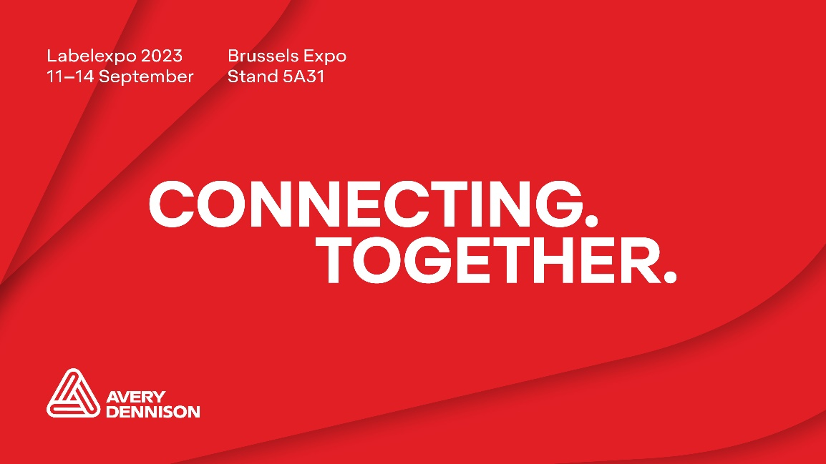

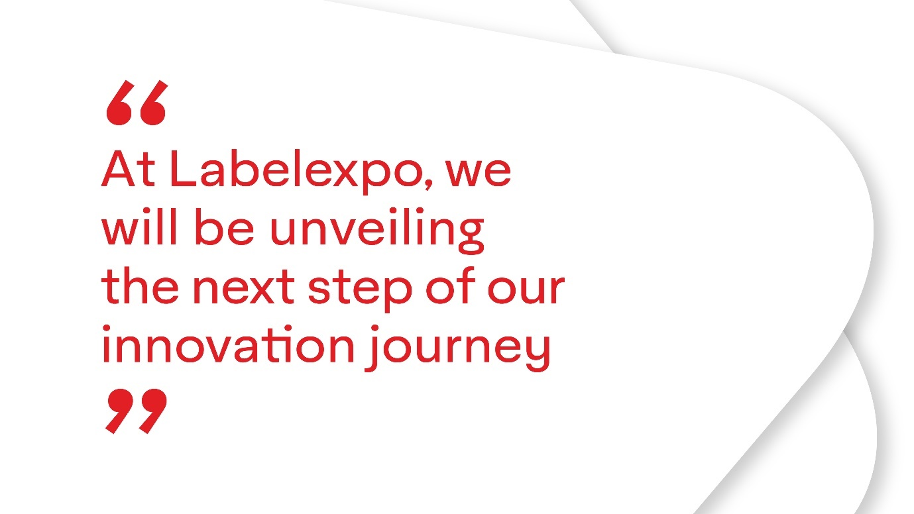
Avery Dennison invites you to join them in Connecting. Together. at Labelexpo Europe in Brussels, 11–14 September 2023. (Photos: Avery Dennison, PR484)

This press release and relevant photography can be downloaded from www.PressReleaseFinder.com.

