Ardagh Glass Packaging-Europe enters Bulgarian renewable energy market, securing deal with Rezolv Energy
Luxembourg (5 September 2024) – Ardagh Glass Packaging-Europe (AGP-Europe), an operating business of Ardagh Group, announced today that it has entered a long-term Virtual Power Purchase Agreement (VPPA) with Rezolv Energy’s St. George solar photovoltaic (PV) project in Bulgaria, securing renewable electricity for its glass manufacturing operations across Europe from April 2026.
Schneider Electric, a leading adviser in corporate renewable energy procurement and carbon management, supported AGP-Europe in the VPPA negotiation.
The VPPA – one of the first to be signed in Bulgaria – is intended to provide 110 GWh per year of renewable electricity to AGP-Europe, over 12 years. It complements AGP-Europe’s renewable energy supply from wind power, secured in Sweden earlier this year. Together, thanks to their different sources, they are designed to provide AGP-Europe with a consistent renewable power supply throughout the year.
In conjunction with other Power Purchase Agreements in its portfolio, this deal is designed to enable AGP-Europe to meet over 80% of its 2030 renewable electricity targets.
Martin Petersson, CEO AGP-Europe said: “We are pleased to have finalised this agreement in just six months, which is largely due to Rezolv’s flexibility, the support and technical know-how of Schneider Electric, and our own experience in this field.
“The Bulgarian solar project perfectly meets our aim to diversify the locations of our renewable energy supply and to support emerging energy markets: AGP-Europe benefits from a supply of renewable electricity, while helping Bulgaria’s transition to low-carbon energy.”
Alastair Hammond, CEO, Rezolv Energy added: “By signing this VPPA, AGP-Europe has become one of the most important corporate investors in Bulgaria’s energy transition. Through it, the company has become the leading enabler of St. George, a 229 MW solar project which, overall, will deliver an average of 313 Gigawatt hours of renewable electricity annually. AGP-Europe is therefore making a direct contribution to reducing Bulgaria’s dependence on fossil fuels and to enhancing its energy security.”
The solar project will comprise nearly 400,000 PV panels and will be one of the largest solar projects in Bulgaria.

Further information
Marketing & Communications at Ardagh Glass Packaging-Europe Sharon.todd@ardaghgroup.com
Download image here
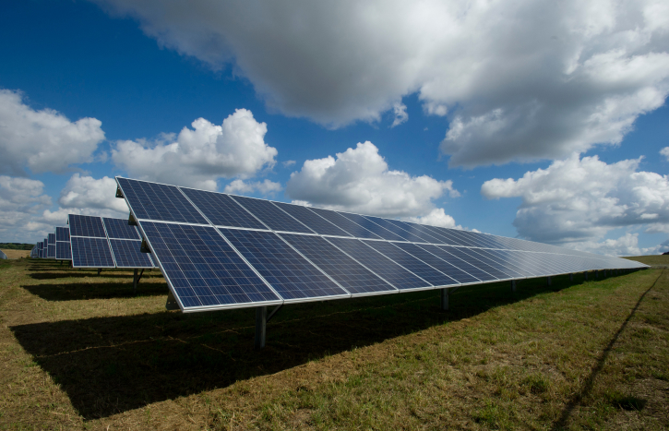
Notes to the editor
Ardagh Glass Packaging is a leading supplier of sustainable and infinitely recyclable glass packaging. Ardagh Glass Packaging operates 38 production facilities in North America, Europe and Africa and employs approximately 14,000 people and has recorded revenues of $4.6bn.
Schneider Electric’s purpose is to create Impact by empowering all to make the most of our energy and resources, bridging progress and sustainability for all. At Schneider, we call this Life Is On.
Our mission is to be the trusted partner in Sustainability and Efficiency.
We are a global industrial technology leader bringing world-leading expertise in electrification, automation and digitization to smart industries, resilient infrastructure, future-proof data centers, intelligent buildings, and intuitive homes. Anchored by our deep domain expertise, we provide integrated end-to-end lifecycle AI enabled Industrial IoT solutions with connected products, automation, software and services, delivering digital twins to enable profitable growth for our customers.
We are a people company with an ecosystem of 150,000 colleagues and more than a million partners operating in over 100 countries to ensure proximity to our customers and stakeholders. We embrace diversity and inclusion in everything we do, guided by our meaningful purpose of a sustainable future for all. www.se.com
Rezolv Energy
Rezolv is a highly experienced, independent renewable energy producer. We provide subsidy-free clean energy at a long-term, stable price for industrial and commercial users, and other off-takers, operating across Central and South Eastern Europe.
Built on a heritage of 15 years in clean energy, we take renewable projects – wind, solar and storage – from late-stage development through construction and into long-term operation.
With long-term investment backing from Actis, one of the world’s foremost energy investors, we are building a multi-GW portfolio that will help companies and countries meet their energy needs today and in the future.
For more information, please visit: Rezolv.Energy

