**PRESS RELEASE: September 2023**

**Look who’s talking: Amazon, Unilever and AB InBev confirmed for AIPIA Congress**

***A stellar line-up of speakers for the upcoming AIPIA World Congress is taking shape. These already include leading global on-line retailer Amazon and major brands such as AB InBev and Unilever.***

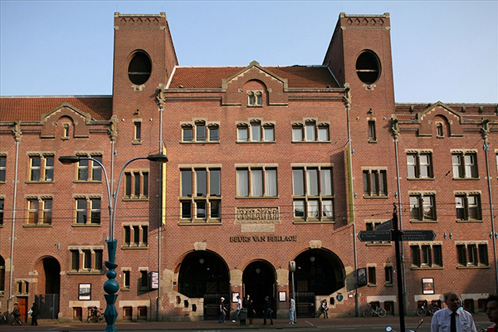

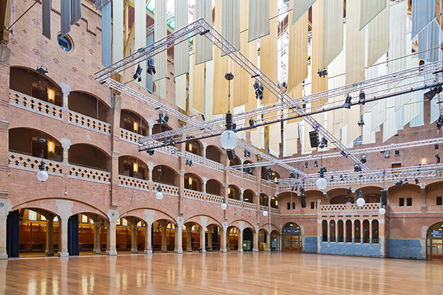

The event – held in the iconic Beurs van Berlage, Amsterdam, 14-15 November – is the only global event for the Smart Packaging sector and brings together stakeholders from the active and intelligent packaging industry and users to share information on trends and the latest connected and active technology developments.

This year the Congress is co-located with the Sustainable Packaging Summit. Both will benefit from the synergies which are being identified between the sustainability agenda and smart technologies, which can aid recycling and reuse of materials and packs, as well as helping to deliver messages about the environmental agenda to consumers.

Major technology providers Crane Automation, OMRON and Zebra Technologies are Platinum sponsors of the Congress and will exhibit some of their latest innovations as well as making keynote presentations. They will be joined by other leading smart packaging technology developers such as Antares Vision Group, AlmaScience, STMicroelectronics, Securikett, Toppan and Wiliot with others important companies set to confirm very soon.

Eef de Ferrante, managing director of AIPIA, commenting on the line up, said, “We have some familiar returning faces who are always at the forefront of smart packaging innovation and so, always with something new to say, as well as some fresh faces to add their own unique take on the way our industry is developing.”

“With 20 + demonstration booths, top quality panel sessions featuring some of the thought leaders in the sector, plus an exciting Brand Challenge from AB InBev the Congress is set to be a very dynamic and disruptive event. Running at the same time as the Sustainable Packaging Summit also adds a different and highly relevant dimension to the proceedings,” he added.

“In the coming weeks we will reveal more details of the presentations and panels and confirm the Brand Challenge topic and scope. But much of the agenda can be seen already on the AIPIA website and this will, as usual, be updated in real time as details are finalised,” explained AIPIA’s communications director Andrew Manly.

To see the [latest program information](https://www.packagingsummit.earth/amsterdam2023/3272217) and to [book your delegate pass](https://www.packagingsummit.earth/amsterdam2023/begin) to the AIPIA World Congress just visit the AIPIA website: [www.aipia.info](http://www.aipia.info)

***About:*** *AIPIA, the Active & Intelligent Packaging Industry Association is the global Smart Packaging hub with 1800 + members in over 50 countries across 6 continents. Our mission is to decimate supply chain costs, improve product security and provenance, enhance consumer engagement, increase food safety and advance sustainability and recycling by better communication and information. AIPIA is the 'go to' organisation for the latest information on applications and smart packaging developments.*

*Visit its website* [*AIPIA | Active & Intelligent Packaging Industry Association*](https://www.aipia.info/) *for more information on AIPIA activities, events (including the famous world congress) and how to become a member.*

Contact:

**Andrew Manly**, Communications Director  
andrew@aipia.info  
Phone: +31-(0)30-420 02 35  
Mobile: +31-(0)657-520 386