Aptar CSP Technologies Collaborates with ProAmpac to Launch New
Active Material Science Packaging Solution

High-performance, moisture-adsorbing flexible packaging powered by Activ-Polymer™ technology delivers simple, fully-integrated protection for moisture-sensitive products

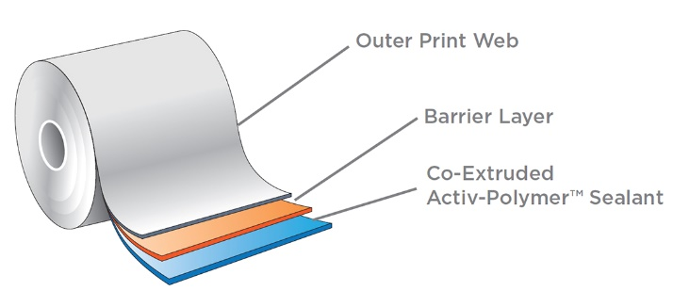
Auburn, AL, February 12, 2024 –Aptar CSP Technologies, part of AptarGroup, Inc. and a leader in active material science, collaborated with ProAmpac, a leader in material science and flexible packaging, to develop and launch ProActive Intelligence Moisture Protect (MP-1000). This next-generation platform technology combines Aptar CSP’s proprietary 3-Phase Activ-Polymer™ technology with ProAmpac’s flexible blown film technology to deliver a patent pending moisture adsorbing flexible packaging solution. This is the first in a series of active microclimate management packaging solutions to mitigate degradation risk, maintain potency and improve product performance.
Aptar CSP’s 3-Phase Activ-Polymer™ platform technology is a highly engineered active material science solution trusted by global brands to protect sensitive drug products, probiotics, medical devices, drug delivery systems, and foods. By incorporating the moisture adsorbing Activ-Polymer™ material into a flexible film structure, MP-1000 delivers high-quality moisture protection without the need for add-on desiccant sachets, thus reducing manufacturing downtime. This solution not only adsorbs excess moisture inside the package, but also shields the contents from moisture exposure that typically occurs when moisture molecules pass through the packaging en route to an add-on desiccant.
This active packaging solution features varying moisture capacities to deliver customized microclimate protection that meets differing product needs. Available in rollstock or pre-made pouches, MP-1000 has excellent seal characteristics and runs on high-speed form-fill-sealing equipment, ensuring product integrity and compatibility with existing flexible packaging equipment.
“We are pleased to unveil this new platform of active material science solutions with ProAmpac. The goal of this collaboration is to transform the way active packaging is delivered and fulfill unmet needs by providing the market with a fully integrated, flexible, multi-layer film solution, powered by CSP’s proven Activ-Polymer™ technology,” said Badre Hammond, vice president of global commercial operations and general manager APAC for Aptar CSP Technologies. “We look forward to continuing our collaboration with ProAmpac to leverage the current platform to develop new active materials that address a broad range of product stability challenges.”
“We are excited to launch the Moisture Protect MP-1000 platforms, the newest addition to the ProActive Intelligence product line. This innovative product has a high moisture-adsorbing capacity and is set to revolutionize moisture protection in flexible packaging. Our extensive material science work and exclusive collaboration with Aptar CSP Technologies has enabled us to bring the latest active packaging products to the market,” said Hesam Tabatabaei, senior vice president of global product development and innovation for ProAmpac.
Aptar CSP’s Activ-Polymer™ technology is a trusted solution for protecting high-value drugs, diabetes test strips, continuous glucose monitoring devices, probiotics, drug delivery devices, and even medical devices and implants across the globe. It is custom-engineered to provide a broad spectrum of product-specific protection in a wide range of physical formats. Key capabilities include scavenging oxygen, odors, and VOCs, emitting aromas or antimicrobials, and mitigating risk of mutagenic N-nitrosamine impurity formation and drug degradation.
###
About Aptar CSP Technologies
Aptar CSP Technologies is part of AptarGroup, Inc., a global leader in drug and consumer product dosing, dispensing and protection technologies. Aptar CSP Technologies leverages its active material science expertise to transform ideas into market opportunities, accelerate and de-risks the product development process, and provide complete solutions that improve consumers’ and patients’ lives. The company offers a complete set of services from concept ideation, to design and engineering, to product development, global production, quality control, and regulatory support that results in expedited speed-to-market. For more information, please visit www.csptechnologies.com and www.aptar.com.

About ProAmpac
ProAmpac is a leading global flexible packaging company with a comprehensive product offering. We provide creative packaging solutions, industry-leading customer service and award-winning innovation to a diverse global marketplace. ProAmpac’s approach to sustainability – ProActive Sustainability – provides innovative sustainable flexible packaging products to help our customers achieve their sustainability goals. We are guided in our work by five core values that are the basis for our success: Integrity, Intensity, Innovation, Involvement and Impact. Cincinnati-based ProAmpac is owned by Pritzker Private Capital along with management and co-investors. For more information, visit www.ProAmpac.com or contact Media@ProAmpac.com.

