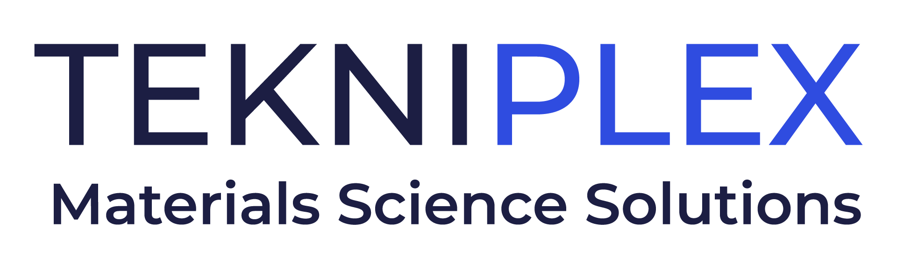
Press release

Media Contact: Peter Gavigan
TekniPlex
+1 (908) 720-5391
Peter.Gavigan@tekni-plex.com

Christopher Dale
Turchette Agency
+1 (973) 227-8080 ext. 116
cdale@turchette.com

At Pack Expo, TekniPlex Consumer Products to Debut Significantly Expanded “GeoPack” Sustainable Products Portfolio

Materials science solutions for food, beverage, and household products
applications meet defined sustainability criteria.

Wayne, PA – TekniPlex Consumer Products, a globally integrated provider of innovative solutions through materials science and manufacturing technologies, will debut a significantly expanded selection of GeoPack sustainable packaging and foodservice products at Pack Expo Booth W-26033, October 23-26 in Chicago.

GeoPack comprises a broad spectrum of product families meeting defined criteria for sustainability. These criteria comprise varying combinations of materials science sustainability’s “4 Rs” – reduce, recycle, reuse and renew – including biodegradable or compostable materials, post-consumer recycled content, recyclability, renewable substrates, and legislation compliance. The goal is to deliver solutions tailored toward customers’ sustainability metrics, including providing information on specific products’ environmental impact. Click here to learn more about the GeoPack criteria.

The original GeoPack portfolio was introduced in 2011 by Grupo Phoenix, which last year was acquired by TekniPlex Consumer Products. The initial GeoPack line consisted primarily of paper, fiber and polylactic acid (PLA) products such as cups, containers, and cutlery derived from corn and beet plants for foodservice applications. In addition to these offerings, GeoPack has now been exponentially expanded to include a broad range of sustainability-minded materials science solutions, including:
- Fiber egg cartons and trays
- Fiber agricultural trays for produce
- Fiber food & beverage carriers used, for instance, in beverage service and wine shipping
- Paper wraps for food service
- Recycled polyester (rPET) egg cartons comprised of 100% post-consumer recycled (PCR) content
- Polypropylene (PP) and polyethylene (PE) dip tubes for aerosols and household cleaning products made with advanced recycled materials

The widely expanded GeoPack portfolio exemplifies TekniPlex’s “Rethink Responsibly” concept, which commits to continually considering what it means to provide responsible solutions to customers, their consumers, and the planet. The approach reflects the company’s promise to perpetual progress across materials science design innovation, supply chain and operational efficiencies, materials reduction, closed loop manufacturing, and promotion of bio-based and post-consumer recycled (PCR) resins, among other areas relevant to sustainability.

“The substantially broadened GeoPack selection furthers our commitment to certifiably sustainable materials science solutions that meet our customers’ needs for product protection, performance and eco-friendliness,” said Eldon Schaffer, CEO of TekniPlex Consumer Products. “We look forward to introducing this reimagined, reinvigorated portfolio at Pack Expo, along with a variety of other innovative solutions.”

# # #

About TekniPlex Consumer Products
TekniPlex Consumer Products specializes in advanced materials science solutions for companies in the food & beverage and CPG industries with a focus on protecting products, strengthening brands, and innovating sustainably. TekniPlex Consumer Products serves companies around the world in sectors including beauty and personal care, household items, and food and beverage.
With an expanding selection of material-diverse solutions – bolstered in recent years, by a series of strategic acquisitions – TekniPlex Consumer Products is leading the way creating next-generation packaging designs that address real-world challenges in the markets it serves. Most notably, the company is focused on developing more sustainable solutions that continue to provide product safety and consumer satisfaction. For more information, visit www.tekni-plex.com/consumer

