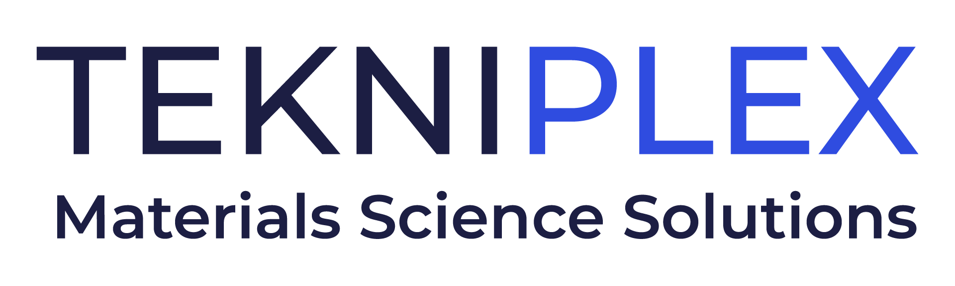
Press release

Media Contact: Peter Gavigan
TekniPlex
+1 (908) 720-5391
Peter.Gavigan@tekni-plex.com

Christopher Dale
Turchette Agency
+1 (973) 227-8080 ext. 116
cdale@turchette.com

TekniPlex Consumer Products Hires Aurélie Emond
as Segment VP for Integrated Performance Solutions

Talented long-term executive will help oversee newly formed segment,
which focuses on sealing & dispensing solutions for various sectors.

Wayne, PA – TekniPlex Consumer Products, a globally integrated provider of innovative solutions through materials science and manufacturing technologies, has hired Aurélie Emond as Segment VP for the division’s recently formed Integrated Performance Solutions (IPS) segment. Working in tandem with regional executives around the world, Ms. Emond’s purview will include solidifying and steering the nascent IPS segment’s global business strategy.

Formed in Q4 2022, TekniPlex Consumer Products’ IPS segment focuses on the sealing and dispensing needs of various markets, including home care, food & beverage, beauty & personal care, and consumer healthcare products. It unites the capabilities of two TekniPlex legacy companies: TriSeal, whose materials science-based liner and lidding solutions and automation technology solutions address ever-changing market needs from sustainability to unique barrier solutions; and Action Technology, which has developed over 100 unique rubber and plastic formulations – including rubber gaskets, bulbs and dip tubes – designed to meet critical performance requirements in the pressurized and non-pressurized dispensing pumps market.

“Aurélie is a true business development pro, with a strong track record of growing industrial and technical B2B and B2B2C initiatives with broad, often international dimensions,” said Eldon Schaffer, CEO of TekniPlex Consumer Products. “She brings a history of fostering collective intelligence in ways that rally diverse teams around clear, shared visions and ambitions.”

With a career spanning more than 25 years, Ms. Emond has experience in several complex industries. Most recently, she was VP of Business Development for active packaging solutions supplier Clariant Healthcare Packaging. There, Ms. Emond broadened market education, identified growth opportunities, and helped expand market presence in the active packaging segment.

Earlier in her career, Ms. Emond held executive roles with cosmetics industry packaging provider Crown Risdon (now part of Berry Plastics), as well as prominent beauty company Albéa. At Albéa, she held several sales, innovation, and marketing leadership roles over a decade-long tenure.

Ms. Emond earned a master’s degree in mechanical engineering from the Université de Technologie de Compiègne in France. She resides near Paris.

# # #

About TekniPlex Consumer Products
TekniPlex Consumer Products specializes in advanced materials science solutions for companies in the food & beverage and CPG industries with a focus on protecting products, strengthening brands, and innovating sustainably. TekniPlex Consumer Products serves companies around the world in sectors including beauty and personal care, household items, and food and beverage.

With an expanding selection of material-diverse solutions – bolstered in recent years, by a series of strategic acquisitions – TekniPlex Consumer Products is leading the way creating next-generation packaging designs that address real-world challenges in the markets it serves. Most notably, the company is focused on developing more sustainable solutions that continue to provide product safety and consumer satisfaction. For more information, visit www.tekni-plex.com/consumer

