**BC Jindal Group’s JPFL Films Becomes India’s First Packaging Manufacturer to Launch BOPA Nylon Films; Invests Rs 120 crore**

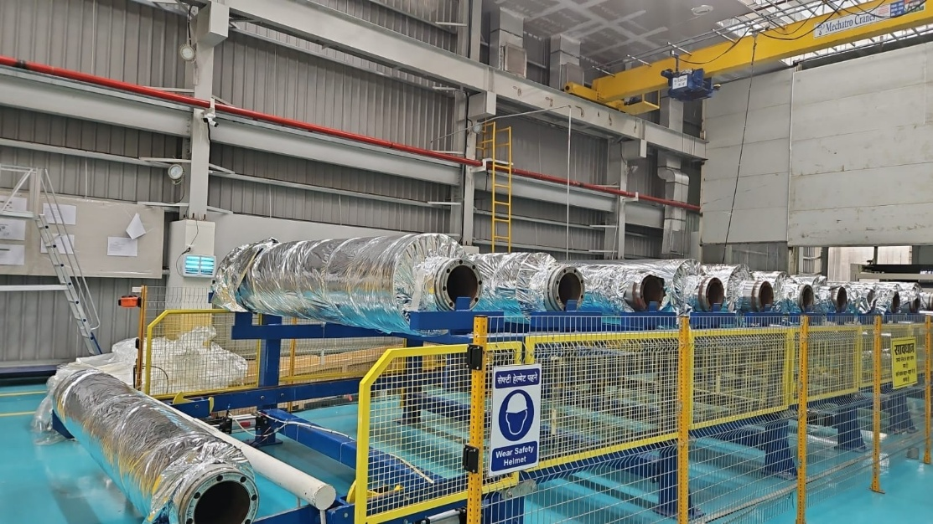

**New Delhi, March 4, 2025:** JPFL Films Private Limited, a subsidiary of India’s biggest flexible packaging company, Jindal Poly Films Ltd, has announced that it has become the first player to launch Biaxially Oriented Polyamide (BOPA) Nylon films in India. JPFL Films Private Limited has invested Rs 120 crore at its state-of-the-art facility in Nasik.

This unveiling of BOPA Nylon Films is in line with the Government’s ‘Make in India’ initiative and a strategic move to bolster the company’s growth. This new product launch mirrors the company’s commitment to infuse technological advancement and innovation in manufacturing processes, enhance quality, optimize costs and ensure enhanced customer satisfaction. This investment also re-iterates the strong commitment of the company to the Indian market.

Speaking on the launch, **Dr Mahesh N Gopalasamudram, Deputy CEO (Growth Division), JPFL Films, *“****With the launch of BOPA Nylon Films, JPFL Films Private Limited has emerged as the first player to bring the innovation to the Indian market. This unique product offers improved mechanical properties and aroma barrier. This will also play a pivotal role in bringing solutions across pharma, medical, FMCG and food applications. It will be noteworthy to point out that 100% of these films were imported till recently.”*

One of the main characteristics of this unique offering is its isotropicity (same set of characteristics or properties in all directions) produced in exclusive Japanese double bubble film technology that promises dimensional stability puncture resistant and homogeneity across the length and width of the product. In addition, the product is suitable for highspeed printing and serves as an effective barrier for aroma and gases.

*“BOPA films is also produced by our group company Jindal Nylon films in Italy. This experience will also help us in serving the Indian customers and bringing global innovation locally,”* ***D*r Mahesh N Gopalasamudram** added**.**

**About Jindal Poly Films Ltd & BC Jindal Group -**

Jindal Poly Films (JPFL) started the flexible packaging films business in 1996 and has grown into a >USD 500 million turnover company with 2500+ workforce. JPFL focuses on building trust with and creating value for all stakeholders through its scale, innovation, advanced technologies and cost efficiencies. The company has demonstrated growth via the execution of capital-intensive projects and multiple acquisitions. JPFL Films, a key subsidiary, is the largest flexible packaging films manufacturer in India and provides a one-stop solution to its customers across all segments. Its Nasik Plant is the world’s largest single location facility for the manufacturing of flexible packaging films.

The US$ 2.5 billion BC Jindal Group is amongst India's leading business houses. Established in 1952, the group has a diverse workforce of more than 10,000 people across India, Europe, and the US. Key business verticals include flexible packaging films, energy generation and downstream steel products. The Group has a continuous growth agenda with a successful track-record of executing capital-intensive projects and multiple global acquisitions.