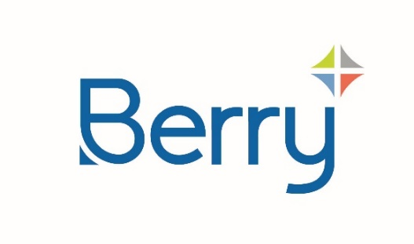
Media Alert

Berry Helps Aquafigure Deliver Reusable ‘Bottle for Life’
Eye-catching bottle supports hundreds of uses and showcases interchangeable, 3D artwork
August 13th 2024 - Global packaging leader, Berry Global Group, Inc., partnered with Norwegian brand, Aquafigure, to deliver a new line of reusable water bottles with a unique design for interchangeable, 3D bottle cards to encourage young people to drink more water.
Intended to provide a ‘bottle for life,’ the 330-millilitre container is made from BPA-free Tritan™, a widely recyclable, food-approved co-polyester that can endure hundreds of dishwasher cycles. The cap is manufactured from widely recyclable, mono-material Polypropylene (PP).
The bespoke bottle design allows Aquafigure’s proprietary range of patented PET bottle cards to be easily inserted and swapped as consumer tastes and trends change. Precise internal measurements ensure the bottle cards are self-supporting and remain in place regardless of angle. The cards are currently available in over 50 different designs including elite football clubs, The Smurfs, and a limited-edition set featuring superstar striker (and Aquafigure ambassador), Erling Haaland.
“Through our innovation expertise and technical resources, we are delivering cutting-edge solutions that help our customers bring exciting, sustainable concepts to market,” said Joe Horton, Sales and Marketing Director for Berry Agile Solutions. “Aquafigure’s commitment to a reusable bottle highlights the endless possibilities to optimize the consumer experience while advancing a circular economy.”
The bottles and caps are manufactured at Berry’s plants in Etten Leur and Market Rasen. Team members at the facilities worked together to ensure the bottle and cap provided a tight seal while still being easy to open for children.
“It has been amazingly helpful to have a single supplier like Berry to partner with us in the development of the bottle and the cap,” said Ørjan Asbjørnsen, Founder and Managing Director of Aquafigure. “Berry Agile Solutions provided us with full-service, expert support from day one. And with the knowledge, expertise, and reach of a global market leader, we can be reassured of the capability to scale up as Aquafigure enters new territories.”
Launched in Norway in 2023, Aquafigure quickly became the fastest selling brand for refillable drink containers, outselling leading brands in stores where there was direct competition. Aquafigure has since diversified its range to include pre-filled bottles.
Ends

About Berry
At Berry Global Group, Inc. (NYSE: BERY), we create innovative packaging solutions that we believe make life better for people and the planet. We do this every day by leveraging our unmatched global capabilities, sustainability leadership, and deep innovation expertise to serve customers of all sizes around the world. Harnessing the strength in our diversity and industry-leading talent of over 40,000 global employees across more than 250 locations, we partner with customers to develop, design, and manufacture innovative products with an eye toward the circular economy. The challenges we solve and the innovations we pioneer benefit our customers at every stage of their journey. For more information visit our website or connect with us on LinkedIn or X.
About Aquafigure
The inspiration for Aquafigure came on a round-the-world trip, where Ørjan Asbjørnsen was struggling to persuade his children to drink water. Realising that the issue wasn’t the drink, but the bottle packaging. Together with his children he conceived the idea of a reusable bottle that would make water more fun and encourage children to drink healthier.
The result is a ‘bottle for life,’ with consumers able to buy new bottle cards as their tastes and fashions change, always keeping the bottle fresh and current. At the same time, this inspires people to make healthier choices by choosing water over less healthy hydration alternatives.
The patented solution is manufactured from PET, containing 30% post-consumer recycled content. The ingenious manufacturing method bond layers together into a continuous block of PET, with the food safe ink encapsulated. This means no adhesives or chemicals are required.
As the bottle cards are digitally printed, they can be updated with very short production runs to cover seasonal events (back to school, Halloween, Christmas) as well as sports events or concert tours.
Aquafigure retails either as a single bottle, or in bundles that include a multipack of bottle cards. Recently, the company has also trialed pre-filled bottles – believed to be the first instance of a reusable bottle that offers a pre-filled option to cater to consumers who need a drink but are also looking for a sustainable bottle option.
Launched to great acclaim in Norway in 2023, Aquafigure is expanding across Europe, while continuing to develop partnerships with brands, to expand the range of bottle cards available.
For more information, visit our website, or connect with us on LinkedIn.

