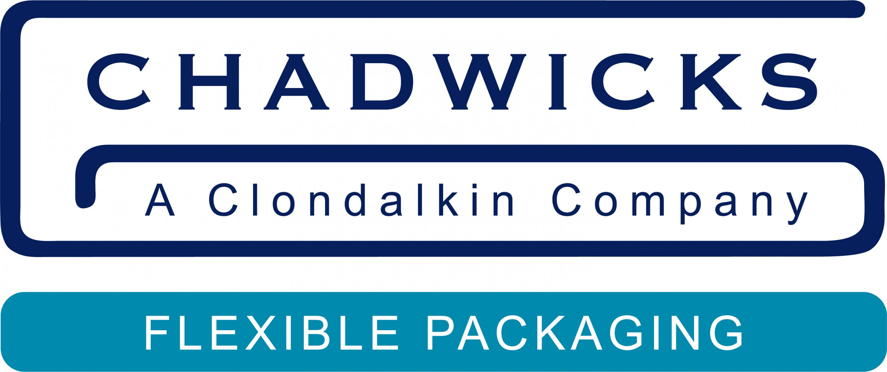

**PRESS RELEASE**

**Chadwicks showcases sustainable lidding innovations at Packaging Innovations**

***“The addition of rPET lidding with 50 percent PCR to our product portfolio is a key milestone.”***

Visitors to stand R34 at the annual Packaging Innovations show at the NEC, Birmingham, on 12th and 13th February, will see a wide range of innovative and sustainable lidding solutions from Chadwicks of Bury, a world leader in heat-seal pre-cut lids.

Among the featured products is Chadwicks’ latest rPET pre-cut lidding film, which contains up to 50 percent post-consumer resin (PCR).

Fully approved for food contact, rPET pre-cut lids are ideal for a wide range of food applications such as butter, dips, spreads, and yogurts, as well as beverages and convenience foods, and offer the same high-performance characteristics as standard PET pre-cut lidding.

“We are committed to reducing our reliance on virgin plastics and embedding more responsible practices across our business,” says Paul Whelan, Chief Technical Officer at Chadwicks. “The addition of rPET lidding with 50 percent PCR to our product portfolio is a key milestone. It offers the same technical properties as virgin plastic, but with a reduced carbon impact and substantial use of recycled material in the supply chain, which we see as the right thing to do.”

**The resealable revolution**

At the Packaging Innovations event, Chadwicks will also unveil its latest innovation – a resealable pre-cut lid. This new product eliminates the need for plastic over-caps, extending product freshness while reducing overall plastic use.

“Our resealable lids are easy to open – and easy to reseal – time and time again, keeping food fresher for longer,” says Paul Whelan. “Ideal for dairy and other food applications, our new resealable lidding film is the perfect solution to add a new level of consumer convenience for any brand.”

**Fully recyclable aluminium pre-cut lids**

Chadwicks will also showcase its versatile aluminium pre-cut lidding, known for its superior sealing across various container types, including PP, PET, Paper PE and glass. Aluminium lids offer excellent barrier properties, protecting against light, moisture, and oxygen, which helps extend shelf life and maintain product quality. They are fully recyclable, supporting sustainability goals while also being compatible with high-speed production lines and various heat-sealing processes.

Aluminium lidding can also be used for hot fill applications and products requiring additional processes such as pasteurization or sterilization, making it a reliable choice for various applications.

**Sustainable lidding solutions**

“At Chadwicks, we are on a constant journey to improve our sustainability credentials, which will also help our customers reduce their carbon footprint.

“We champion the use of aluminium – which is one of the most recycled materials on earth – and can be recycled over and over again without any loss of quality. We are working to include higher percentages of post-consumer waste in our PET products, and our polypropylene (PP) aluminium-free die-cut lids can be collected for recycling in the PP waste stream. When sealed to a PP cup, the film offers a sustainable recycle-ready mono material package.

“We have already achieved zero to landfill in our factories and our lidding solutions protect food, extend shelf-life and maintain product quality, contributing to a reduction in food waste.

“Visit Chadwicks at Packaging Innovations to chat with your partners in lidding innovation.”

Visit:

**https://chadwickslids.com/**

*Chadwicks’ latest rPET pre-cut lidding film, which contains up to 50 percent post-consumer resin.*

______________________________

For further information, please contact:

Bill Bruce

**Bill Bruce Communications**

Tel: +44 (0)7799 347046

Email: bill@billbrucecommunications.com

**Notes for editors**

**About Chadwicks**

For over 50 years, Chadwicks of Bury has been designing, manufacturing and delivering practical lidding solutions that help global food brands protect their products.

Chadwicks of Bury is a world leader in heat-seal pre-cut lids, dedicated to producing

high-quality custom-made sealing solutions for food, dairy, beverage, personal care, and household products. With over 300 cutting tools, lids can be cut to almost any size or shape.

Chadwicks of Bury maintains BRCGS Global standard for packaging materials Grade AA certification, and ISO 9001 accreditation.