|  |  |  |
| --- | --- | --- |
| e  Editorial Contact: | Ana Juraga | [ana.juraga@ecocortec.hr](mailto:ana.juraga@ecocortec.hr) |
| Cortec® Europe Advertising Agency | + 385 (0) 1 4854 486 |  |
| Company Contact: Cortec® Corporation: | Ivana Radic Borsic  + 385 ( 0 ) 31 705 011 | [iborsic@cortecvci.com](mailto:iborsic@cortecvci.com) |

**Attention: Editor May 23, 2024 PRESS RELEASE**



EcoCortec® Bioplastics Plant Starts State-of-the-Art Compounding Operations for Bio-Resins in New Polymer Processing Factory!

EcoCortec®, a subsidiary of Cortec® Corporation, is proud to announce the launch of its state-of-the-art compounding operations for VpCI® polymers and bio-resins. Utilizing modern, high-tech compounding lines in its polymer processing facility, the plant is now producing premium concentrated masterbatch. EcoCortec’s compounding line will ensure the highest film quality for the plant’s customers. Launching compounding

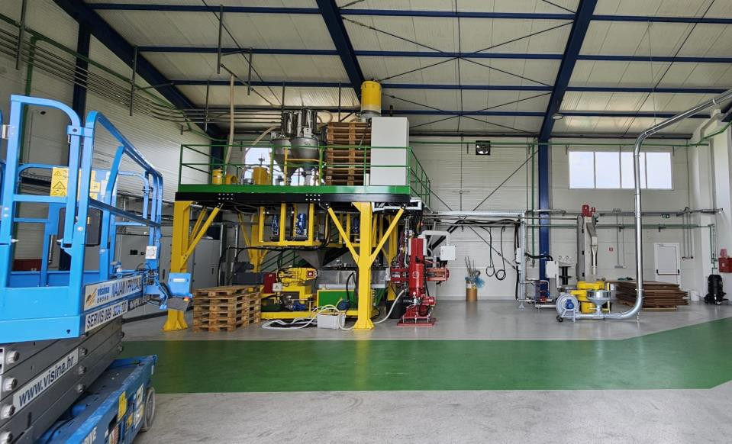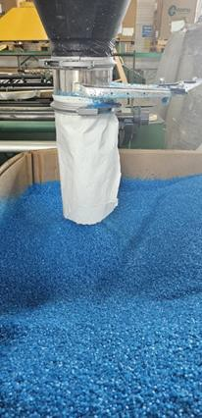

**High quality masterbatch under the license of Cortec® Corporation is now produced at EcoCortec’s plant in Croatia.**

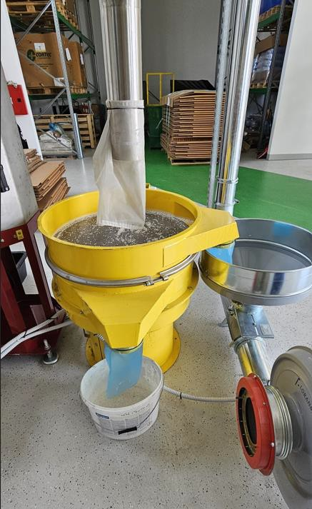operations at the Croatian plant in Beli Manastir offers numerous benefits for both EcoCortec® and its European licensees and distributors. Conducting the entire process in-house from start to finish enhances the plant's self-sustainability and significantly shortens lead times for customers. Cortec® Corporation is a global manufacturer of “green” VCI/VpCI® corrosion protection solutions. Cortec’s VpCI® masterbatch is used in the production of patented, environmentally responsible films for corrosion protection. The VpCI® embedded in the film vaporizes and diffuses throughout an enclosed package, adsorbing onto metal surfaces inside. A thin, molecular, hydrophobic layer protects the metal against corrosive elements such as oxygen, moisture, and chlorides. EcoCortec® can now produce a variety of concentrated masterbatch products and integrate Cortec’s patented VpCI® Technology into biodegradable packaging solutions.

# Vertical Integration at EcoCortec®

While Cortec® has been a pioneer in the formulation and compounding of biobased and biodegradable resins for the last 20 years, the start of EcoCortec® compounding operations marks a significant step for its Croatian plant. “By completing the entire production process in-house, EcoCortec® is now less dependent on outside sources, enhancing its self-sufficiency. Our Croatian

**VpCI® masterbatch is produced in EcoCortec® and used in the production of their patented, environmentally responsible packaging solutions for corrosion protection.**

plant can now fully implement a vertical integration philosophy. By overseeing operations from VpCI® masterbatch compounding all the way to extrusion, converting, and printing, we can achieve better quality control. Once we have the raw materials, production can proceed seamlessly from start to finish,” says EcoCortec’s General Manager, Dijana Zrinski. Additionally, EcoCortec’s efficient shipping system minimizes any supply chain disruptions, enabling the plant to offer significantly faster turnaround times compared to VCI film suppliers who contract their production to other facilities.

Cortec’s environmentally responsible VpCI® Films and Bags are used in countless industries and applications around the globe, giving users an easy and effective way to protect metal parts and equipment from rust and corrosion. This is critical for manufacturers who want their newly made metal goods to be protected in-process and stored

or shipped in safety without fear of corrosion. It is also vital for facilities that need to keep critical spares and large or small assets corrosion-free during periods of layup or mothballing.

# Sustainable Production Model and Green Initiatives

A key mission of EcoCortec® is to prioritize environmental responsibility. The plant is dedicated to implementing a high-level circular economy model through a multitude of initiatives and innovative approaches. One such initiative involves extending the life of materials. Within the "Plastic Recycling Project," EcoCortec’s customers can send their waste VpCI® material back to the Croatian plant for recycling and reuse in manufacturing new products. EcoCortec® reprocesses VpCI® Film scrap and incorporates the "repro" back into the virgin film. The company’s goal is reaching 30% recycled content in plastics packaging by 2030.

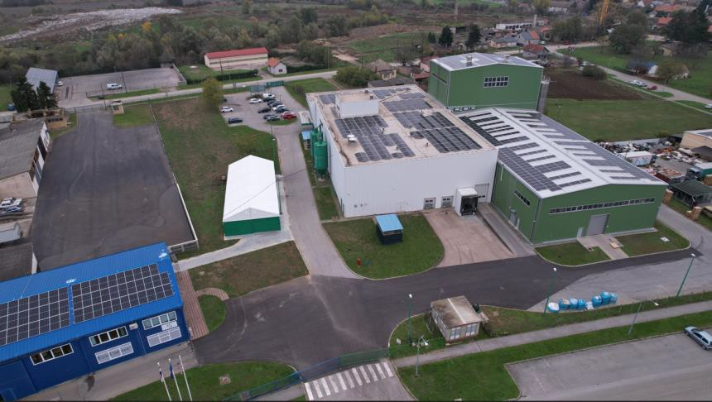EcoCortec® demonstrates a successful model of environmental resource management. Boris Miksic, CEO of Cortec® Corporation, laid the foundations for an environmentally responsible business model that has become the company's trademark. As a visionary, he recognized the importance of sustainable development decades ago. "By reprocessing film scrap at EcoCortec®, we gain numerous benefits, such as significantly decreasing waste and avoiding potential environmental problems

**EcoCortec’s solar-powered** **plant is located on the green fields of Croatia’s Baranja region.**

associated with its disposal. Moreover, we achieve significant fuel savings and reduce our carbon footprint. I am very proud of our EcoCortec® plant as it stands as a true example of the circular economy in action," says Miksic. He adds, "With new compounding operations, we have completed the entire production process in-house. We are dedicated to developing safe and effective products for corrosion prevention within sustainable manufacturing processes. In addition to being passionate advocates for preserving natural resources, we recognize our responsibility to our customers, the environment, and our local community, and we take this responsibility very seriously."

* You can find more information about the EcoCortec® plant at <https://ecocortec.hr/eng/index>

* You can find EcoCortec’s brochure here: <https://www.ecocortec.hr/eng/assets/files/EcoCortec_brochure.pdf>

***Keywords: EcoCortec, sustainability, corrosion inhibitors, compounding, corrosion protection, packaging solutions, VCI, VpCI, films recycling, circular economy, polymer processing***

Need a photo? Visit: [**www.cortecadvertising.com**](http://www.cortecadvertising.com/)**.** Cortec® Corporation is the global leader in innovative, environmentally responsible VpCI® and MCI® corrosion control technologies for Packaging,,Metalworking, Construction, Electronics, Water Treatment, Oil & Gas, and other industries. Our relentless dedication to sustainability, quality, service, and support is unmatched in the industry. Headquartered in St. Paul, Minnesota, Cortec® manufactures over 400 products distributed worldwide. ISO 9001:2015, ISO 14001:2015, & ISO/IEC 17025:2017 certified.

Cortec® Website: [http://www.cortecvci.com](http://www.cortecvci.com/)