Editorial Contact:  Cortec® Advertising Agency | Jeni Duddeck  (651) 429-1100 Ext. 1114 | jduddeck@cortecvci.com
Company Contact: Cortec® Corporation | Julie Holmquist  (651) 429-1100 Ext. 1194 | jholmquist@cortecvci.com
Technical Contact: Cortec® Corporation | Rick Shannon  (651) 429-1100 Ext. 1146 | rshannon@cortecvci.com

Attention: Editor
March 05, 2024
PRESS RELEASE

The Many Shapes and Sizes of CorShield® VpCI®-146 Rust Prevention

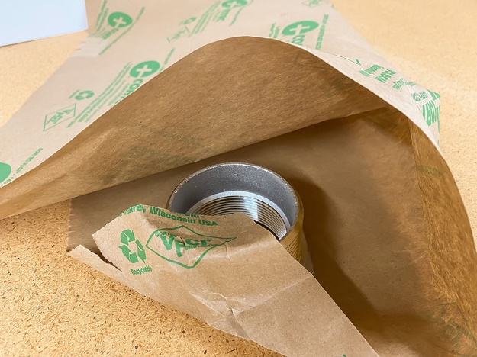
Rust prevention is a must-have for manufacturers and distributors of metal goods. Unpredictable shipping conditions paired with corrosion-susceptible metals create a recipe for disaster if no precautions are taken. Fortunately, the solution is sometimes as simple as grabbing a piece of CorShield® VpCI®-146 Paper to pack metal parts and get them to customers in like-new condition.

How VCI Paper Works
CorShield® VpCI®-146 is a 100% recycled content paper with a water-based coating that contains Vapor phase Corrosion Inhibitors. When the paper is wrapped around a metal part or placed in an enclosed container, these Vapor phased Corrosion Inhibitors vaporize and spread throughout the compartment. They are attracted to metal surfaces, where they form a protective molecular layer that remains and replenishes itself until the package is opened. The metal part can be used immediately after unwrapping the paper—no cleaning required. CorShield® VpCI®-146 is a USDA Certified Biobased Product and may be recycled into a variety of new paper products after use.

Who Needs VCI Paper?
Almost any company that manufactures or distributes metal parts can find a place to use CorShield® VpCI®-146 Paper. Good candidates for packaging include:

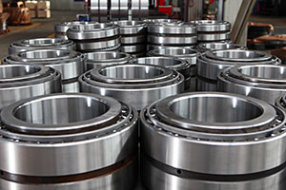
- Bearings
- Brakes
- Transmission components
- Other auto parts
- Sheet metal
- Tools
- Gauges
- Airplane propellers

VCI Paper in Many Formats and Sizes
CorShield® VpCI®-146 Paper comes in a variety of sizes and formats for the convenience of the customer:

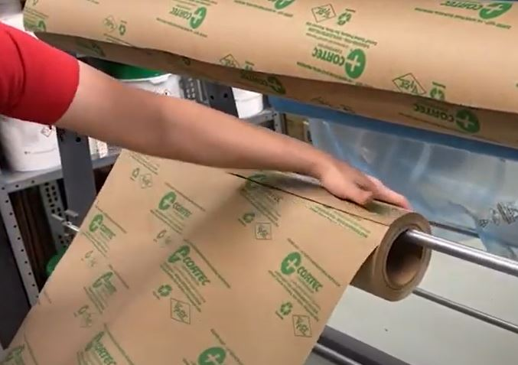
- Stock precut sheeting in sizes ranging from 4 x 8 inches (10.2 x 20.3 cm) to 36 x 36 inches (91.4 x 91.4 cm) (35# basis weight).
- Stock perforated rolls for easy tear-off (12 x 12 inch [30.5 x 30.5 cm] pieces).
- Stock uncut rolls in sizes ranging from 12 to 48 inches (30 to 122 cm) wide and 600 feet (183 m) long.
- Custom uncut rolls from 3 to 98 inches (7.6 to 248.9 cm) wide and 50 to 50,000 feet (15.24 to 15,240 m) long (depending on basis weight).
- Custom perforations of 24 to 72 inches (61 to 183 cm) can be ordered on rolls 12 to 48 inches (30.5 to 122 cm) wide in a variety of paper weights.
- Cradle pack pallets of CorShield® VpCI®-146 Paper are available at a discount for those who want to order large quantities and reduce the amount of cardboard typically used to individually box each roll.

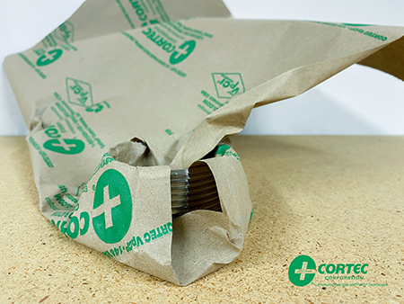
How to Use VCI Paper
The size and style of paper selected will depend on the final application and workplace preferences. Precut sheets of CorShield® VpCI®-146 Paper are great for small items that need to be individually wrapped. All workers must do is make sure the part is clean and dry, then wrap the paper around the metal, taping folds in place if necessary. Some workers prefer dispensing paper by tearing it off a perforated roll. This can now be done to fit standard pallet sizes, thanks to expanded perf capabilities at Cortec®. Whatever the size or precut condition, a common practice is to “interleave” or “sandwich” brake discs or other auto parts between pieces of CorShield® VpCI®-146 Paper to separate and protect them from corrosion inside a bin or on a pallet. In 2020, one brake rotor manufacturer began automating this process, using a machine to automatically cut pieces from a 48” (1.2 m) wide roll of CorShield® VpCI®-146 Paper. A robot would sandwich the layers of paper and rotors on a pallet, which was then automatically wrapped in Cor-Pak® VpCI® Stretch Film (another corrosion inhibiting packaging material) before being shipped out.

Ready, Set, Choose!
The wide variety of VCI paper forms and sizes provides a wealth of options for manufacturers or distributors who need a simple biobased packaging option to inhibit corrosion on metal goods. Contact Cortec® today to discuss the right shape and size of CorShield VpCI®-146 Paper to keep your metal parts from rusting in shipping or storage.

Keywords: rust prevention, CorShield VpCI-146, VCI paper, how VCI paper works, VCI paper sizes, how to use VCI paper, Cortec, corrosion protection, packaging for auto parts, biobased packaging

Need a High-Resolution Photo? Visit: www.cortecadvertising.com
Cortec® Corporation is the global leader in innovative, environmentally responsible VpCI® and MCI® corrosion control technologies for Packaging, Metalworking, Construction, Electronics, Water Treatment, Oil & Gas, and other industries. Our relentless dedication to sustainability, quality, service, and support is unmatched in the industry. Headquartered in St. Paul, Minnesota, Cortec® manufactures over 400 products distributed worldwide. ISO 9001:2015, ISO 14001:2015, & ISO/IEC 17025:2017 certified. Cortec® Website: http://www.cortecvci.com Phone: 1-800-426-7832 FAX: (651) 429-1122

