**Cosmo First Introduces Revolutionary Paint Protection Films to Safeguard Vehicle Exteriors with Lifetime Warranty**

**New Delhi, 20 December 2024:** Cosmo First, a leading global manufacturer of specialty films for packaging, labelling, lamination, and more, is set to transform vehicle protection with the launch of its innovative Paint Protection Films (PPF), designed to preserve and enhance automotive exteriors. The company will now begin market trials for the product.

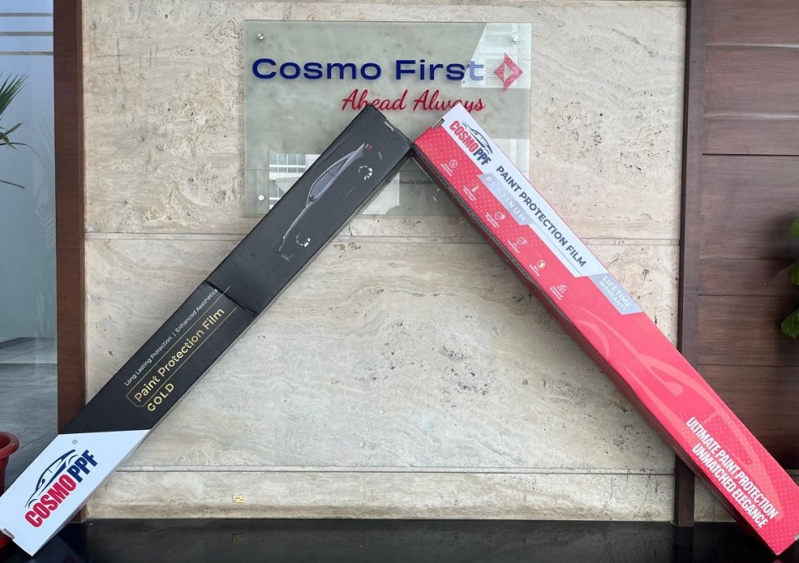

Cosmo PPF offers vehicle owners a comprehensive solution to maintain their car's pristine appearance. Key features of Cosmo PPF include advanced scratch resistance, innovative self-healing technology, hydrophobic properties, and comprehensive UV and chemical protection. The product line features two distinct variants tailored to different protection needs.

The Cosmo PPF Platinum, the premium offering, stands out with its impressive 8-mil thickness and an unprecedented lifetime warranty. This top-tier variant provides deep scratch resistance, maximum durability and flexibility in application, protecting vehicles against environmental challenges including stains, scratches, and harmful UV rays, and maintaining their unmatched elegance.

Complementing the Platinum line, the Cosmo PPF Gold offers long lasting protection with a 5-year warranty. The self-healing properties of Cosmo PPF ensure enhanced aesthetics, strengthening Cosmo First's commitment to delivering superior automotive protection solutions. Engineered with high-quality Thermoplastic Polyurethane (TPU) technology and best-in-class advanced pressure-sensitive adhesive, the films are designed to maintain a vehicle's showroom-like finish, repelling environmental contaminants and preventing paint degradation.

*“As the automotive landscape evolves, we're seeing an unprecedented rise in premium vehicle ownership, with discerning customers investing significant resources in their dream cars,”* said **Mr Pankaj Poddar, Group CEO, Cosmo First.** *“Our Paint Protection Films are more than just a protective layer – they're a precision-engineered solution that meets the expectations of modern car enthusiasts who view their vehicles as valuable assets. Cosmo PPF transforms car care from a maintenance task to a premium value addition, ensuring that every vehicle’s paint maintains its showroom brilliance even against environmental challenges.”*

The launch comes in response to growing consumer demand for long-lasting, effective paint protection solutions. Vehicle owners can look forward to experiencing the Cosmo PPF difference when the product becomes widely available.

**About Cosmo First Limited:**

Founded by Mr. Ashok Jaipuria in 1981 as Cosmo Films, today Cosmo First is a multinational conglomerate with 5 major business verticals. The flagship company, Cosmo Films, is a global leader in specialty films for packaging, lamination, labelling, and industrial and synthetic paper, serving over 5000 customers across 100+ countries. Cosmo Films over the years has been partnering with worlds’ leading F&B and personal care brands and packaging & printing converters to enhance the end-consumer experience. With manufacturing units in India and warehousing in different parts of the world, the company has been at the forefront of developing customer-centric solutions to deliver the finest product and service experience, backed by innovation, people, and processes.

The other verticals include Cosmo Speciality Chemicals (Masterbatches, Adhesives, & Coating), Cosmo Plastech (Rigids - IML Containers and Specialty Sheets of PP / PET and HIPS) and Cosmo Sunshield (Window, Privacy and Security Films), along with a digital-first omni-channel pet care business, Zigly. Cosmo First is into D2C, B2B2C and B2B businesses and has operations in India, Japan, Korea, Europe and Americas.

Visit www.cosmofirst.com for more details.