Editorial Contact:  Cortec® Advertising Agency | Jeni Duddeck  (651) 429-1100 Ext. 1114 | jduddeck@cortecvci.com
Company Contact: Cortec® Corporation | Julie Holmquist  (651) 429-1100 Ext. 1194 | jholmquist@cortecvci.com
Technical Contact: Cortec® Corporation | Rick Shannon  (651) 429-1100 Ext. 1146 | rshannon@cortecvci.com

Attention: Editor
February 12, 2024
PRESS RELEASE

Fitting the Right Packaging to Oversized Metal Items with Cortec® VpCI® Film!

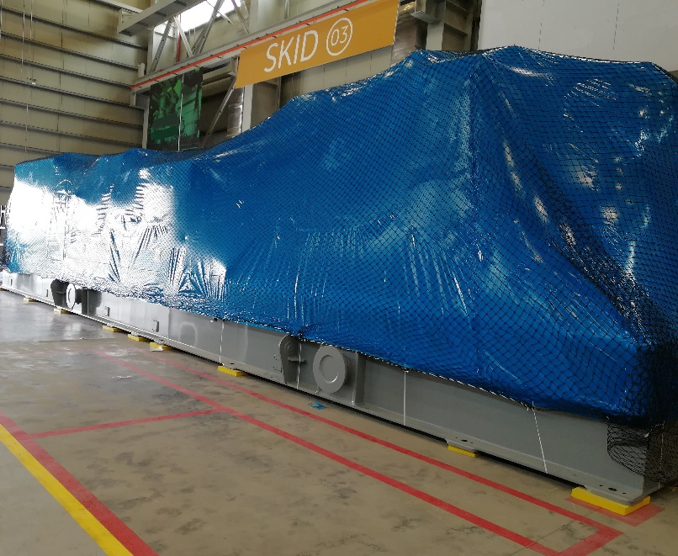
VpCI®-126 Film and Bags are an easy way to package and protect many different types of metal parts. Simply sliding a small gear or a handful of bolts into a VpCI®-126 Top-Seal Bag and zipping the bag shut can keep the metal from rusting for up to two years. But what happens when the metal component or equipment is taller than a person’s head or too wide for even three people to wrap their arms around? Fortunately, Cortec® VpCI® Film offers the flexibility users need to create custom packaging solutions for oversized metal items.

Rust Prevention with VpCI® Film
VpCI® Film is a rust preventative option for manufacturers and third-party packagers. Instead of requiring the application of greasy rust preventatives that eventually need to be cleaned off, VpCI® Film offers clean, dry corrosion protection—not only by means of a physical barrier, but also with corrosion inhibitors that work in both the contact and vapor-phase. This means the film protects metal surfaces inside the package that are directly touching the film as well as surfaces that are not.

Finding the Right Packaging for Large Items
At Cortec® Corporation, VpCI® Films come in widths up to 30 feet (9.1 m), allowing users to package extra large objects. When this is not wide enough, users can seam together sections of VpCI®-126 HP UV Shrink Film and MilCorr® VpCI® Shrink Film, two heavy duty versions of VpCI® Film, to shrink wrap extremely large or bulky items that will be exposed to outdoor conditions. For an even better fit with less fuss on the application side, users can order customized bags that will easily slip over specific sizes of equipment, requiring only a quick final shrink wrap to finish the packaging job.

Unusual Packaging Examples
Past examples show that many creative VpCI® Film packaging solutions exist for large or unwieldy metal goods.

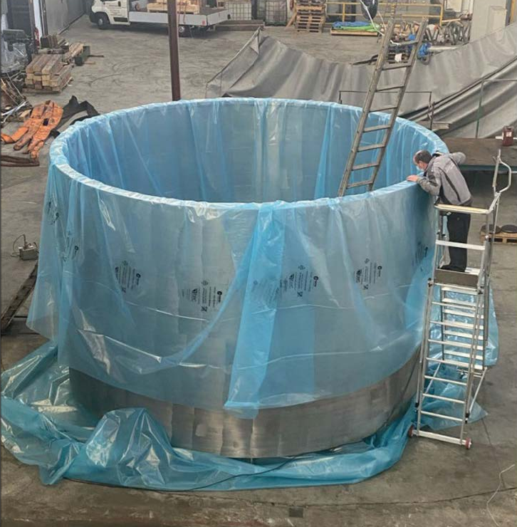
- Packaging a Giant Ring
At one time, a giant metal ring 3.5 yards (3.168 m) tall and 6 yards (5.5 m) in diameter needed to be protected for the trip to its final destination at a nuclear facility. A third-party packager used strips of VpCI®-126 Film 3.3 yards (3 m) wide to wrap the shiny new ferrule, providing protective peace of mind for the journey.
- Packaging Wind Turbine Components
Several years ago, a manufacturer of wind energy components started using VpCI®-126 HP UV Shrink Film and MilCorr® VpCI® Shrink Film to wrap new wind turbine shafts, rings, and hubs. In addition to a protective coating on some of the most sensitive parts, the components needed this heavy-duty VpCI® Film for two to five years of storage, possibly outdoors.
- Packaging Massive Power Cable Drums
In 2022, PRESSERV used MilCorr® VpCI® Shrink Film to package giant power cable drums stored outdoors as emergency backups for offshore platforms. The drums were so large that MilCorr® was seamed together to cover the entire bulk. These shrink-wrapped units were also equipped with access doors for later inspection.
- Packaging 3D Printers
Last year, a manufacturer of 3D printers used customized bags made of VpCI®-126 HP UV Shrink Film to cut down on wood crating. The specialty bags were easy to fit over the printers, shrink wrap, and finish preparing for shipment in about 15 minutes while significantly reducing wood packaging costs.

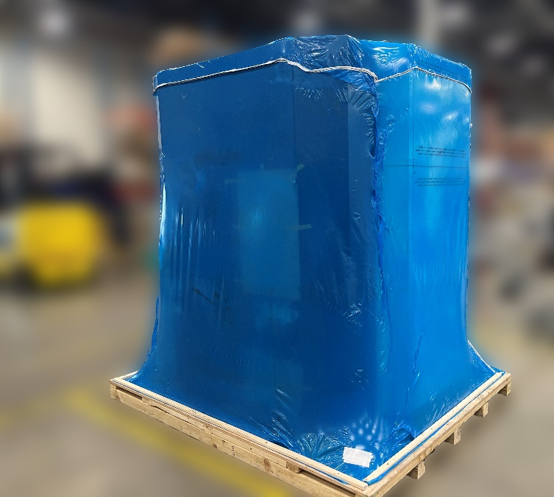
When you encounter an out-of-the-ordinary packaging application that needs corrosion protection, VpCI® Film provides the needed flexibility to adapt to challenging sizes and storage conditions. Contact Cortec® for more help on fitting the right VpCI® Film to oversized packaging applications.

Keywords: packaging oversized items, packaging metal, packaging for large items, VCI film, VpCI Film, corrosion protection, rust preventatives, rust prevention, Cortec, unusual packaging solutions

Need a High-Resolution Photo? Visit: www.cortecadvertising.com
Cortec® Corporation is the global leader in innovative, environmentally responsible VpCI® and MCI® corrosion control technologies for Packaging, Metalworking, Construction, Electronics, Water Treatment, Oil & Gas, and other industries. Our relentless dedication to sustainability, quality, service, and support is unmatched in the industry. Headquartered in St. Paul, Minnesota, Cortec® manufactures over 400 products distributed worldwide. ISO 9001:2015, ISO 14001:2015, & ISO/IEC 17025:2017 certified. Cortec® Website: http://www.cortecvci.com Phone: 1-800-426-7832 FAX: (651) 429-1122

