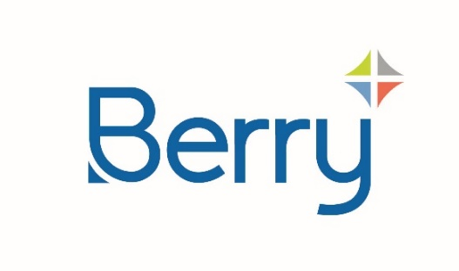
Media Alert

Issue Date: 8th March 2024
For Immediate Release

Berry Launches Fully Recyclable, Customizable Domino Bottle Available with Recycled Plastic
Rectangular bottle is fully recyclable and allows for customized branding on all four sides
BECCLES, Suffolk. –June, 17th 2024 – Global sustainable packaging leader Berry Global Group, Inc. (NYSE: BERY) has launched a customizable, rectangular Domino bottle available with up to 100% post-consumer recycled (PCR) plastic for the beauty, home, and personal care markets.
The 250ml Domino bottle includes a 75-millimetre-wide front face and customizable side panels. This allows all four sides of the container to be printed, maximizing opportunities for brands to create unique packaging experience with high impact shelf presence. The side panels can be further customized with distinctive, textured embossing or debossing to create a tactile experience for consumers.
Manufactured in high density polyethylene (HDPE), the Domino bottle is fully recyclable where appropriate collection schemes exist. And the neck is suitable for a variety of caps and closures, including the recently launched Wave2cc all plastic dispenser. The rectangular bottle shape also allows for more efficient stacking, minimizing wasted space on shelf and during transportation and storage.
The Domino bottle is available through Berry Agile Solutions, which specialises in rapid sample delivery, low-cost customisation options, and low minimum order quantities - to help brands stay on top of the latest consumer trends.
“In a retail environment where consumers are influenced by how brands are presented on-shelf, impactful packaging and graphic design is critical,” said Joe Horton, Sales and Marketing Director at Berry Agile Solutions. “We want companies to be able to easily create eye-catching designs in line with their own brand objectives. Domino helps brands quickly respond to current consumer trends and create the ‘Wow’ factor at lower cost.”
For more information on the Domino bottle, visit berryglobal.com.
###

About Berry
At Berry Global Group, Inc. (NYSE: BERY), we create innovative packaging solutions that we believe make life better for people and the planet. We do this every day by leveraging our unmatched global capabilities, sustainability leadership, and deep innovation expertise to serve customers of all sizes around the world. Harnessing the strength in our diversity and industry-leading talent of over 40,000 global employees across more than 250 locations, we partner with customers to develop, design, and manufacture innovative products with an eye toward the circular economy. The challenges we solve and the innovations we pioneer benefit our customers at every stage of their journey. For more information, visit our website, or connect with us on LinkedIn or X.
Media Contact:
mediarelations@berryglobal.com

