

|  |  |  |
| --- | --- | --- |
| Editorial Contact:  Cortec® Advertising Agency | Jeni Duddeck  (651) 429-1100 Ext. 1114 | [jduddeck@cortecvci.com](mailto:jduddeck@cortecvci.com) |
| Company Contact: Cortec® Corporation | Julie Holmquist  (651) 429-1100 Ext. 1194 | [jholmquist@cortecvci.com](mailto:jholmquist@cortecvci.com) |
|  |  |  |

**Attention: Editor**

**July 31, 2024**

**PRESS RELEASE**

**Take a New Approach to**

**ESD Packaging for Electronics**

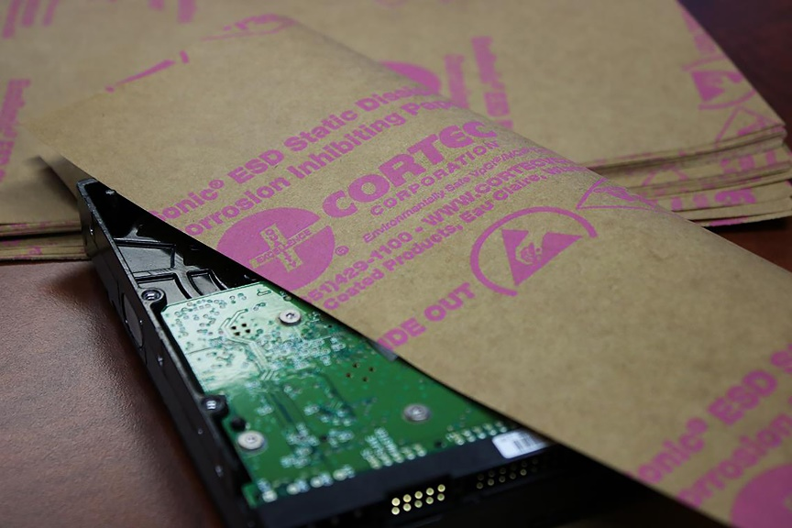In the world of electronics manufacturing, ESD managers have the critical role of ensuring that components do not get damaged by electrostatic discharge (ESD). Corrosion protection is often a lower priority but should also be on the radar for manufacturers who want their electronics to reach the end user in good condition. Fortunately, Cortec® has led the industry in designing two-in-one packaging solutions that meet both needs and today is eager to turn the spotlight on [EcoSonic® ESD Paper](https://www.cortecpackaging.com/product/ecosonic-esd-paper-powered-by-nano-vpci/) as a sustainable alternative to standard plastic ESD bags.

**Corrosion + ESD Protection**

Shipping is a vulnerable time for electronics as they pass through a variety of climates and temperature fluctuations that could prompt condensation on subassemblies inside a package. Any corrosion or even staining will call the integrity of an electronic into question when the end user unwraps it. Cortec® therefore coats EcoSonic® ESD Paper with Vapor phase Corrosion Inhibitors (VCI/VpCI®) to protect multi-metals from oxidizing. VpCI® molecules in the coating vaporize and diffuse throughout a packaging enclosure, adsorb on metal surfaces, and form a protective molecular layer that does not need to be cleaned off when the module is installed. To address ESD concerns, EcoSonic® ESD Paper also has a static-dissipative coating to eliminate static electricity buildup. With this coating, the ESD properties of EcoSonic® ESD Paper meet the requirements of ANSI/ESD STM11.11 for surface resistance and MIL-STD 3010C Method 4046 for static decay rate. The final result is a two-in-one recyclable VCI/ESD paper.

**Replacing Plastic Bags for Everyday Use**

Even while Cortec® has been creating dual corrosion inhibiting / static-dissipative packaging for electronics, plastic bags have remained the main packaging format for a variety of reasons. EcoSonic® ESD Paper takes an important departure from this norm by replacing plastic with recyclable paper sourced from trees, a renewable resource. This answers the call for paper packaging options from electronics manufacturers in Europe and Asia. EcoSonic® ESD Paper can be easily applied by wrapping it around an electronic and taping the folds to hold them in place and create an enclosure. EcoSonic® ESD Paper can also be used to create an instant static-dissipative workspace by laying the paper on a work bench where employees assemble or inspect sensitive electronic parts.

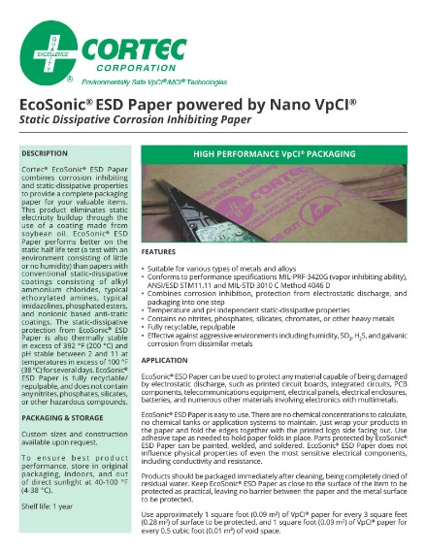**Take a New Approach to Electronics Packaging**

ESD managers and packaging engineers who need static dissipation should also consider whether a specific application needs corrosion protection. With EcoSonic® ESD Paper, they have the additional option of choosing recyclable paper over plastic—in sync with the growing demand for environmentally responsible electronics packaging options. [If you are ready to try a new approach to ESD packaging for electronics, contact Cortec® today.](https://www.cortecpackaging.com/contact-us/)

***Keywords: ESD packaging, packaging for electronics, VCI paper, packaging solutions for electronics, corrosion protection, replacing plastic bags, Cortec, corrosion on electronics, ESD paper, corrosion inhibitors***

Need a High-Resolution Photo? Visit: [**www.cortecadvertising.com**](http://www.cortecadvertising.com/)

Cortec® Corporation is the global leader in innovative, environmentally responsible VpCI® and MCI® corrosion control technologies for Packaging, Metalworking, Construction, Electronics, Water Treatment, Oil & Gas, and other industries. Our relentless dedication to sustainability, quality, service, and support is unmatched in the industry. Headquartered in St. Paul, Minnesota, Cortec® manufactures over 400 products distributed worldwide. ISO 9001:2015, ISO 14001:2015, & ISO/IEC 17025:2017 certified. Cortec® Website: [http://www.cortecvci.com](http://www.cortecvci.com/) Phone: 1-800-426-7832 FAX: (651) 429-1122