GUALA CLOSURES ACQUIRES 100% OF GUALA CLOSURES BULGARIA

*Founded in 2000, the Bulgarian company has a focus on the Prestige range, Guala Closures' luxury line, as well as a strategic mold production for the Group’s needs.*

*This acquisition reinforces Guala Closures' growth trajectory and strengthens its leadership in the high-end closure market.*

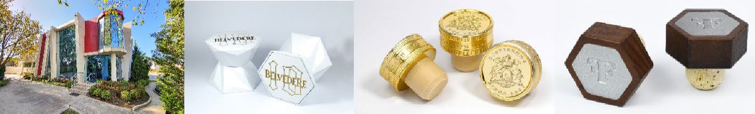

Milan, 28 November 2024 – Guala Closures S.p.A. ("Guala Closures" or the “Group”) announces the acquisition of the remaining 30% stake in Guala Closures Bulgaria.

Guala Closures Bulgaria, acquired by Guala Closures in 2010, serves as one of the Group's key hubs for producing luxury closures, primarily catering to the spirits market. The Bulgarian facility employs over 270 people and achieved a turnover of more than 15 million euros in 2023, with a growth of more than 40% in the last four years.

*"This acquisition,"* said **Gabriele Del Torchio, President of Guala Closures**, *"aims to strengthen Guala Closures’ presence in the luxury closures segment, those closures designed to enhance the distinctive identity of each brand by embodying aesthetics, design, and functionality, thanks to the combination of premium materials and cutting-edge production technologies promoted by our R&D centers."*

Spanning from Mexico to China, these centers of excellence are strategically positioned worldwide, enabling the Group to leverage over 200 active intellectual property rights. The R&D Center in Bulgaria possesses extensive technical expertise in producing closures crafted from specialized materials, including glass, wood, ceramics, and zamak, among others.

Furthermore, Guala Closures Bulgaria has extensive experience in mold production, a strategic capability that facilitates vertical integration within the Group, enabling the company to swiftly respond to production demands.

*"In recent years,"* said **Tancho Mihaylov, General Manager of Guala Closures Bulgaria**, *"we have worked not only to ensure that our products are manufactured with cutting-edge technologies and materials but also to maintain full control over the entire production process, from design to the final product. We firmly believe in the importance of specialization and in pursuing one of the Group's most important objectives: offering tailor- made solutions that best meet our customers' needs"* concluded Tancho Mihaylov.

# About Guala Closures

Guala Closures offers premium and innovative closure solutions that provide protection and convenience to consumers while enhancing customers’ brands. With 35 production plants worldwide, Guala Closures is a world leader in the production of closures for spirits, wines, beverages, oil, and condiments, that guarantees proximity to its customers, with a localized and customized offer of services and solutions. Guala Closures today employs over 5,000 people.

Visit [www.gualaclosures.com](http://www.gualaclosures.com/) and follow the [Linkedin](https://www.linkedin.com/company/guala-closures/posts/?feedView=all) corporate page.

**For more information:**

|  |
| --- |
| ***Guala Closures***  Group Marketing Department [marketing@gualaclosures.com](mailto:marketing@gualaclosures.com)  Luca Mammola Group CFO  [lmammola@gualaclosures.com](mailto:lmammola@gualaclosures.com) |
| ***Ad Hoc Communication Advisors***  Edoardo Corsi  Tel: +39 3351415582  Email: [edoardo.corsi@ahca.it](mailto:edoardo.corsi@ahca.it)  Maria Lucia Boi  Tel: +39 3426523390  Email: [marialucia.boi@ahca.it](mailto:marialucia.boi@ahca.it) |

# Disclaimer

This release relates to the disclosure of information that qualifies or may have qualified as inside information for the purposes of Article 7 of the Market Abuse Regulation (EU) 596/2014.

The information contained in this release may contain forward-looking statements. These statements involve elements of subjective judgment and analysis and are based upon the best judgment of the Guala Closures as of the date hereof. These statements are subject to change without notice and are based on a number of assumptions and entail known and unknown risks and uncertainties, as there are a variety of factors that may cause actual events and developments to differ materially from any future events and developments expressed or implied by such forward-looking statements. Therefore, you should not rely on these forward-looking statements. Neither Guala Closures nor any other person gives any undertaking, or is under any obligation, to update these forward-looking statements for events or circumstances that occur subsequent to the date of this release or to update or keep current any of the information contained herein and this release is not a representation by Guala Closures or any other person that they will do so, except to the extent required by law.

This release is for information purposes only and does not constitute any offer to sell or the solicitation of an offer to buy any security in the United States or in any other jurisdiction. This press release does not constitute an offer of financial products to the public in Italy, as defined under legislative decree of February 24, 1998, no. 58, as amended and supplemented from time to time.

This release does not constitute and shall not, in any circumstances, constitute a public offering or an invitation to the public in connection with any offer within the meaning of the Regulation (EU) 2017/1129, as amended and supplemented from time to time, and any relevant implementing measure in each member state of the European Economic Area and, in the United Kingdom, as it forms part of domestic law by virtue of the European Union (Withdrawal) Act 2018.