Ardagh Glass Packaging produces new lightweight bottles in Sweden for Hernö Gin

Luxembourg (12 Dec 2024) – Ardagh Glass Packaging-Europe (AGP-Europe), an operating business of Ardagh Group, has worked with Hernö Gin to produce their new lightweighted 500ml glass bottle.

The new Hernö Gin bottle, and the brand’s first bespoke bottle, has launched with an upgraded graphic profile, and is produced and decorated at AGP-Europe’s Limmared facility in Sweden. The new bottle design features the Hernö copper still, with the wording ‘Hernö Gin Distillery Home of Swedish Gin’ embossed on the shoulder of the bottle.

The new bottle weighs 480g: a reduction of 100g on the previous bottle design, with a significantly increased recycled cullet content, which together have reduced carbon emissions in each bottle by 31%* currently.

Emma Edfors, CEO of Hernö Gin comments on the new bottle design: “Following in-depth design and development work, we are proud to present a visual upgrade to the Hernö bottle that is also a major sustainability investment.

"We are so proud of our new bottle. For us, glass is the obvious choice. By moving production to Ardagh in Sweden, we are minimising our transport, and thereby significantly lowering our climate footprint. We think this is an important and sustainable choice."
Magnus Ridefjord, Sales Manager, AGP-Sweden, added: “The new bottles have been produced on the multi-production line at AGP-Limmared in Sweden, which offers the flexibility of producing different bottle shapes and sizes together. The technology developed by our sister company, Heye International, is ideal for customers that want to produce specialist bottles for the premium drinks sector.”
The first of the new bottle designs to be launched, are the bestsellers: Hernö Dry Gin, Hernö Old Tom Gin and Hernö Botanical Gin.
For more information about Ardagh Glass Packaging, click here.

*LCA calculation based on current cullet use which may vary.

Further information
Sharon Todd, Head of Marketing, Ardagh Glass Packaging - Europe sharon.todd@ardaghgroup.com +44 7768 718941

Download image
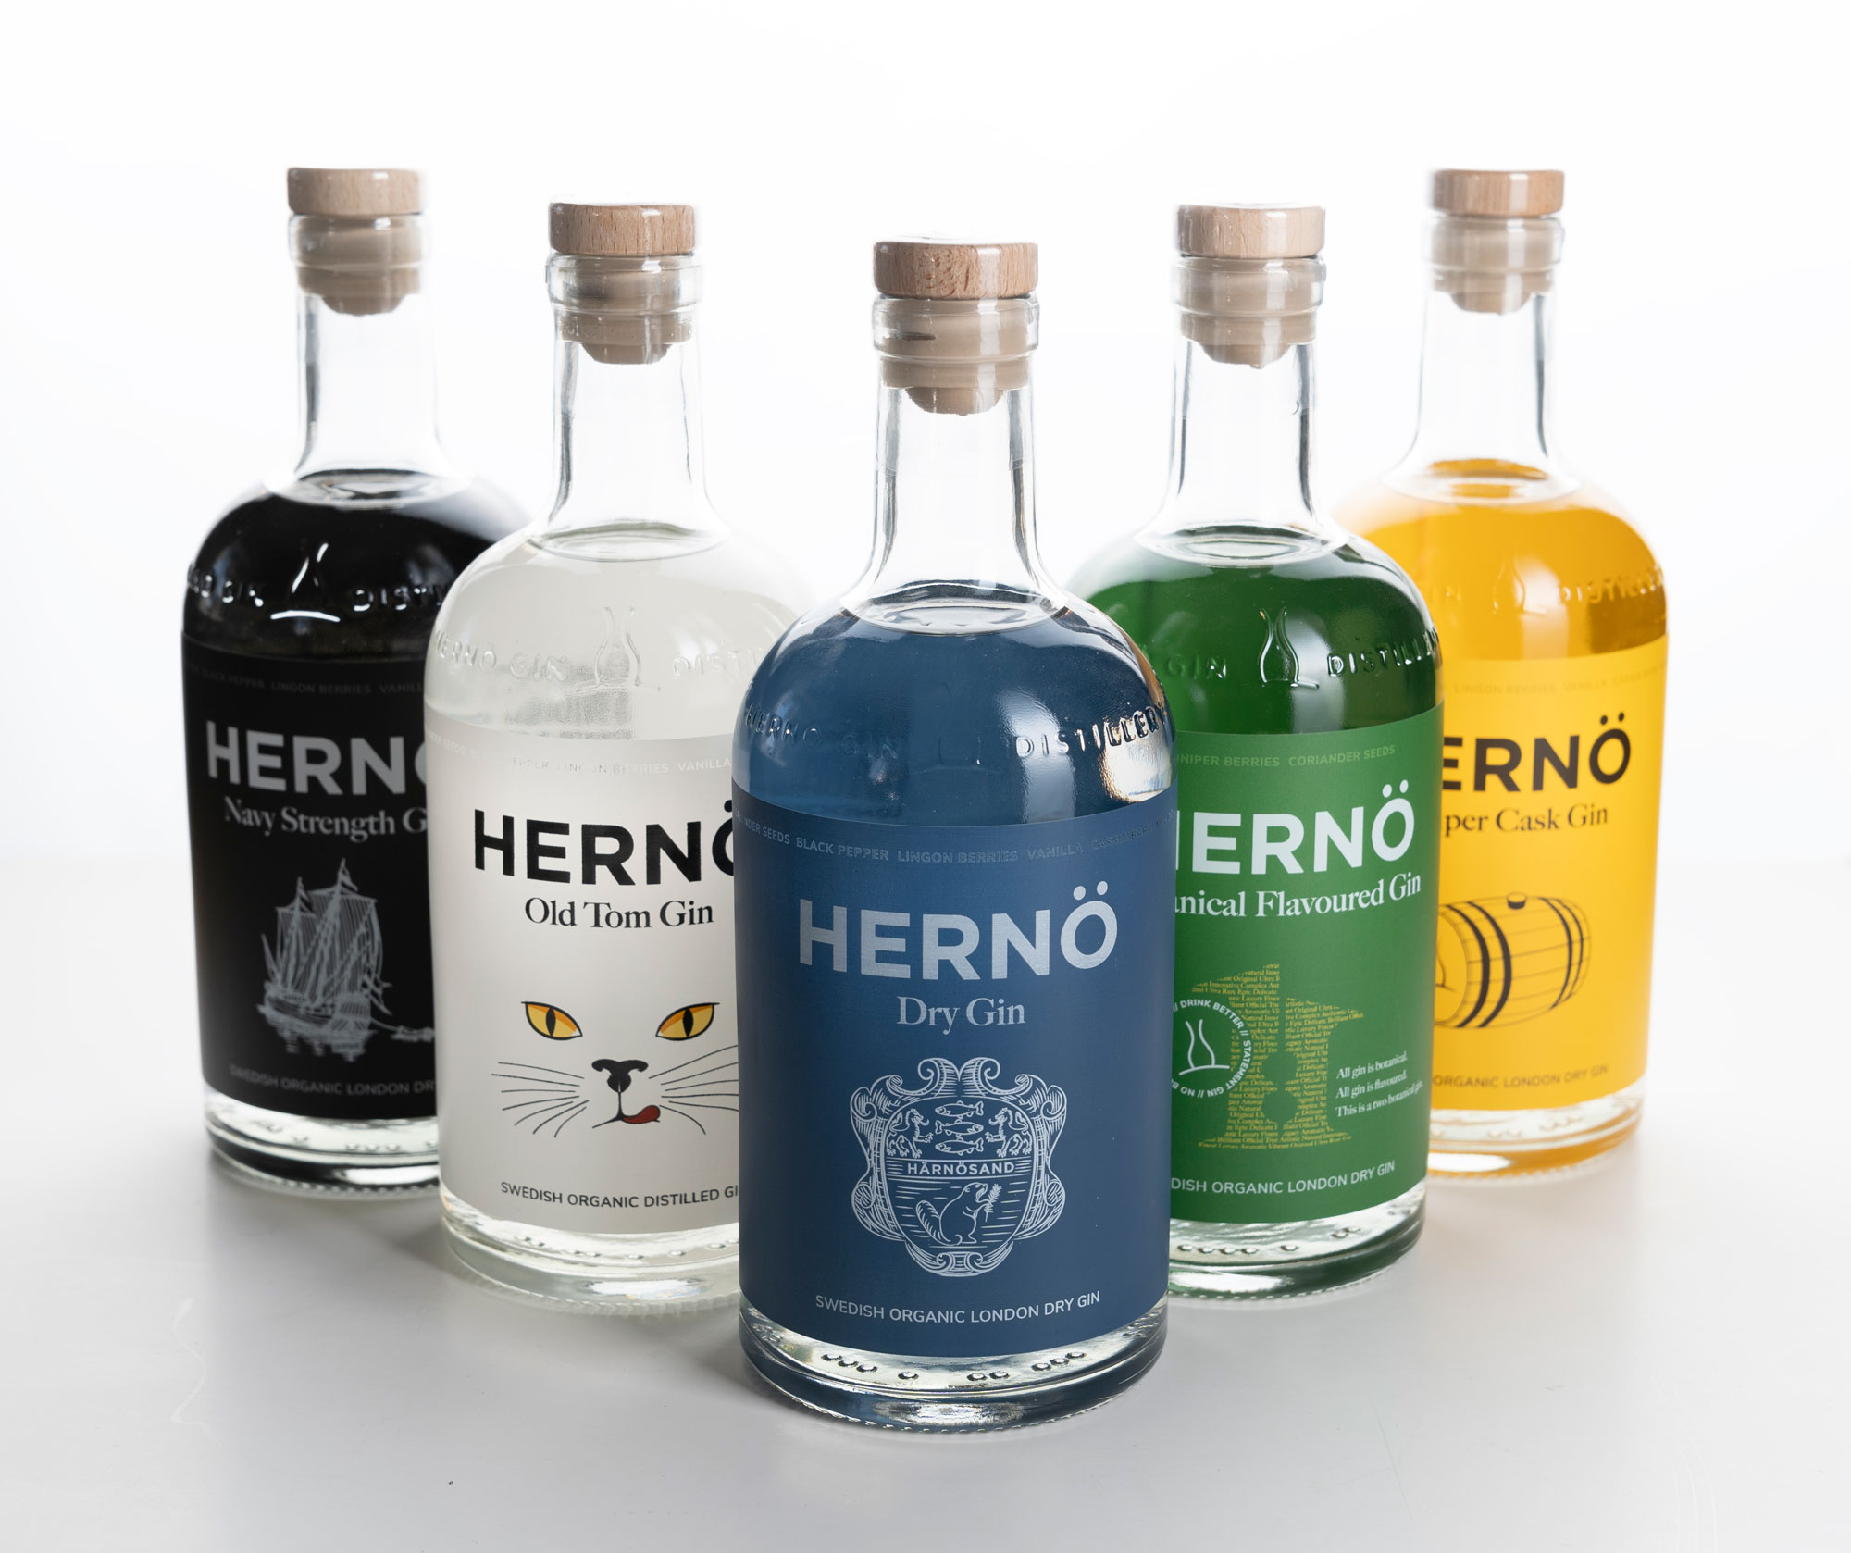
The range of redesigned 500ml Hernö Gin bottles
Notes to the editor
Ardagh Glass Packaging is a leading supplier of sustainable and infinitely recyclable glass packaging. Ardagh Glass Packaging operates 37 production facilities in North America, Europe and Africa and employs approximately 14,000 people and has recorded revenues of $4.6bn.
Hernö Gin is Sweden's first gin distillery and creator of the world's most award-winning gin. We are on Systembolaget's shelves throughout Sweden and in some 30 countries around the world. We believe in the idea of drinking better but less often and have our sights set on bringing premium gin culture into everyone's living room.

