Ardagh Glass Packaging launches rooftop solar energy plant in Scotland

Luxembourg (April 3, 2024) – Ardagh Glass Packaging-Europe (AGP-Europe), an operating business of Ardagh Group, announced today that a new solar installation at its glass facility in Irvine, Scotland, is now generating on-site renewable electricity, which will add enough electricity back to the grid to remove the equivalent of an estimated 356 tonnes of CO₂e annually.

During the summer months the solar panels will provide up to 25% of AGP-Irvine's total electricity usage. The remaining renewable electricity used at the facility will continue to be supplied by a third party.

Working together with energy partner ESB Energy, AGP has installed a 1.75MWp solar PV system of 3842 panels on two warehouse roofs at the facility, which will generate approximately 1.584MWh of electricity each year, to support the site’s production of over 350 million glass bottles for some of the world’s leading spirits brands.

Graeme Shepherd, Plant Director at AGP-Irvine, said:
“This solar installation is another step forward in enhancing the sustainability of our operations at Irvine, as well as reducing the amount of electricity we take from the grid. It shows our commitment to decarbonising the glass containers we produce, while maintaining the highest standards of quality and excellence.”

Annelene Ikemann, Sustainability Director, AGP-Europe, added:
“The Irvine installation achieves another step in our decarbonisation strategy. It is one of three AGP-Europe on-site sustainable solar projects that, together, are expected to replace more than 12,000 MWh of electricity consumption from the grid, avoiding the release of c. 5,000 tons of carbon emissions per year.”

Pat Fenlon, Executive Director, Customer Solutions, ESB Energy, commented:
“The successful deployment of the 1.75MWp solar array at Ardagh Irvine represents our continued commitment to supporting sustainability and innovation projects for our customers. Our continued monitoring and maintenance ensures optimal performance which can help support Ardagh Irvine to focus on the core aim of reducing carbon emissions.”

This project contributes to Ardagh Group’s strategy to use 100% renewable electricity by 2030 and follows the launch of solar power installations in Ardagh’s glass and metal production facilities in the Netherlands, in the past six months. Ardagh Group plans to install more solar power at its facilities across Europe in the coming years, to progress toward its 2030 targets.

Further information
Sharon Todd, Head of Marketing at Ardagh Glass Packaging – Europe, sharon.todd@ardaghgroup.com, +44 1 977 674111 +44 7768 718941
communications@ardaghgroup.com

Download image

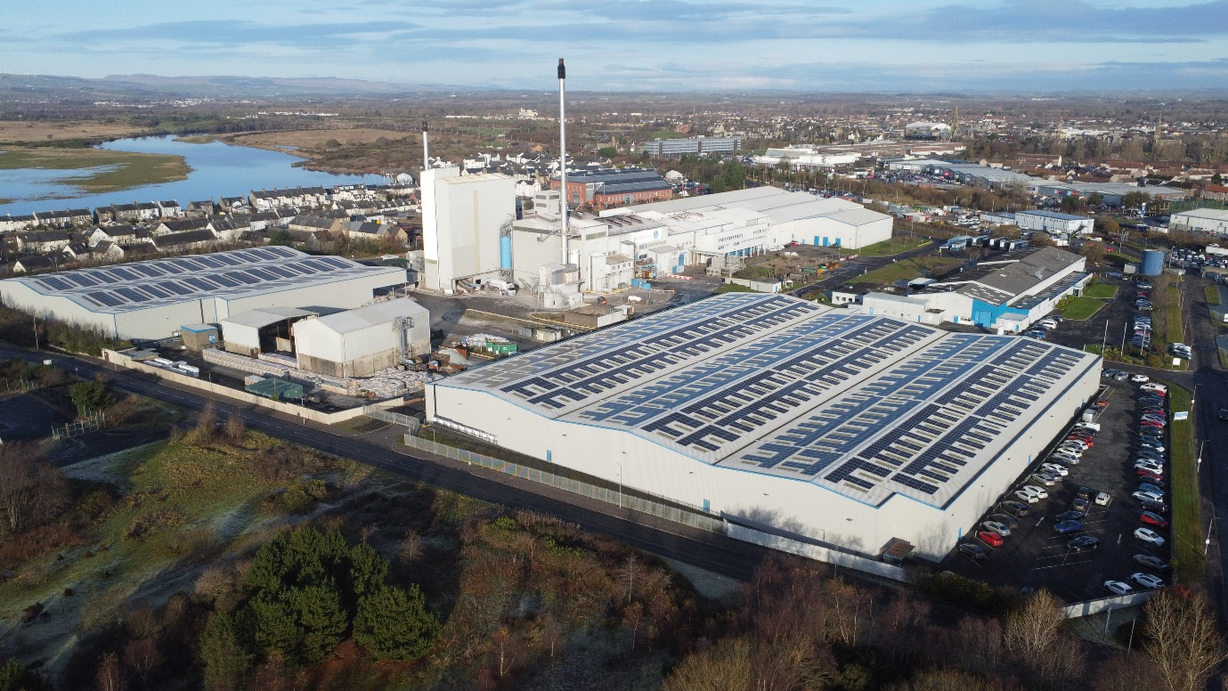

The new rooftop solar installation at AGP-Irvine, Scotland

Notes to the editor
Ardagh Glass Packaging is a leading supplier of sustainable and infinitely recyclable glass packaging. Ardagh Glass Packaging operates 39 production facilities in North America, Europe and Africa and employs approximately 14,000 people and has recorded revenues of $4.6bn.

