KRAIBURG TPE Breathes Innovation into Advanced Inhaler Mask Solutions
Inhaler masks are essential for delivering life-saving medications and treatments directly to the lungs. They are the bridge between patients and the relief they seek from conditions like asthma, chronic obstructive pulmonary disease (COPD), and respiratory infections. These masks, which provide control and precision during therapy, have become indispensable tools for healthcare professionals.

Inhaler mask design and construction are of utmost importance. They have to carefully establish a balance between comfort, functionality, and safety. This is where innovative materials like thermoplastic elastomer (TPE) come in.

KRAIBURG TPE, a global leader in thermoplastic elastomer (TPE) solutions redefines healthcare with its innovative Inhaler Mask material. With an array of material advantages and versatile applications, this groundbreaking TPE material is set to make a significant impact on the healthcare industry.

Elevating Healthcare with Innovative Inhaler Mask Material
TPE, a versatile material known for its elasticity, durability, and adaptability, is the ideal choice for various healthcare applications. When incorporated into inhaler masks, it brings diverse advantages that significantly enhance their performance and functionality.

In the ever-evolving landscape of healthcare, innovation takes center stage, especially when it comes to critical medical devices. Introducing KRAIBURG TPE's THERMOLAST® H HC/AP series.

KRAIBURG TPE's is highly committed to driving innovation, quality, and sustainability in the healthcare sector. With the introduction of the Inhaler Mask Material, the company is empowering healthcare professionals and manufacturers to elevate patient care and enhance the overall healthcare landscape. In practical terms, this means that inhaler masks made with TPE material provide a superior user experience. They are comfortable, reliable, customizable, easy to clean, and, most importantly, safe.

Advantages of THERMOLAST® H HC/AP Series
The series’ good adhesion to PP and PE ensures secure and durable connections in mask assembly, enhancing overall reliability. Optimized compression set properties guarantee that these masks maintain their shape and seal, ensuring a snug and comfortable fit for users.

Additionally, the material is colorable, https://www.kraiburg-tpe.com/en/coloring allowing for customizable and aesthetically pleasing designs. Its sterilizable nature, suitable for autoclave sterilization at 121°C and EtO sterilization, meets the highest hygiene standards, https://www.kraiburg-tpe.com/en/safe-soft-touch-and-ergonomic-tpe-benefit-pipette-manufacturers vital for healthcare applications. Furthermore, being free from animal ingredients aligns with ethical and health-conscious considerations. The flexibility in processing methods, encompassing both injection molding and extrusion, streamlines manufacturing.

Compliance with various international regulations and approvals, including Regulation (EU) No 10/2011, US FDA CFR 21, China GB4806-2016, ISO 10993-5 (Cytotoxicity), and GB/T 16886.5 Cytotoxicity, underscores the material's commitment to safety and quality in the healthcare sector, making it an ideal choice for inhaler masks.

Sustainability successes of our TPEs
KRAIBURG TPE’s recent sustainability innovations include a series of material solutions specially developed for automotive, consumer, consumer electronics, wearables and industry applications. Comprising up to 48% post-consumer recycled (PCR) and 50% post-industrial recycled (PIR) content, the material complies with multiple global standards such as FDA raw material compliance, RoHS and REACH SVHC requirements. KRAIBURG TPE also provides customers with product carbon footprint values.
Are you looking for a sustainable TPE solution? Talk to us!
Our experts are happy to answer any questions you have, as well as to offer the right solution for your application.
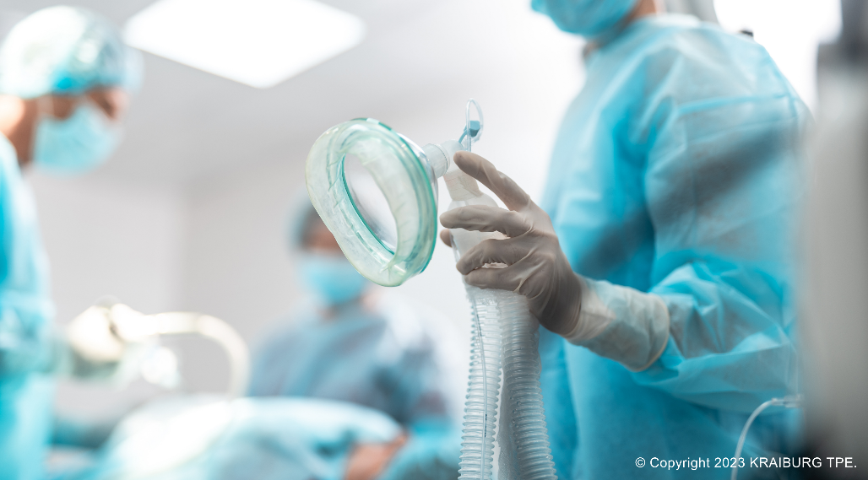 (Photo: © 2023 KRAIBURG TPE)
For high-resolution photography, please contact Bridget Ngang (bridget.ngang@kraiburg-tpe.com , +6 03 9545 6301).

Information for members of the press:
download high-resolution images
latest news on KRAIBURG TPE

Let’s connect on Social Media:
Follow us on WeChat
KRAIBURG TPE (www.kraiburg-tpe.com) is a global manufacturer of custom thermoplastic elastomers. KRAIBURG TPE was founded in 2001 as an independent business unit of the KRAIBURG Group and is now the industry's competence leader in the field of TPE compounds. The company's goal is to provide safe, reliable and sustainable products for customer applications. With more than 680 employees worldwide and production sites in Germany, the USA and Malaysia, the company offers a large product portfolio for applications in the automotive, industrial and consumer goods industries, as well as for the strictly regulated medical sector. The established THERMOLAST®, COPEC®, HIPEX® and For Tec E® product lines are processed by injection molding or extrusion and offer manufacturers numerous advantages not only in processing but also in product design. KRAIBURG TPE is characterized by its innovative strength, global customer orientation, customized product solutions and reliable service. The company is ISO 50001 certified at its headquarters in Germany and holds ISO 9001 and ISO 14001 certifications at all its sites worldwide.

