**KRAIBURG TPE: Innovative Packaging Solutions with TPE Materials**

Have you ever pondered about the packaging materials used in cosmetics, food and medical packaging in our daily lives? Among paper, plastic, glass, and metal, plastics are likely the most common. However, thermoplastic elastomer (TPE) materials are gaining more prominence in the packaging industry.

**Cosmetics and Food-Contact Packaging**

KRAIBURG TPE’s materials are not only utilized in cosmetics packaging, <https://www.kraiburg-tpe.com/en/cosmetic-packaging> such as lipstick, lip gloss, mascara, perfume bottles, and hoses, but also in food packaging, including tableware, beverage bottles, food containers, and material dispensers.

THERMOLAST® K <https://www.kraiburg-tpe.com/en/thermolast-k> is your ideal solution for cosmetics and food-contact packaging with the following characteristics:

* Compliance with a range of international standards, including EU Regulation 10/2011, US CFR 21 FDA, China GB4806-2016 for materials in contact with food. <https://www.kraiburg-tpe.com/en/controlled-migration-tpe>
* Offering a diverse range of hardness options.
* Capability for pre-coloring and maintaining consistent color quality globally.
* Chemical resistance.
* Premium surface quality with elasticity and resilience.
* Ability for multi-component injection molding.
* Free from animal-derived and halogen materials.
* Overmolding possible with PP, PE, PC, PET, PETG, PBT, POM, ABS, PS, ASA, SAN, PMMA, PA6, PA6.6, PA12.

**Medical and Pharmaceutical Packaging**

In addition, there’s also THERMOLAST® H for medical packaging materials, <https://www.kraiburg-tpe.com/en/medical> utilized in seals, valves, hoses, syringe protective caps, plugs and spacers.

THERMOLAST® H <https://www.kraiburg-tpe.com/en/thermolast-h-healthcare-tpe> is your ideal solution for medical and pharmaceutical packaging with the following characteristics:

* Compliance with a range of international standards, including (EU) No. 10/2011, GB 4806, FDA CFR 21 REACH SVHC and RoHS Directive.
* Bio-compatibility testing according to ISO 10993-5 and GB/T 16886.5.
* Free from heavy metals, latex, PVC, and silicon.
* Adhesion to PP.
* No animal-derived ingredients.
* Excellent compression set properties.
* Excellent sealing properties.
* Good haptics.
* Pre-coloration available in-house.

TPE materials with these characteristics offer cost-effective packaging solutions, especially in medical, cosmetic, and food packaging - where safe, non-toxic, and recyclable materials are essential.

In the future, TPE materials will continue to be explored as an alternative material to unlock innovative possibilities in the packaging industry - contributing to growing demand and use.

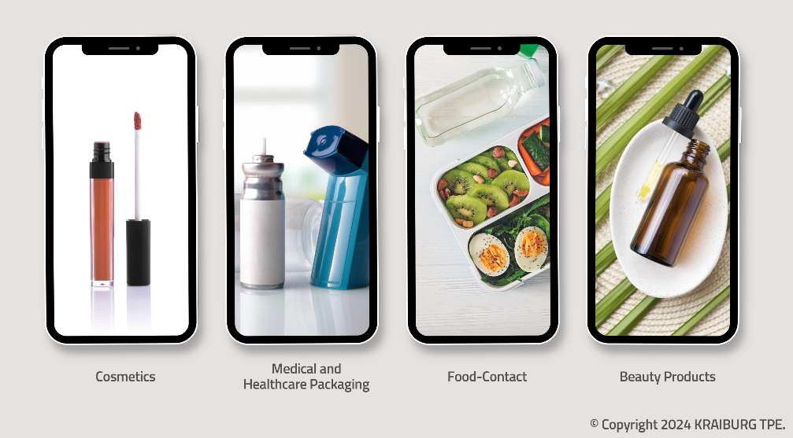

**(Photo: © 2024 KRAIBURG TPE)**

For high-resolution photography, please contact Bridget Ngang ([bridget.ngang@kraiburg-tpe.com](mailto:bridget.ngang@kraiburg-tpe.com) , +6 03 9545 6301).

**](https://bit.ly/34qxBOV)**

[download high-resolution images](https://bit.ly/34qxBOV)

](https://www.kraiburg-tpe.com/de/news)

[latest news on KRAIBURG TPE](https://www.kraiburg-tpe.com/de/news)

**Let’s connect on Social Media:**

**](https://i.youku.com/i/UMTYxNTExNTgzNg==)**

**Follow us on WeChat**

KRAIBURG TPE (www.kraiburg-tpe.com) is a global manufacturer of custom thermoplastic elastomers. KRAIBURG TPE was founded in 2001 as an independent business unit of the KRAIBURG Group and is now the industry's competence leader in the field of TPE compounds. The company's goal is to provide safe and reliable products for customer applications. With more than 660 employees worldwide and production sites in Germany, the USA and Malaysia, the company offers a large product portfolio for applications in the automotive, industrial and consumer goods industries, as well as for the strictly regulated medical sector. The established THERMOLAST®, COPEC®, HIPEX® and For Tec E® product lines are processed by injection molding or extrusion and offer manufacturers numerous advantages not only in processing but also in product design. KRAIBURG TPE is characterized by its innovative strength, global customer orientation, customized product solutions and reliable service. The company is ISO 50001 certified at its headquarters in Germany and holds ISO 9001 and ISO 14001 certifications at all its sites worldwide.