**KRAIBURG TPE Introduces** **Cutting-Edge TPE Solution for Car Window Shades**

As drivers spend increasingly longer hours on the road, the demand for solutions that enhance comfort and convenience within the vehicle has never been greater. Recognizing this need, KRAIBURG TPE, a leading global manufacturer of thermoplastic elastomers (TPEs), is proud to announce the launch of its latest TPE solution tailored for car window shade applications.

**Redefined Driving Experience with Advanced TPE Materials**

Introducing the THERMOLAST® K FG/SF/AP series, an innovative solution meticulously engineered to meet the stringent requirements of the automotive sector. <https://www.kraiburg-tpe.com/en/automotive> This cutting-edge material combines advanced features and regulatory compliance, making it an ideal choice for automotive interior components.

**Enhanced Features for Unmatched Performance**

The THERMOLAST® K <https://www.kraiburg-tpe.com/en/thermolast-k> FG/SF/AP series from KRAIBURG TPE offers a host of advantages designed to elevate the driving experience:

* **Low Density:** Provides lightweight yet durable protection for vehicle interiors.
* **Adhesion to PP:** Ensures seamless integration with existing vehicle components.
* **Controlled Emission and Odor:** Maintains a clean and odor-free automotive interior environment.
* **Optimized Flow Properties:** <https://www.kraiburg-tpe.com/en/automotive-thumbwheel-flexible-tpe-solutions> Facilitates ease of processing during manufacturing.
* **Surface Mapping:** Enhances aesthetics and design flexibility.
* **Temperature Stability:** Withstands temperatures up to 100°C, ensuring long-lasting performance.
* **Demolding:** Simplifies production processes for efficient manufacturing.
* **Processing Method:** Compatible with injection molding for streamlined production.
* **Color:** Available in sleek black for seamless integration with vehicle interiors.

Ideal applications for the THERMOLAST® K FG/SF/AP series include handles, function and design elements, thumb wheels, soft touch surfaces, seals and automotive interior applications.

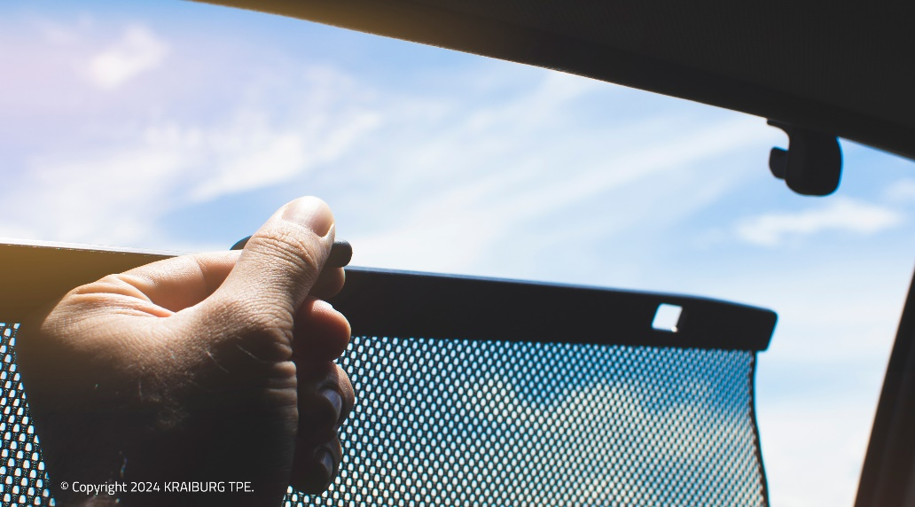 **(Photo: © 2024 KRAIBURG TPE)**

For high-resolution photography, please contact Bridget Ngang ([bridget.ngang@kraiburg-tpe.com](mailto:bridget.ngang@kraiburg-tpe.com) , +6 03 9545 6301).

**](https://bit.ly/34qxBOV)**

[download high-resolution images](https://bit.ly/34qxBOV)

](https://www.kraiburg-tpe.com/de/news)

[latest news on KRAIBURG TPE](https://www.kraiburg-tpe.com/de/news)

**Let’s connect on Social Media:**

**](https://i.youku.com/i/UMTYxNTExNTgzNg==)**

**Follow us on WeChat**

KRAIBURG TPE (www.kraiburg-tpe.com) is a global manufacturer of custom thermoplastic elastomers. KRAIBURG TPE was founded in 2001 as an independent business unit of the KRAIBURG Group and is now the industry's competence leader in the field of TPE compounds. The company's goal is to provide safe, reliable and sustainable products for customer applications. With more than 660 employees worldwide and production sites in Germany, the USA and Malaysia, the company offers a large product portfolio for applications in the automotive, industrial and consumer goods industries, as well as for the strictly regulated medical sector. The established THERMOLAST®, COPEC®, HIPEX® and For Tec E® product lines are processed by injection molding or extrusion and offer manufacturers numerous advantages not only in processing but also in product design. KRAIBURG TPE is characterized by its innovative strength, global customer orientation, customized product solutions and reliable service. The company is ISO 50001 certified at its headquarters in Germany and holds ISO 9001 and ISO 14001 certifications at all its sites worldwide.