**KRAIBURG TPE Showcases Sustainable TPEs and Automotive Innovations at Plastics & Rubber Thailand 2024**

KRAIBURG TPE is proud to unveil its latest sustainable TPEs featuring up to 48% PCR and 50% PIR recycled content. Alongside its cutting-edge automotive TPE solutions, the company is primed to make a significant impact at the Plastics & Rubber Thailand Exhibition from May 15th to 18th, Hall 100, Booth AB28, located at BITEC Bangkok.

Renowned as a global leader in thermoplastic elastomers manufacturing, KRAIBURG TPE specializes in delivering custom-engineered TPE solutions across diverse industries and applications. At this year's exhibition, the company will showcase its sustainable TPE series and innovative automotive TPE solutions tailored for the Asia Pacific market.

**Introducing New Sustainable TPE Solutions**

KRAIBURG TPE's newest sustainable TPE <https://www.kraiburg-tpe.com/en/sustainability> series caters to a spectrum of industries, including consumer electronics, wearables, consumer goods, and industrial applications. These TPEs feature up to 48% post-consumer recycled (PCR) and 50% post-industrial recycled (PIR) content.

Characterized by superior adhesion to PP, PC, ABS and PC/ABS, along with non-sticky surfaces and excellent mechanical properties, these TPEs offer temperature stability up to 80°C. Compliant with global standards such as FDA raw material regulations, RoHS, and REACH SVHC requirements, they find applications in electric and electronic components, wearables, household articles, and more.

**Innovative TPE Solutions for the Automotive Sector**

At the forefront of automotive innovation, KRAIBURG TPE presents its latest TPE solutions tailored for interior and exterior automotive applications in the Asia Pacific region. The sustainable automotive exterior <https://www.kraiburg-tpe.com/en/unveiling-innovative-tpe-compound-series-automotive-exterior-applications> TPE boasts a post-consumer recycled content of up to 40%, while the interior TPE ensures superior surface appearance and performance.

Our TPEs exhibit excellent adhesion to PP, low density, weather resistance, optimal flowability, controlled emissions, and minimal odor. Ideal for diverse automotive applications such as cowl gaskets, window encapsulations, handles, and car mats, these TPEs underscore KRAIBURG TPE's commitment to driving innovation within the automotive sector.

**A Comprehensive Portfolio for Varied Markets**

With a comprehensive TPE portfolio, KRAIBURG TPE offers tailored solutions that meet the unique requirements of diverse markets, including healthcare and medical applications, <https://www.kraiburg-tpe.com/en/medical> cosmetic and food packaging, <https://www.kraiburg-tpe.com/en/controlled-migration-tpe> as well as sports equipment and household applications. The unwavering commitment to quality, innovation, and customer satisfaction has solidified us a position as a trusted partner, providing high-performance thermoplastic elastomers for a myriad of applications.

**Join Us at the Live Forum**

Don't miss our exclusive live forum designed to explore the latest Sustainable TPE innovations for the Asia Pacific's consumer electronics, wearable, consumer, industry, and automotive markets.

Date: May 16th, 2024

Topic: KRAIBURG TPE Innovative Sustainable TPE Solutions

Time: 2:30 p.m. – 3:00 p.m.

Speaker: Wanwanat Yookachen

Language: Thai

Date: May 17th, 2024

Topic: KRAIBURG TPE: Automotive TPE Innovations and Solutions

Time: 12.30p.m – 1.00p.m

Speaker: Sukantalak Maneerattanasuporn

Language: Thai

Visit KRAIBURG TPE at Hall 100, Booth AB28!

Connect with KRAIBURG TPE's technical consultants at Plastics & Rubber Thailand to discover more about our new Sustainable TPE series and the latest automotive TPE solutions.

**Sustainability successes of our TPEs**

KRAIBURG TPE’s recent sustainability innovations include a series of material solutions specially developed for automotive, consumer, consumer electronics, wearables and industry applications. Comprising up to 48% post-consumer recycled (PCR) and 50% post-industrial recycled (PIR) content, the material complies with multiple global standards such as FDA raw material compliance, RoHS and REACH SVHC requirements. KRAIBURG TPE also provides customers with product carbon footprint values.

Are you looking for a sustainable TPE solution? Talk to us!

Our experts are happy to answer any questions you have, as well as to offer the right solution for your application.

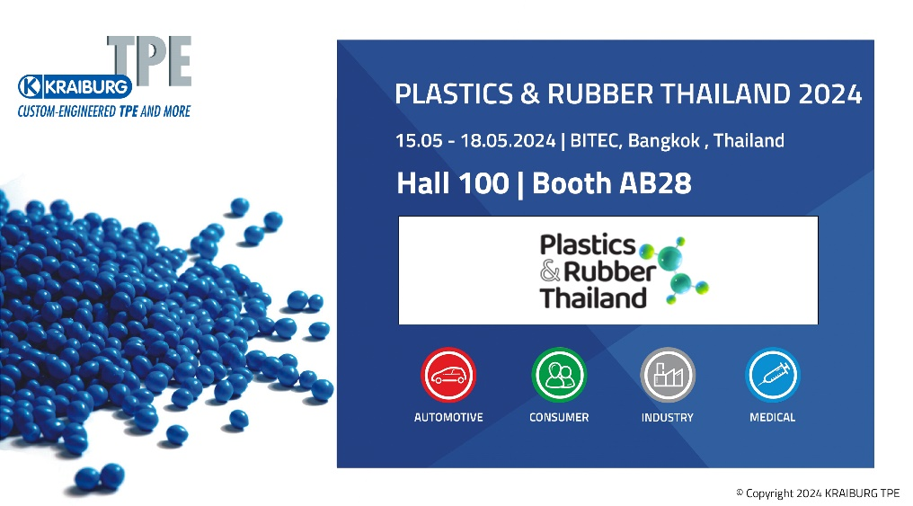

**(Photo: © 2024 KRAIBURG TPE)**

For high-resolution photography, please contact Bridget Ngang ([bridget.ngang@kraiburg-tpe.com](mailto:bridget.ngang@kraiburg-tpe.com) , +6 03 9545 6301).

**](https://bit.ly/34qxBOV)**

[Download high-resolution images](https://bit.ly/34qxBOV)

](https://www.kraiburg-tpe.com/de/news)

[Latest news on KRAIBURG TPE](https://www.kraiburg-tpe.com/de/news)

**Let’s connect on Social Media:**

**](https://i.youku.com/i/UMTYxNTExNTgzNg==)**

**Follow us on WeChat**

KRAIBURG TPE (www.kraiburg-tpe.com) is a global manufacturer of custom thermoplastic elastomers. KRAIBURG TPE was founded in 2001 as an independent business unit of the KRAIBURG Group and is now the industry's competence leader in the field of TPE compounds. The company's goal is to provide safe, reliable and sustainable products for customer applications. With more than 660 employees worldwide and production sites in Germany, the USA and Malaysia, the company offers a large product portfolio for applications in the automotive, industrial and consumer goods industries, as well as for the strictly regulated medical sector. The established THERMOLAST®, COPEC®, HIPEX® and For Tec E® product lines are processed by injection molding or extrusion and offer manufacturers numerous advantages not only in processing but also in product design. KRAIBURG TPE is characterized by its innovative strength, global customer orientation, customized product solutions and reliable service. The company is ISO 50001 certified at its headquarters in Germany and holds ISO 9001 and ISO 14001 certifications at all its sites worldwide.