PRESS RELEASE

**Ken Forlenza Joins Schreiner Group as U.S. President**

*Blauvelt, NY*, *October 9, 2024* – Schreiner Group, a leader in innovative high-tech labels and functional parts for healthcare, mobility and general industry, has hired Ken Forlenza as its new U.S. President. Mr. Forlenza will oversee operations at the company’s U.S. headquarters in Blauvelt, NY.

Mr. Forlenza brings a distinguished background in engineering, business development, and leadership across various industries. He is tasked with guiding Schreiner Group through a significant growth phase, as the company continues to leverage its prominence in innovative and multifunctional labeling solutions. Notably, Schreiner Group LP is in the early stages of expanding the company’s capabilities to new applications in healthcare, electronics, industrial and automotive/mobility applications.

“With our anticipated expansion into new market opportunities, attracting top talent and investing in staff development will be critical to success,” Mr. Forlenza explains, adding that his focus is on fostering a collaborative culture to ensure Schreiner Group continues to exceed customer expectations.

His extensive experience in the specialty chemicals industry – and adhesives in particular – aligns well with Schreiner Group’s core product offerings. Overall, Mr. Forlenza’s career has spanned manufacturing, sales, marketing, and strategy, giving him a well-rounded perspective. His hands-on approach, reputation for problem-solving, and consistent focus on customer satisfaction position him to successfully lead Schreiner Group’s U.S. operations.

“We are thrilled to have Ken Forlenza join us as the new President of our U.S. site,” says Roland Schreiner, CEO of Schreiner Group. “His wealth of experience in various sectors, combined with his passion for innovation and collaboration, make him the perfect fit to drive our growth in our key healthcare and mobility markets.”

Schreiner Group established its production site in Blauvelt in 2008, with the facility initially catering to pharmaceuticals and healthcare industries through its Schreiner MediPharm division. The site soon expanded to include Schreiner ProTech, which focuses on the automotive, electronics and other industries. Today, over 90 employees at the Blauvelt facility produce high-tech labels and functional parts for the North American market.

+++

**CAPTIONS:**

Ein Bild, das Kleidung, Person, Menschliches Gesicht, Wand enthält.

“We are thrilled to have Ken Forlenza join us as the new President of our U.S. site,” says Roland Schreiner (left), President and CEO of Schreiner Group.

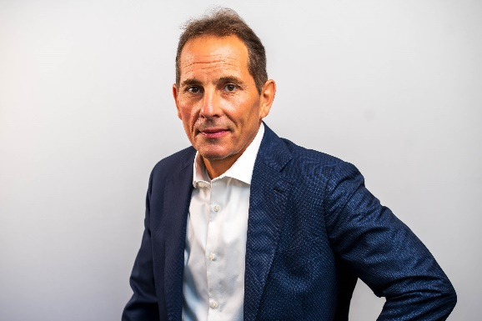

Ken Forlenza is new President of Schreiner Group’s U.S. headquarters in Blauvelt, NY.

+++

For more information, please contact:  
Susanne Höppner, Corporate Communications  
Phone +49 89 31584-5852, susanne.hoeppner@schreiner-group.com

**About Schreiner Group**

Schreiner Group GmbH & Co. KG is an internationally active German family-owned company and regarded as a preferred partner in the Healthcare and Mobility markets. Its core business is focused on top-quality functional labels enhanced by complementary system solutions and services. Schreiner Group’s innovative high-tech labels and functional parts create new dimensions for smart solutions and help make life healthier and safer, and enhance human mobility.

Ca. 1,300 employees generate total annual sales of approximately 220 million euros. The high-tech company has four locations: In addition to the headquarters in Oberschleissheim and another production site in the Munich metropolitan region (Dorfen), they include the two international manufacturing facilities in the United States (Blauvelt, New York) and in China (Fengpu, Shanghai).

Collaboration and exchange are shaped by the core values of Innovation, Quality, Performance and Enthusiasm. Schreiner Group defines itself as a company committed to acting sustainably and therefore deliberately assumes responsibility for people, the environment and society.

**Schreiner Group GmbH & Co. KG**

Bruckmannring 22  
85764 Oberschleissheim  
Phone +49 89 31584-0  
Fax +49 89 31584-5166  
info@schreiner-group.com  
[www.schreiner-group.com](http://www.schreiner-group.com)