Ardagh Glass Packaging pioneers hydrogen energy mix from onsite electrolyser

Luxembourg (3 December 2024) – Ardagh Glass Packaging-Europe (AGP-Europe), an operating business of Ardagh Group, announced today that it is now producing green hydrogen for glass melting via a hydrogen electrolyser at its facility in Limmared, Sweden.

The 5MW Proton Exchange Membrane (PEM) hydrogen electrolyser uses renewable electricity to split water into hydrogen and oxygen, supplying hydrogen to the energy mix in the furnace. Since testing of the electrolyser began in October, the furnace has successfully combusted 109,000m³ of hydrogen produced onsite, saving 70 tonnes of CO₂.

Daniel Johansson, Project Manager, AGP-Europe explained: “The testing phase using the hydrogen energy mix is progressing well, with no impact on the quality of the glass or the furnace. Our target is to replace 20% of the natural gas in the furnace with green hydrogen, which will reduce carbon emissions from our glass packaging produced in Limmared.”

This partly hydrogen-fired glass furnace follows the launch of AGP’s flagship NextGen Furnace in Obernkirchen, Germany, where 60% electrical heating has already been achieved, delivering a 64%* reduction in carbon emissions.

AGP-Europe CEO Martin Petersson added: “Replacing a proportion of the natural gas with green hydrogen in the furnace represents a step change in the way we sustainably produce glass packaging.

“The future combination of hydrogen and other sustainable technologies such as hybrid melting, will help Ardagh Group and our customers to achieve their emissions reduction targets, as well as advancing the decarbonisation of the glass industry.”

* Based on LCA calculation: January to June 2024.

Further information
Sharon Todd, Head of Marketing at Ardagh Glass Packaging – Europe, sharon.todd@ardaghgroup.com, +44 1 977 674111 +44 7768 718941
communications@ardaghgroup.com

Download image

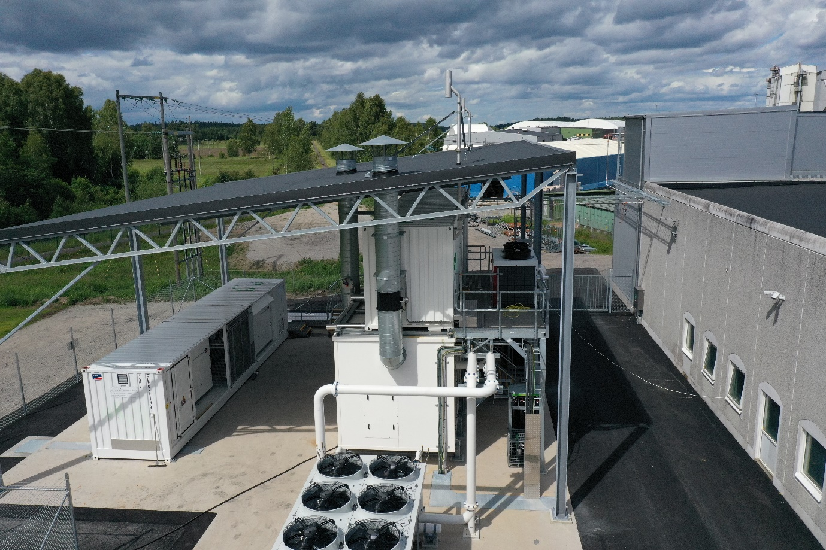

The hydrogen electrolyser at AGP-Limmared, Sweden

Notes to the editor
A part of Ardagh Group, Ardagh Glass Packaging (AGP) is a global supplier of recyclable glass packaging for brand owners in the beverage, food, pharmaceutical and chemical sectors. Ardagh Glass Packaging operates 38 production facilities in North America, Europe and Africa and employs approximately 14,000 people.

