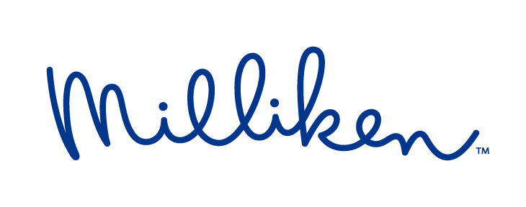

FOR IMMEDIATE RELEASE  (October 13, 2022) | MEDIA CONTACT  Veerle de Wolf  Veerle.Dewolf@milliken.com  +32 9 265 1136  Kim Lommaert  klommaert@emg-marcom.com  +31 164 317 021

Huhtamaki, Milliken partner to design for circularity
-- Joint research yields highly recyclable, mono-material HDPE tube

Ghent, Belgium – Milliken & Company, a trusted expert in plastics additive and colorant technology, is partnering with Finnish flexible packaging giant Huhtamaki Group to develop a more sustainable, mono-material laminate for use in tubes targeting cosmetics, toothpaste and other personal-care applications.
The results of this joint effort, designed to create a healthier future, will be on display at the K 2022 trade fair in Dusseldorf from Oct.19-26. Milliken will display high-density polyethylene (HDPE) tubes produced using Huhtamaki laminates optimized with Milliken UltraGuard™ Solutions technology, at our booth (Hall 6 Booth A27). Executives from the two firms also will participate in a TechTalk presentation at the show on Tuesday morning, Oct. 25 (from 10:30-11:00 a.m.) at Milliken’s Gallery (Hall 6, Gallery 1O-05).
With the market’s keen focus on recycling and circularity, it is more vital than ever to find technologies that can eliminate the typical metalized (usually aluminum) layers while maintaining the necessary barrier properties, especially against water vapor and oxygen transmission needed in personal-care applications.
By improving the barrier properties of HDPE film by up to 50 percent, UltraGuard Solutions contribute to sustainability by enabling more mono-material construction of popular products such as stand-up flexible pouches and tubes and making them ultimately more recyclable. These improved barrier properties also allow for downgauging of the polyethylene (PE) film, resulting in a lighter-weight end product and a reduction in the amount of resin needed to achieve the desired result.

Huhtamaki’s work on this project fits in perfectly with its blueloop™ initiative for sustainable, flexible packaging. Huhtamaki blueloop is a product portfolio aiming to make flexible packaging circular by introducing a range of recyclable solutions with mono-material structures using polypropylene (PP), PE and paper. The blueloop program contains recyclable and sustainable laminate solutions, with dedicated criteria, to ensure the resulting mono-HDPE-laminate is fully recyclable and approved by RecyClass.
“The tube resulting from this joint development work is opaque with a silver shine, making it ideal for beauty product applications,” said Dr. Detlev Schulz, Senior Manager - Sustainability and Business Development for Huhtamaki’s Global Tube Laminates business. “White would work as well, offering outstanding moisture barrier and improved oxygen transmission for all who don’t need a shiny silver option." The most likely end uses will be in 40 to 200 ml tubes.
For more information on Milliken’s purposeful collaborations, visit Hall 6 Booth A27 at the K Show or k2022.milliken.com.

About Milliken & Company
Milliken & Company is a global manufacturing leader whose focus on materials science delivers tomorrow’s breakthroughs today. From industry-leading molecules to sustainable innovations, Milliken creates products that enhance people’s lives and deliver solutions for its customers and communities. Drawing on thousands of patents and a portfolio with applications across the textile, flooring, specialty chemical and healthcare businesses, the company harnesses a shared sense of integrity and excellence to positively impact the world for generations. Discover more about Milliken’s curious minds and inspired solutions at milliken.com and on Facebook, Instagram, LinkedIn and Twitter.
Milliken, and the Milliken logo are registered trademarks of Milliken & Company in the US, E.U. and elsewhere.
UltraGuard is a trademark of Milliken & Company.
blueloop is a registered trademark of Huhtamaki.

###

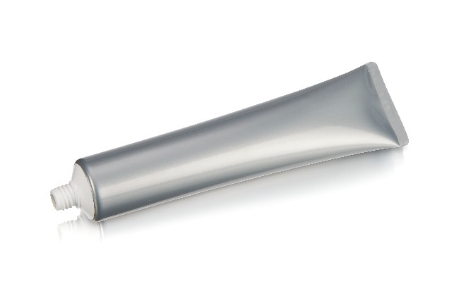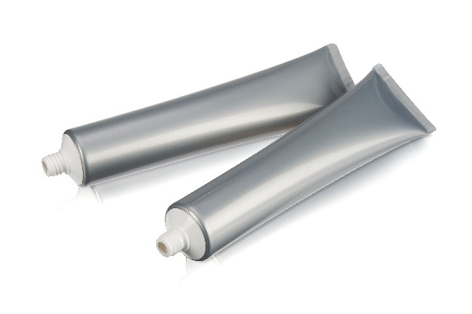

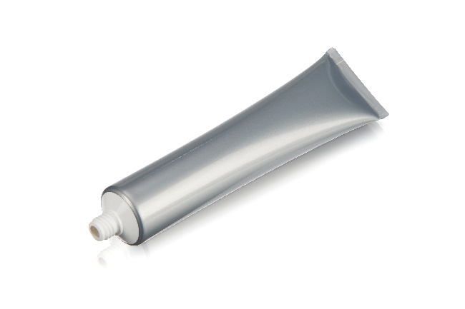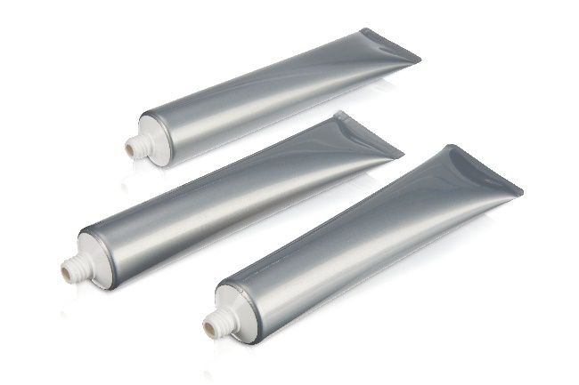

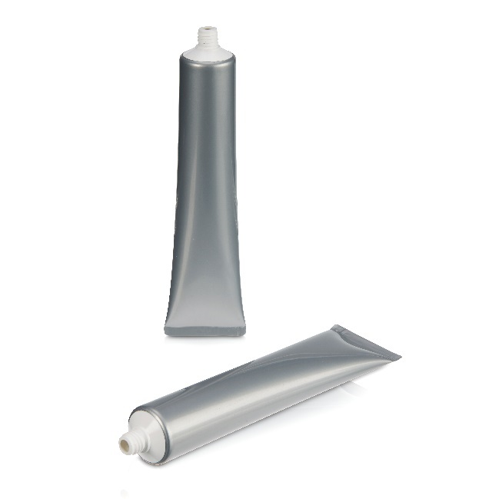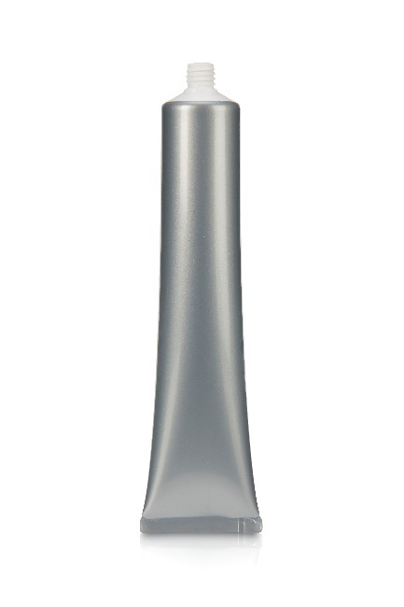
Huhtamaki, Milliken partner to design for circularity.
(Photos © 2022 Milliken & Company, all rights reserved, MKPR281)

This press release and relevant photography can be downloaded from www.PressReleaseFinder.com.
Alternatively for high resolution pictures please contact
Kim Lommaert (klommaert@emg-marcom.com, +31 164 317 021).

