PRESS RELEASE

Mondi and Fiorini International team up to develop new fully recyclable paper packaging for premium pasta

- Mondi and converter Fiorini International have collaborated to create a new paper packaging solution for Antico Pastificio Umbro, an Italian manufacturer of premium pasta products.
- The new packaging is completely recyclable and when rolled out across the full pasta range will eliminate up to 20 tonnes of plastic every year.
- Providing strength and style, the appealing packaging even features a paper window allowing the consumer to see the products.
- The innovative pasta packaging was included in The Waste Age Exhibition hosted by the London Design Museum and the Ellen MacArthur Foundation, which ran between October 2021 and February 2022.

2 August 2022 – Mondi, a global leader in packaging and paper, in partnership with Fiorini International, a world leading converter and packaging producer based in Italy, has successfully created and launched a new fully recyclable paper packaging for a premium Italian pasta brand.

Following a complete overhaul of its packaging design, Antico Pastificio Umbro decided to combine the expertise of Mondi and Fiorini International to design and produce a paper bag with a viewing window for its premium pasta ranges. After the complete roll out, this new packaging solution will support the company’s sustainability goal of reducing plastic by saving up to 20 tonnes of plastic per year.

The successful partnership between Mondi and Fiorini International has resulted in an innovative paper bag design with a large window made of transparent, recyclable and biodegradable cellulose that allows the end user to see the contents. Thanks to the paper selected by Mondi and Fiorini International, the bag is fully recyclable while offering the same protective properties as the previous plastic packaging. The pasta has the same shelf life and is kept safe during transport. A new closure system sealed with a special food contact hot-melt glue, together with a reinforced patch on the bottom, improves hygiene and ensures easy opening. Made from renewable resources, the packaging can be easily disposed of by consumers in existing paper waste streams. The high paper recycling rates in Europe of over 80% mean that paper that has reached the end of its life can contribute to a circular economy. The new pasta bag offers superior printability so that all brand and product messages can be communicated effectively and it has great runnability on filling machines.

The groundbreaking packaging was included in the Ellen MacArthur Foundation’s Upstream Innovation Guide to Packaging Solutions, published in November 2021. It was also part of The Waste Age Exhibition, hosted by the London Design Museum and the Ellen MacArthur Foundation, which was open to the public between October 2021 and February 2022. Here it was recognised as an innovative example of substitution for better recyclability, an approach that is in line with the Foundation’s vision for a circular economy for plastics.

Massimiliano Scottà, Head of Sales Region South & America Kraft Paper, Mondi says: “We used our customer-centric EcoSolutions approach to develop this recyclable packaging and worked very closely with Fiorini International and Antico Pastificio Umbro. This is a great example of best practice in creating packaging that keeps materials in circulation and contributes to Mondi’s MAP2030 sustainability target to make 100% of its products reusable, recyclable or compostable by 2025. In addition, we are delighted to have been part of the Ellen MacArthur Foundation and London Design Museum's Upstream Innovation installation, which is about rethinking packaging and developing solutions that are sustainable by design: This means focusing on the purpose while optimising the material and even changing it completely if necessary, as with this new paper bag for pasta.”

Pietro Fiorini, Sales Director Packaging Division at Fiorini International, explains: “Ethical and environmental responsibility are the values that lead the daily activities in Fiorini International. These same values, together with research on market trends, innovative technologies and a qualified manufacturing system, have been the key elements we used in this exciting project of transformation. We designed, together with Mondi, the best performing paper solution for the pasta bag. We are proud to be part of a sustainable mission and we know that this requires a systematic and cooperative approach among stakeholders in the supply chains, from producer to consumer. This includes involving consumers in initiatives to raise awareness of sustainable consumption and lifestyles, providing them with appropriate information about packaging. The partnership with Pastificio Umbro is a successful pilot project where Fiorini International’s experience, research, innovation and technology have defined a sustainable production model perfectly integrated within a brand strategy and a common mission.”

Leonardo Faccendini, CEO Antico Pastificio Umbro, concludes: “Reducing the environmental impact of our products – their manufacture, packaging and transport – is a top priority for us as a company, and replacing traditional plastic packaging with paper is a major step towards achieving this goal. We are investing in new systems and a plant and are plan to roll out this plastic-free packaging across our entire pasta range.”

/ends

About Mondi
Mondi is a global leader in packaging and paper, contributing to a better world by making innovative packaging and paper solutions that are sustainable by design. Our business is integrated across the value chain – from managing forests and producing pulp, paper and plastic films, to developing and manufacturing effective industrial and consumer packaging solutions. Sustainability is at the centre of our strategy and intrinsic in the way we do business. We lead the industry with our customer-centric approach, EcoSolutions, where we ask the right questions to find the most sustainable solution. In 2021, Mondi had revenues of €7.7 billion and underlying EBITDA of €1.5 billion.

Mondi has a premium listing on the London Stock Exchange (MNDI), and a secondary listing on the JSE Limited (MNP). Mondi is a FTSE 100 constituent, and has been included in the FTSE4Good Index Series since 2008 and the FTSE/JSE Responsible Investment Index Series since 2007.

www.mondigroup.com

About Fiorini International
Fiorini International is synonymous in the world of excellence, reliability and quality in the manufacturing of industrial packaging, medium and small paper bags and e-commerce bags: a range of products and finishes that provides a flexible response to every need. Fiorini International leads the packaging industry with 1.5 billion of paper bags produced per year, a turnover of 125 mio € and 50K tons of paper used per year. The company's strong reputation is the result of experience, advanced engineering and continuous research on partners' needs. Fiorini International collaborate with national and international customers of human and pet food industry, agriculture and chemical industry, and with global leaders in mass distribution. All the manufacturing systems and processes, supported by the most important certifications, guarantees full integration of technologies and professional skills, minimizing the environmental impact. Research and Development team Generate and test new solutions, materials and technologies in order to develop and produce new and competitive products or services responding to market trends and customer needs.

www.fiorinint.com

Contact:
Judith Wronn
Senior Communication Manager, Flexible Packaging & Engineered Materials
Tel: +49 151 1771 4692
Email: Judith.Wronn@mondigroup.com

Kim Lommaert
EMG
Tel: +31 164 317 021
Email: klommaert@emg-marcom.com

Photos:
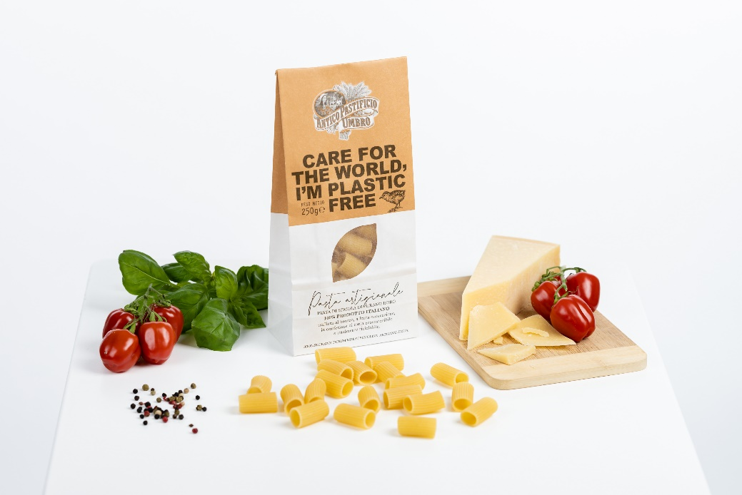

Mondi and Fiorini International team up to develop new fully recyclable paper packaging for premium pasta. (Photos: Mondi, PR221)

This press release and relevant photography can be downloaded from
www.PressReleaseFinder.com.
Alternatively for very high resolution pictures please contact Kim Lommaert (klommaert@emg-marcom.com, +31 164 317 021).

