PRESS RELEASE

Mondi and Reckitt launch paper-based packaging for Finish dishwasher tabs with 75% less plastic

- Mondi and Reckitt created an innovative paper-based packaging solution for Finish dishwasher tablets
- New packaging reduces plastic by 75% and will eliminate more than 2,000 tonnes of plastic each year once roll-out is complete
- Move contributes to Reckitt's ambition to halve the amount of virgin plastic in its packaging by 2030

27 October 2022 – Mondi, a global leader in sustainable packaging and paper, has helped Reckitt on its sustainability journey by designing new paper-based packaging for the company’s market-leading Finish dishwasher tablets.

Packaging for dishwasher tablets must be sealable, durable and water resistant, so using paper has traditionally been challenging. However, by working closely together along Mondi’s EcoSolutions approach, Mondi and Reckitt were able to create a solution that is sustainable by design: the new Finish packaging has successfully replaced 75% of the plastic with responsibly sourced paper. The remaining plastic is used to strengthen the paper structure and provide barrier protection to ensure the quality and safety of the Finish product as well as a re-closable seal.

The new paper-based packaging for Finish will initially launch exclusively with Carrefour in France, where the packaging is recyclable in the existing paper recycling streams. Any adaptations required following the initial market launch will be incorporated before its roll out in other countries over the next few years. Once the launch is complete, Reckitt will be eliminating more than 2,000 tonnes of plastic every year - which is the equivalent of 50 million 1-litre bottles.

Angela Naef, Chief Research & Development Officer at Reckitt said: "Removing plastic from our products is a priority across all Reckitt’s brands. We are always looking at new and innovative ways to improve sustainability in our packaging and we are committed to pioneering further packaging innovation. One of Reckitt’s sustainability ambitions is to reduce virgin plastic in our packaging by half by 2030. As well as removing plastic, the new packaging is expected to generate 15% less CO2 emissions across the product’s lifecycle compared to the previous plastic packaging.”

Gonzalo Balcazar, Global Category Vice President at Finish added: “This latest design represents our commitment to build better future solutions, not just for cleaner dishes but for a cleaner, more sustainable world. The paper-based solution ensures that Finish customers can enjoy the same product they know and love, with the added benefit of doing something for the environment."

Olivier Seux, Head of Global Key Accounts at Mondi said: "With Reckitt, we were able to develop a paper-based packaging solution that reduces plastic usage while still providing the necessary product protection. This project is a great example of Mondi's approach of using paper where possible, plastic when useful. The packaging has been designed with sustainability in mind to minimise the impact on the environment. We look forward to working with Reckitt to continue to test and develop solutions that help them achieve their sustainability goals.”

About Mondi
Mondi is a global leader in packaging and paper, contributing to a better world by making innovative solutions that are sustainable by design. Our business is integrated across the value chain – from managing forests and producing pulp, paper and films, to developing and manufacturing sustainable consumer and industrial packaging solutions using paper where possible, plastic when useful. Sustainability is at the centre of our strategy, with our ambitious commitments to 2030 focused on circular driven solutions, created by empowered people, taking action on climate.

In 2021, Mondi had revenues of €7.0 billion and underlying EBITDA of €1.2 billion from continuing operations, and employed 21,000 people worldwide. Mondi has a premium listing on the London Stock Exchange (MNDI), where the Group is a FTSE100 constituent, and also has a secondary listing on the JSE Limited (MNP).

www.mondigroup.com

Contact:
Judith Wronn
Head of Communication, Mondi Flexible Packaging
Tel: +49 151 1771 4692
Email: Judith.Wronn@mondigroup.com

Kim Lommaert
EMG
Tel: +31 164 317 021
Email: klommaert@emg-marcom.com

Photo:
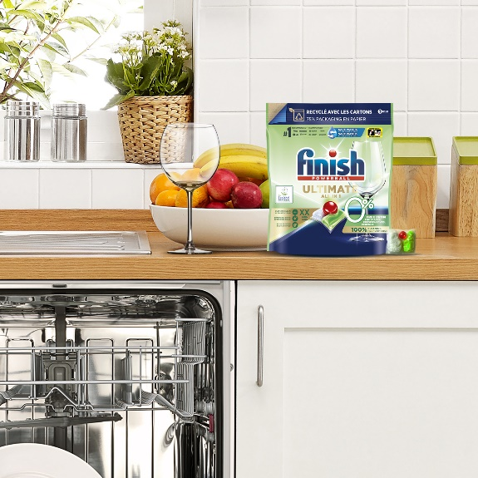
Mondi and Reckitt launch paper-based packaging for Finish dishwasher tabs with 75% less plastic. (Photo: Mondi, PR231)

This press release and relevant photography can be downloaded from
www.PressReleaseFinder.com.
Alternatively for very high resolution pictures please contact Kim Lommaert (klommaert@emg-marcom.com, +31 164 317 021).

