PRESS RELEASE

Food paper packaging with recycled content created by Mondi and Syntegon

- Mondi and Syntegon have teamed up to develop new recyclable paper-based packaging for dry food products.
- Mondi's EcoVantage kraft paper using recycled fibres utilised for dry food packaging for the first time.
- Packaging approved for food contact by the ISEGA.

15 June 2023 – Mondi, a global leader in packaging and paper, has partnered with Syntegon, a manufacturer of process and packaging machinery, to develop a recyclable paper packaging solution using recycled fibres for dried foods such as flour, sugar and pasta.

The packaging uses Mondi’s award-winning EcoVantage kraft paper which has been approved by ISEGA for the entire food packaging sector. EcoVantage is made from recycled and responsibly sourced fresh fibres and was previously mainly used for paper shopping bags. Mondi’s commitment to investing in research and development and its successful collaboration with industry players has enabled it to expand its application, meeting consumer’s growing demand for paper-based packaging.

Mondi supplies EcoVantage rollstock to Syntegon who then applies spot coating to create dust-tight, heat sealable packaging that eliminates contamination throughout the entire product lifecycle – from production to the consumer’s home. Syntegon’s unique technology ensures that only the minimum amount of sealing agent needed is used. The versatility of their technology ensures protection of powdered food goods and packaging strength which is recyclable in existing paper streams.

The development of these new packaging solutions illustrates a key element of Mondi Group’s MAP2030 targets – by using recycled fibres EcoVantage kraft paper prevents waste, keeps materials in circulation and is recyclable in existing paper waste streams, as evidenced by Mondi’s Recycling Lab.

Elisabeth Schwaiger, Head of R&D and Intellectual Property Flexible Packaging, Mondi, says: “Thanks to the close partnership with Syntegon and our extensive technical expertise and knowledge of paper, we can support our customers in making more sustainable choices. With high recycling rates of paper and the use of wood as a renewable material, we are delivering a packaging innovation that embraces resource efficiency, waste reduction and recyclability.”

Torsten Sauer, Director Sustainability at Syntegon, adds: “It is our goal to create sustainable packaging solutions with the minimum environmental impact possible. With paper packaging that is both recyclable and containing recycled material we are making a big step towards closing the circularity loop for primary food packaging.”

/ends

About Mondi
Mondi is a global leader in packaging and paper, contributing to a better world by making innovative solutions that are sustainable by design. Our business is integrated across the value chain – from managing forests and producing pulp, paper and films, to developing and manufacturing sustainable consumer and industrial packaging solutions using paper where possible, plastic when useful. Sustainability is at the centre of our strategy, with our ambitious commitments to 2030 focused on circular driven solutions, created by empowered people, taking action on climate.

In 2022, Mondi had revenues of €8.9 billion and underlying EBITDA of €1.8 billion from continuing operations, and employed 22,000 people worldwide. Mondi has a premium listing on the London Stock Exchange (MNDI), where the Group is a FTSE100 constituent, and also has a secondary listing on the JSE Limited (MNP).

www.mondigroup.com

Contact:
Judith Wronn
Head of Communication, Mondi Flexible Packaging
Tel: +49 151 1771 4692
Email: Judith.Wronn@mondigroup.com

Kim Lommaert
EMG
Tel: +31 164 317 021
Email: klommaert@emg-marcom.com

Photos:
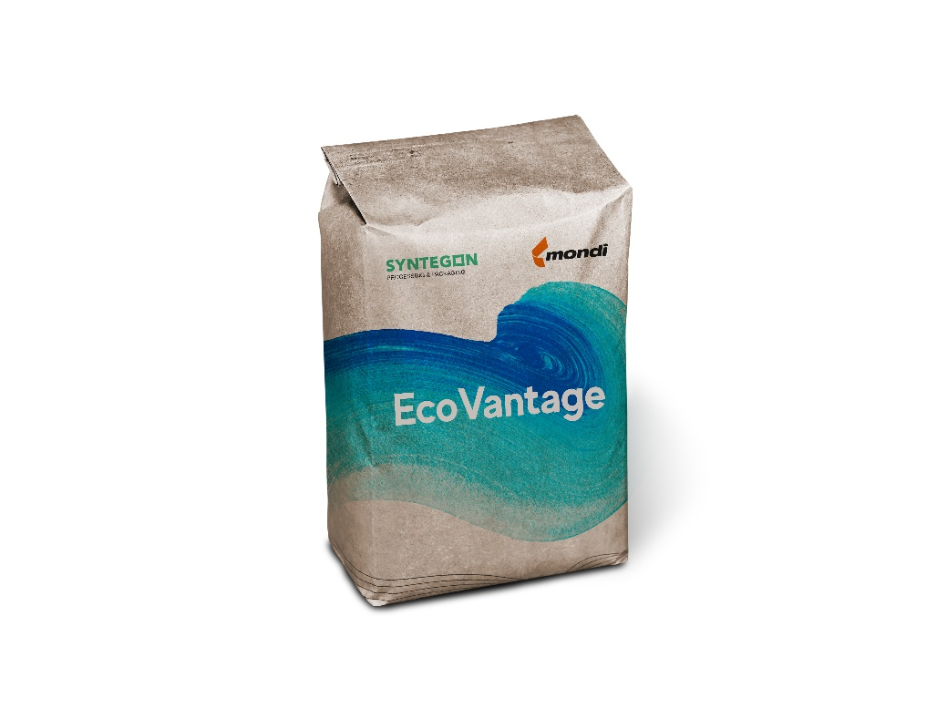

Food paper packaging with recycled content created by Mondi and Syntegon.
(Photos: Mondi, PR253)

This press release and relevant photography can be downloaded from
www.PressReleaseFinder.com.
Alternatively for very high resolution pictures please contact Kim Lommaert (klommaert@emg-marcom.com, +31 164 317 021).

