PRESS RELEASE

Mixing sustainability and convenience: Mondi and Baumit launch water-soluble bag for dry mix mortar

- Mondi launches SolmixBag, a paper packaging solution that dissolves in water, eliminating waste.
- SolmixBag is made from one-ply Mondi kraft paper, using renewable resources, and offering high strength and excellent product protection.
- Launched with building materials supplier Baumit, the solution helps to reduce waste for the global construction industry.

22 June 2023 – Mondi, a global leader in sustainable packaging and paper, is introducing SolmixBag, a water-soluble bag for the construction industry.

SolmixBag is a one-ply paper bag created to store and transport dry construction materials such as cement and dry mix mortar products. It’s designed to dissolve when getting in contact with water during the mixing process - the fibre of the packaging simply integrates with the product as it is mixed. This eliminates waste, reduces paper waste management costs and minimises dust on the construction site, as the bag is simply placed into the mixer without the necessity to open it up front.

The bag is produced in-house thanks to the company’s uniquely integrated value chain: SolmixBag is created from Mondi’s water-soluble sack kraft paper and uses 20% less paper than the industry standard 2-ply paper bags. The solution is able to run on existing filling machines, and it is available in standard sizes, offering customers a smooth transition from their existing solutions. SolmixBag provides the same strength and shelf-life as its predecessors, with good printing results for a quality, stand-out appearance on shelf.

Mondi has worked with its long-standing customer Baumit to bring SolmixBag to market for dry mix concrete. The two organisations collaborated closely throughout the product development and are committed to supporting the whole construction industry as it endeavours to reduce waste.

Ferdinand Muck, International Key Account Manager, Mondi says: "We are closely collaborating with our partners in the building material industry to eliminate waste disposal and dust, which benefits both the environment and the workers on site. The launch of SolmixBag with Baumit is an important step to make a real difference to the sustainability of the whole industry.”

Peter Weißmann, Head of R&D Dry Mix Mortar, Baumit Group says: “Working closely with Mondi means we have been able to test and trial these bags thoroughly and the results will soon benefit new product groups. The impacts on sustainability are vast. Our customers on building sites love the new technology due to the multiple benefits – no waste and reduced dust as the two most important. It was a pleasure to work with the Mondi team, their packaging expertise enables us to help the construction industry make effective, positive change for the future.”

/ends
About Mondi
Mondi is a global leader in packaging and paper, contributing to a better world by making innovative solutions that are sustainable by design. Our business is integrated across the value chain – from managing forests and producing pulp, paper and films, to developing and manufacturing sustainable consumer and industrial packaging solutions using paper where possible, plastic when useful. Sustainability is at the centre of our strategy, with our ambitious commitments to 2030 focused on circular driven solutions, created by empowered people, taking action on climate.

In 2022, Mondi had revenues of €8.9 billion and underlying EBITDA of €1.8 billion from continuing operations, and employed 22,000 people worldwide. Mondi has a premium listing on the London Stock Exchange (MNDI), where the Group is a FTSE100 constituent, and also has a secondary listing on the JSE Limited (MNP).

www.mondigroup.com

Contact:
Judith Wronn
Head of Communication, Mondi Flexible Packaging
Tel: +49 151 1771 4692
Email: Judith.Wronn@mondigroup.com

Kim Lommaert
EMG
Tel: +31 164 317 021
Email: klommaert@emg-marcom.com

Photos:
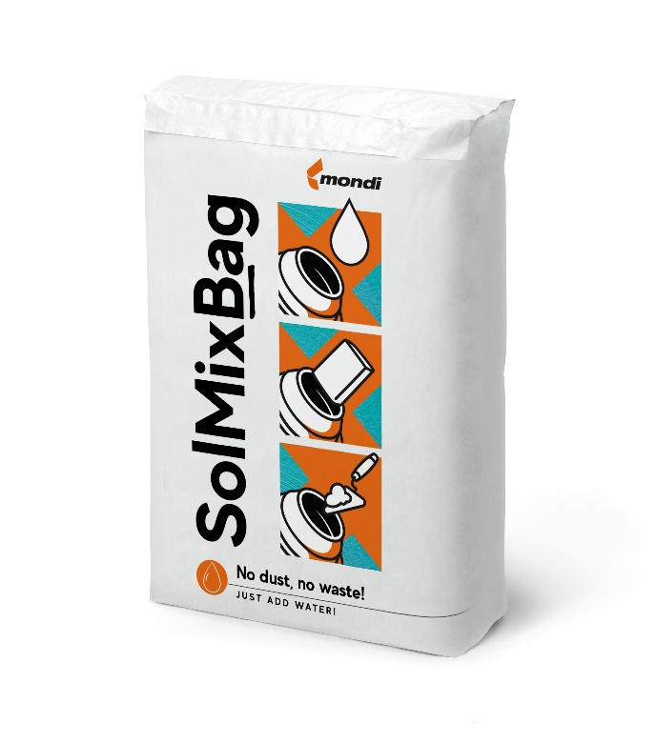
Mixing sustainability and convenience: Mondi and Baumit launch water-soluble bag for dry mix mortar. (Photo: Mondi, PR254)

This press release and relevant photography can be downloaded from
www.PressReleaseFinder.com.
Alternatively for very high resolution pictures please contact Kim Lommaert (klommaert@emg-marcom.com, +31 164 317 021).

