PRESS RELEASE

Mondi Secures Four Prestigious WorldStar Awards for Innovative Packaging Solutions

- The coveted WorldStar Global Packaging Awards recognise exceptional packaging innovations on a global stage, attracting 435 entries from 41 countries in 2024.
- Mondi’s award-winning products include Hug&Hold, Statorfold and Protector Bag ExpandForm.
- The four wins further solidify Mondi’s position as an industry leader in sustainable packaging solutions.

9 January 2024 – Mondi, a global leader in sustainable packaging and paper solutions, is celebrating a significant achievement at this year’s WorldStar Global Packaging Awards, having received four accolades across four categories. Renowned as the ultimate recognition in global packaging excellence, the WorldStar Awards highlight Mondi’s dedication to sustainable and circular-driven packaging solutions.

Mondi’s impressive array of 2024 WorldStar Award-winning products include Hug&Hold (Non-Alcoholic Beverages), Protector Bag ExpandForm (Packaging Materials and Components), Statorfold (Transit) and Mix-Berry (Fresh Fruits and Vegetables).

“We are thrilled to see our sustainable and innovative packaging solutions receive global acclaim. Our collaborative efforts with valued customers drive us to create solutions that not only solve their challenges but also set industry benchmarks. These prestigious awards are a testament to the creativity and hard work of our teams, and we’re excited to bring more groundbreaking ideas to life in the coming year,” says Markus Gärtner, CEO Mondi Corrugated Packaging.

“Receiving accolades from the WorldStar Awards highlights Mondi’s commitment to sustainable packaging design. Our award-winning products showcase our dedication to helping customers achieve their sustainability goals, ensuring packaging becomes part of a circular economy. We look forward to showcasing our packaging innovations on the global stage at the Awards Ceremony in Bangkok,” says Thomas Ott, CEO Mondi Flexible Packaging.

The Awards Ceremony and Gala Event for the 2024 WorldStar Packaging Awards will be held in Bangkok in June.

Mondi’s 2024 WorldStar Award winners are:
Hug&Hold, Non-Alcoholic Beverages category
Protector Bag ExpandForm, Packaging Materials and Components category
Statorfold, Transit category
Mix-Berry, Fresh Fruits and Vegetables category

High-res product images can be downloaded here.

/ends

Further information on the award-winning packaging innovations:

Hug&Hold
Hug&Hold is a paper packaging solution that is designed to wrap and transport PET beverage bottles, replacing plastic shrink wrap. It comprises of two elements that are 100% paper based; the first a sleeve made of kraft paper that wraps around the bottles to hold them securely, and the second a corrugated clip which holds the bottles around the neck and offers a comfortable handle for transportation. This sustainable, functional and fully automated alternative to plastic shrink wrap means that FMCG brands and beverage producers can safely switch to the new solution without any risk to their product or logistics. It is recyclable and suitable for existing paper waste streams throughout Europe.

Protector Bag ExpandForm
The Protector Bag ExpandForm replaces the current plastic packaging for mattress rollpacking with a flexible and recyclable paper bag solution. Developed in collaboration with Megaflex Schaumstoff, a family-owned manufacturer for flexible foams, mattresses and sleeping products, the innovative packaging not only helps to reduce plastic waste but also ensures optimal product protection and handling during the transportation and storage of rolled mattresses. Its unique design and superior strength provide secure packaging that retains its shape and protects the mattresses throughout the transport journey.

Statorfold
Designed by Mondi Ansbach in conjunction with Swedish packaging company, aPak, the Statorfold corrugated solution protects sensitive electric car motor components during transport and storage. The new cardboard design replaces the client’s former plastic packaging and reduces material use, weight and volume by 25%. The strong and study interior protects the delicate parts from shocks or pressure by allowing them to ‘hang freely’, with all weight evenly distributed on four solid bulges. A specifically-developed anti-corrosion bag protects it from moisture and corrosion, and acts as a protective layer against dust and scratches. The modular construction is delivered flat and is assembled fast and easily without glue or other fasteners. The construction is just as easy to dismantle when it’s time for recycling.

Mix-Berry
Mix-Berry is a sustainable packaging solution designed for the safe transport of groceries, particularly delicate berries. The packaging is easy to install and features a pick-up-&-go handle, while it can also be transported flat in order to support stacking tabs and maximise warehouse and shipping advantages. Eliminating the need for plastic entirely, Mix-Berry is 100% recyclable and paper-based. The strong corrugated cardboard fully protects the food product inside while also prolonging its shelf life, further supporting the circular economy by not only reducing packaging waste but also food waste.

About Mondi
Mondi is a global leader in packaging and paper, contributing to a better world by making innovative solutions that are sustainable by design. Our business is integrated across the value chain – from managing forests and producing pulp, paper and films, to developing and manufacturing sustainable consumer and industrial packaging solutions using paper where possible, plastic when useful. Sustainability is at the centre of our strategy, with our ambitious commitments to 2030 focused on circular driven solutions, created by empowered people, taking action on climate.

In 2022, Mondi had revenues of €8.9 billion and underlying EBITDA of €1.8 billion from continuing operations, and employed 22,000 people worldwide. Mondi has a premium listing on the London Stock Exchange (MNDI), where the Group is a FTSE100 constituent, and also has a secondary listing on the JSE Limited (MNP).

www.mondigroup.com

About WPO Awards
World Packaging Organisation (WPO) is a non-profit, non-governmental, international federation of packaging institutes, associations, federations and other interested parties including corporations and trade associations. Its mission is “Better quality of life through better packaging for more people”. WPO rewards outstanding achievements in packaging innovation. The focus is on sustainable packaging solutions that achieve convenience for the end-user through innovation. The complete list of WorldStar Packaging Awards 2024 winners can be viewed at www.worldstar.org/winners/worldstar/2024/.

Contact:
Judith Wronn
Head of Communication, Mondi Flexible Packaging
Tel: +49 151 1771 4692
Email: Judith.Wronn@mondigroup.com

Siobhan Plowman
Senior Content Manager, Mondi Corrugated Packaging
Tel: +43 676 760 9329
Email: siobhan.plowman@mondigroup.com

Kim Lommaert
EMG
Tel: +31 164 317 021
Email: klommaert@emg-marcom.com

Photos:
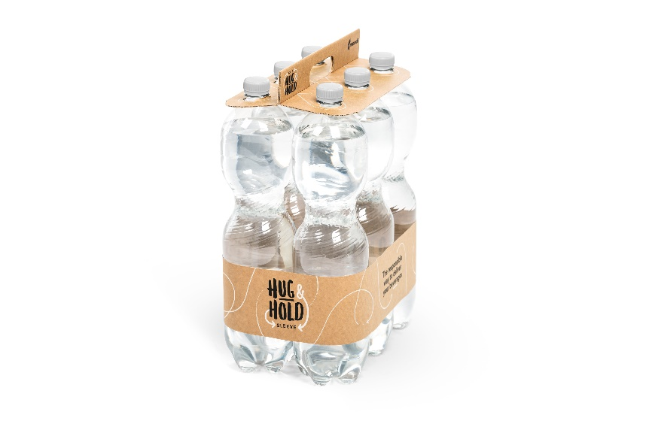
Hug&Hold. (Photo: Mondi, PR273)

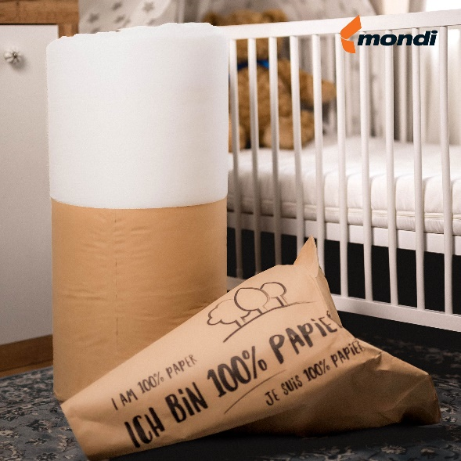
Protector Bag ExpandForm. (Photo: Mondi, PR273)

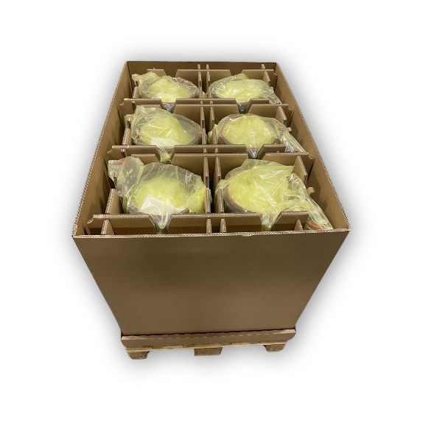
Statorfold. (Photo: Mondi, PR273)

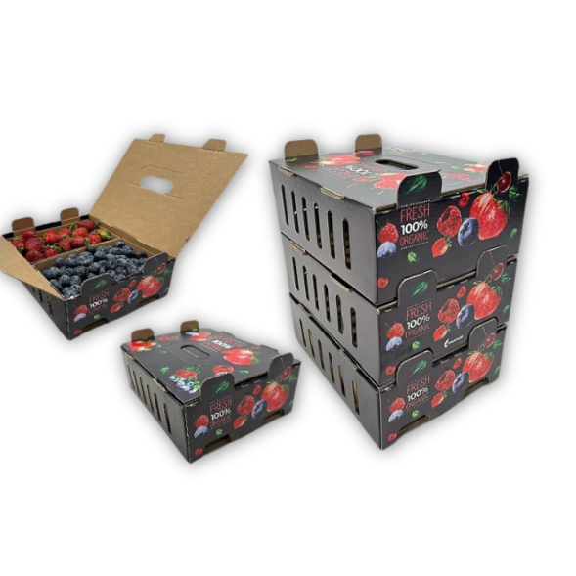
Mix-Berry. (Photo: Mondi, PR273)

This press release and relevant photography can be downloaded from
www.PressReleaseFinder.com.
Alternatively for very high resolution pictures please contact Kim Lommaert (klommaert@emg-marcom.com, +31 164 317 021).

