PRESS RELEASE

Mondi expands production of paper-based EcoWicketBags to meet demand for sustainable packaging in home and personal care industry

- Mondi is increasing production of paper-based EcoWicketBags at its plant in Szada (Hungary), leveraging the Group's integrated value chain, from in-house paper production to coating and converting.
- EcoWicketBags are designed for recycling and offer the advanced barrier protection required for diapers and feminine hygiene products.

21 February 2024 – Mondi, a global leader in sustainable packaging and paper is expanding production of its innovative range of paper-based EcoWicketBags. This comes in response to increasing demand for sustainable packaging in the home and personal care (HPC) industry, particularly for products such as diapers and feminine hygiene products.

By expanding the production of EcoWicketBags at its plant in Szada (Hungary), Mondi further leverages the Group’s integrated value chain, from in-house paper production to coating and converting. EcoWicketBags are made from Mondi’s FunctionalBarrier Paper 95/5 – an exceptionally strong kraft paper which can be customised with specific barrier and protective properties to meet diverse product needs. They are available in a variety of sizes for different applications and provide protection from filling to transporting and storage, as well as being ideal for printing customer branding.

EcoWicketBags are made from a renewable material and designed to be recycled in standard European paper recycling mills according to the 4evergreen guidelines. Paper-based packaging has very high recycling rates in Europe (82%) and Mondi’s EcoWicketBags can support customers in the HPC industry to meet their sustainability goals on their journey towards a circular economy.

EcoWicketBags add to Mondi's range of recyclable, mono-material polymer WicketBags that follow CEFLEX recycling guidelines. The range also includes WicketBags that use a high amount of post-consumer content in line with customer needs. With various choices available, customers can select the best fit for their product to meet their sustainability goals.

Piotr Barczykowski, Sales Director Consumer Flexibles at Mondi, says: “Our Szada plant in Hungary is well positioned to serve customers across Europe and we are pleased to respond to consumer and customer demands for sustainable solutions with our paper-based EcoWicketBags.”

/ends

Editors note
Mondi’s EcoWicketBags will be showcased at Packaging Innovations in Birmingham from 21 to 22 February 2024. Visitors can find them at the Mondi booth, number J106.

About Mondi
Mondi is a global leader in packaging and paper, contributing to a better world by making innovative solutions that are sustainable by design. Our business is integrated across the value chain – from managing forests and producing pulp, paper and films, to developing and manufacturing sustainable consumer and industrial packaging solutions using paper where possible, plastic when useful. Sustainability is at the centre of our strategy, with our ambitious commitments to 2030 focused on circular driven solutions, created by empowered people, taking action on climate.

In 2022, Mondi had revenues of €8.9 billion and underlying EBITDA of €1.8 billion from continuing operations, and employed 22,000 people worldwide. Mondi has a premium listing on the London Stock Exchange (MNDI), where the Group is a FTSE100 constituent, and also has a secondary listing on the JSE Limited (MNP).

www.mondigroup.com

Contact:
Judith Wronn
Head of Communication, Mondi Flexible Packaging
Tel: +49 151 1771 4692
Email: Judith.Wronn@mondigroup.com

Kim Lommaert
EMG
Tel: +31 164 317 021
Email: klommaert@emg-marcom.com

Photos:
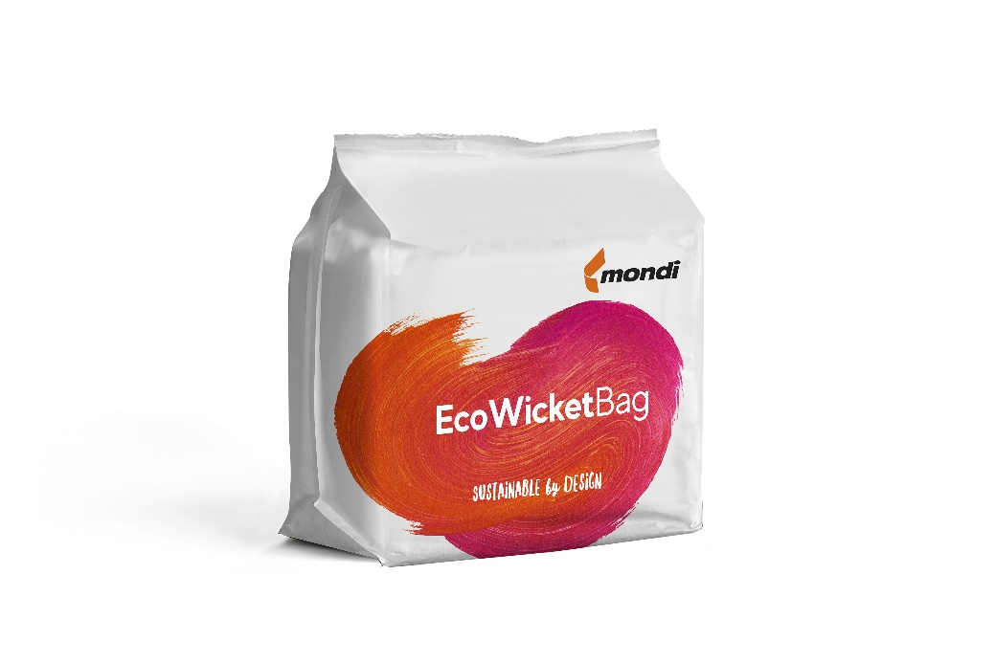
Mondi expands production of paper-based EcoWicketBags to meet demand for sustainable packaging in home and personal care industry. (Photo: Mondi, PR278)

This press release and relevant photography can be downloaded from
www.PressReleaseFinder.com.
Alternatively for very high resolution pictures please contact Kim Lommaert (klommaert@emg-marcom.com, +31 164 317 021).

https://www.statista.com/statistics.

