PRESS RELEASE

**Mondi breaks ground on €200 million recycled containerboard mill investment in Duino, Italy**

* *Mondi is investing €200 million into a high-quality recycled containerboard machine with an annual capacity of around 420,000 tonnes at its Duino mill near Trieste, acquired in January 2023.*
* *Investment is part of the company's €1.2 billion of approved investments in organic growth projects aimed at meeting the growing demand for sustainable packaging, enhancing its product offering, and reducing its environmental impact*

**23 May 2024** – Mondi, a global leader in sustainable packaging and paper, held a groundbreaking ceremony in Duino, Italy, today laying the cornerstone on its €200 million investment in the mill acquired [in January 2023](https://www.mondigroup.com/news-and-insight/2023/mondi-completes-duino-mill-acquisition/). The facility’s existing paper machine is being converted into a high-quality recycled containerboard machine which will create job opportunities for current and potential employees, build and evolve partnerships with local stakeholders as well as contribute to the region’s overall economic development.

The start-up of the new machine is expected in 2025. Once fully operational, it will be capable of producing 420,000 tonnes of recycled containerboard for sustainable packaging solutions and will be Mondi’s widest recycled paper machine at 8.5 metres. Where possible, the mill will source materials locally in order to contribute to the local economy, reduce greenhouse gas emissions through shorter transport distances and strengthen supply chain resilience.

“We are excited about the progress of the Duino investment project and the opportunity this provides our growing packaging business,” says Andrew King, CEO of Mondi Group. “This containerboard machine will strengthen our backward integration and provide us with security of supply to better serve our customers.”

“Our investment in Duino allows us to meet the increasing demand for sustainable solutions across Central Europe, the Mediterranean area, and the local Italian market. The project team is currently preparing for the upcoming construction works, with a new recycled fibre plant, wastewater treatment plant and the associated infrastructure and warehousing,” says Markus Gärtner, CEO Mondi Corrugated Packaging.

/ends

**About Mondi**

Mondi is a global leader in packaging and paper, contributing to a better world by producing products that are sustainable by design. We employ 22,000 people in more than 30 countries and operate an integrated business with expertise spanning the entire value chain, enabling us to offer our customers a broad range of innovative solutions for consumer and industrial end-use applications. Sustainability is at the centre of our strategy, with our ambitious commitments to 2030 focused on circular driven solutions, created by empowered people, taking action on climate.

In 2023, Mondi had revenues of €7.3 billion and underlying EBITDA of €1.2 billion. Mondi has a premium listing on the London Stock Exchange (MNDI), where the Group is a FTSE100 constituent, and also has a secondary listing on the JSE Limited (MNP).

[www.mondigroup.com](http://www.mondigroup.com)

**Contact:**

Bettina Pokorny

Senior Communication & Marketing Manager, Mondi Corrugated Packaging

Tel: +43 1 79013 4347

Email: [Bettina.Pokorny@mondigroup.com](mailto:Bettina.Pokorny@mondigroup.com)

Kim Lommaert

EMG

Tel: +31 164 317 021

Email: [klommaert@emg-marcom.com](mailto:klommaert@emg-marcom.com)

**Photos:**

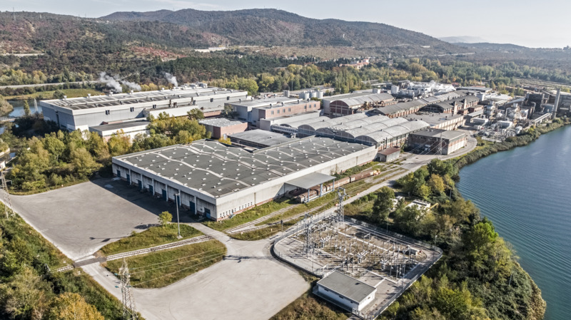

Mondi Duino mill. (Photo: Mondi, PR283)

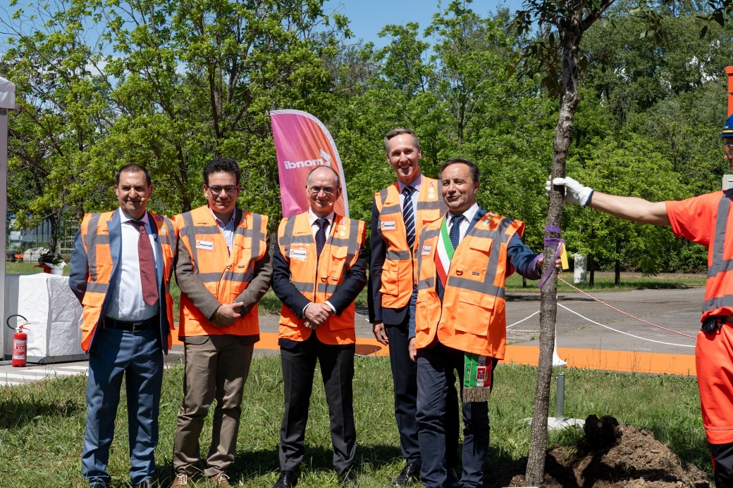

From left to right: Bruno Cottone, Managing Director Mondi Duino, Luca Antonicelli, Regional office for work, training, education, research, university and family, Andrew King, CEO Mondi Group, Igor Gabrovec, Mayor of Duino, Markus Gärtner, CEO Mondi Corrugated Packaging. (Photo: Mondi, PR283)

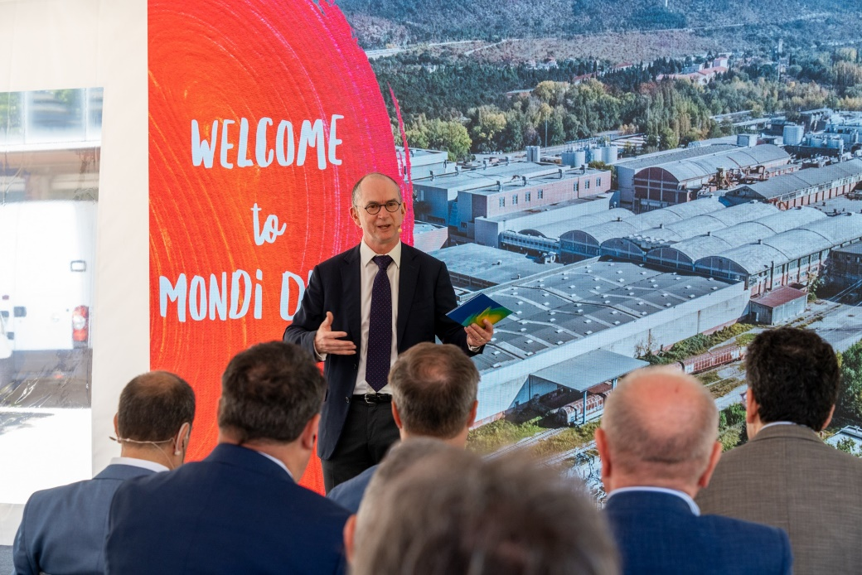

Andrew King, CEO Mondi Group, speaking at the Mondi Duino Groundbreaking ceremony on 23 May 2024. (Photo: Mondi, PR283)

This press release and relevant photography can be downloaded from

[www.PressReleaseFinder.com](http://www.PressReleaseFinder.com).

Alternatively for very high resolution pictures please contact Kim Lommaert ([klommaert@emg-marcom.com](mailto:klommaert@emg-marcom.com), +31 164 317 021).