PRESS RELEASE

**Life Cycle Assessment finds 43% reduced climate impact for Mondi’s Hug&Hold**

* *Mondi takes data-driven approach to analyse Hug&Hold's environmental impact.*
* *Critically reviewed Life Cycle Assessment (LCA) compares the product to conventional plastic shrink wrap for 6 1.5 l PET beverage bundles.*
* *ISO-compliant approach shows the paper packaging performs better across several impact categories, including 43% less climate change impact than plastic.*

**28 May 2024** – Mondi, a global leader in packaging and paper, has commissioned and completed a life cycle assessment (LCA) for its ground-breaking paper-based Hug&Hold solution, to determine its environmental impact compared to that of conventional low-density polyethylene shrink wrap for six 1.5 litre PET beverage bottles.

Hug&Hold is an innovative, sustainable and fully recyclable solution to replace plastic shrink wrap on the PET bottle bundle packs. It comprises two elements - a kraft paper sleeve to provide secure and safe transportation and a corrugated carrying handle that firmly holds the bottles around the neck, featuring an integrated handle for convenience and strength.

Mondi commissions critically reviewed and ISO-compliant LCAs to assess the products’ life cycle impacts, using the Environmental Footprint (EF) method. A total of 16 indicators have been assessed, from raw material acquisition and production and end of life treatment (typical disposal in the EU27).

The assessment shows that Hug&Hold has lower impacts in the categories of climate change, fossil resource use, photochemical ozone formation, acidification, ionising radiation, water use and eutrophication of freshwater. The overall carbon footprint is 43% lower than average LDPE virgin plastic shrink wrap and 15% lower than LDPE shrink wrap with 100% recycled content, meaning it can be recommended to reduce the climate change impacts of packaging while providing a strong solution for the customer and end user.

Silvia Hanzelova, Sales Director Speciality Kraft Paper, Mondi says: “Mondi values independent critical reviews and a data-driven route to help customers assess the environmental impact of their products. This LCA on Hug&Hold delivers on that. The results play a vital role in our customers’ decision-making process, which ensures that we keep creating sustainable solutions in line with our MAP2030 (Mondi Action Plan 2030) commitments, providing effective and creative solutions – that are sustainable by design and successful in application.”

Mondi will host a live webinar on the beverage packaging market incl. Hug&Hold and its sustainability benefits on 5 June 2024 at 2pm. You can register for the free webinar [here](https://hugandhold.grwebsite.com/).

/ends

**About Mondi**

Mondi is a global leader in packaging and paper, contributing to a better world by producing products that are sustainable by design. We employ 22,000 people in more than 30 countries and operate an integrated business with expertise spanning the entire value chain, enabling us to offer our customers a broad range of innovative solutions for consumer and industrial end-use applications. Sustainability is at the centre of our strategy, with our ambitious commitments to 2030 focused on circular driven solutions, created by empowered people, taking action on climate.

In 2023, Mondi had revenues of €7.3 billion and underlying EBITDA of €1.2 billion. Mondi has a premium listing on the London Stock Exchange (MNDI), where the Group is a FTSE100 constituent, and also has a secondary listing on the JSE Limited (MNP).

[www.mondigroup.com](http://www.mondigroup.com)

**Contact:**

Judith Wronn

Head of Communication, Mondi Flexible Packaging

Tel: +49 151 1771 4692

Email: [judith.wronn@mondigroup.com](mailto:Judith.Wronn@mondigroup.com)

Siobhan Plowman

Senior Content Manager, Mondi Corrugated Packaging

Tel: +43 676 760 9329

Email: [siobhan.plowman@mondigroup.com](mailto:siobhan.plowman@mondigroup.com)

Kim Lommaert

EMG

Tel: +31 164 317 021

Email: [klommaert@emg-marcom.com](mailto:klommaert@emg-marcom.com)

**Photos:**

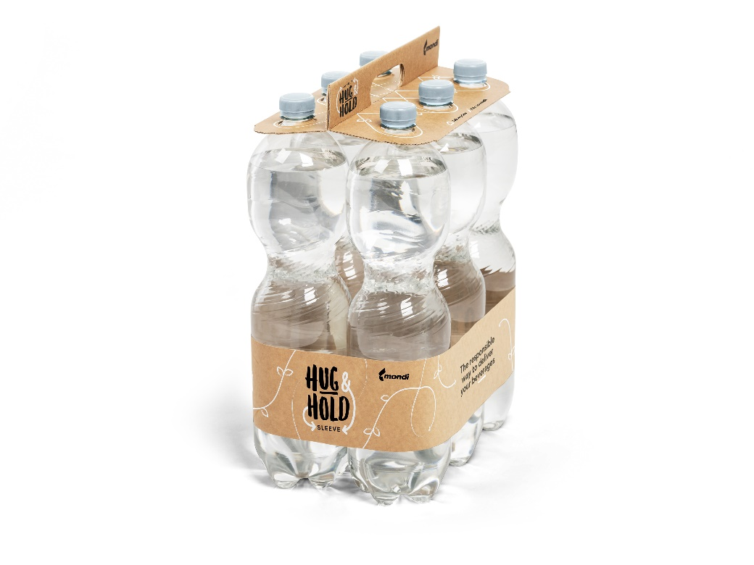

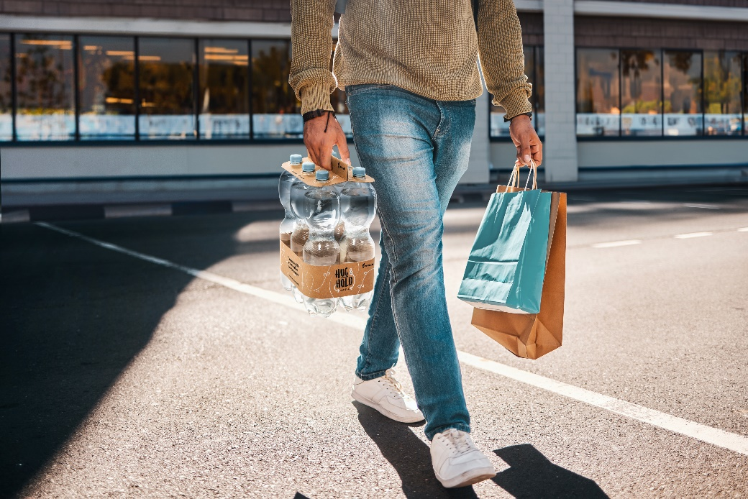

Life Cycle Assessment finds 43% reduced climate impact for Mondi’s Hug&Hold.   
(Photos: Mondi, PR286)

This press release and relevant photography can be downloaded from

[www.PressReleaseFinder.com](http://www.PressReleaseFinder.com).

Alternatively for very high resolution pictures please contact Kim Lommaert ([klommaert@emg-marcom.com](mailto:klommaert@emg-marcom.com), +31 164 317 021).