PRESS RELEASE

**Find your packaging zen: Mondi's ProVantage SmartKraft brings peace of mind to packaging decisions**

* *Mondi introduces ProVantage SmartKraft Brown and White, an innovative blend of fresh and recycled fibres, setting new standards in sustainability and performance.*
* *These two containerboard grades offer exceptional strength, enhanced runnability, and the necessary printability to cater to diverse packaging needs while championing environmental responsibility.*

**12 June 2024** – Amidst the daily whirlwind of business, achieving balance can be truly gratifying. Mondi’s Containerboard team is today launching a campaign to help customers achieve just that. Introducing [ProVantage SmartKraft Brown and White](https://www.mondigroup.com/products-and-solutions/containerboard/provantage-smartkraft/) — offering a harmonious packaging solution that brings peace of mind. No more compromises; these two containerboard paper grades strike the ideal balance between sustainability, strength, and printability, providing the tranquillity needed in packaging decisions.

The papers are made of 100% fresh fibre on the top and 100% recycled fibre underneath (two ply solution), making them the perfect blend of sustainability, strength, cost efficiency and printability. Like all Mondi Containerboard papers, they are 100% recyclable and made from 100% responsibly sourced raw materials.

ProVantage SmartKraft grades combine fresh and recycled fibres and are available in both brown and white variations, aiming to minimise environmental impact while maintaining high standards of quality and strength. These containerboard paper grades are ideally suited to the needs of e-commerce, retail and fast-moving consumer goods packaging, by using responsibly sourced raw materials.

“The timing of the campaign could not be better as we are currently executing a €95 million upgrade of Mondi Świecie’s containerboard mill in Poland, to serve customers even more efficiently with shortened lead times and further grammage options. Our customers need high performance, sustainable paper and packaging solutions and we can offer this with our extended range of ProVantage containerboard papers”, says Gijs Huisman, Mondi Sales Director Containerboard.

Explore the full range of benefits of ProVantage SmartKraft paper grades, and receive expert guidance from our team: [www.mondigroup.com/products-and-solutions/containerboard/provantage-smartkraft](http://www.mondigroup.com/products-and-solutions/containerboard/provantage-smartkraft).

/ends

**About Mondi**

Mondi is a global leader in packaging and paper, contributing to a better world by producing products that are sustainable by design. We employ 22,000 people in more than 30 countries and operate an integrated business with expertise spanning the entire value chain, enabling us to offer our customers a broad range of innovative solutions for consumer and industrial end-use applications. Sustainability is at the centre of our strategy, with our ambitious commitments to 2030 focused on circular driven solutions, created by empowered people, taking action on climate.

In 2023, Mondi had revenues of €7.3 billion and underlying EBITDA of €1.2 billion. Mondi has a premium listing on the London Stock Exchange (MNDI), where the Group is a FTSE100 constituent, and also has a secondary listing on the JSE Limited (MNP).

[www.mondigroup.com](http://www.mondigroup.com)

**Contact:**

Michael Schwarz

Marketing Manager, Mondi Corrugated Packaging

Tel: +43 1 79013 4518

Email: [Michael.Schwarz@mondigroup.com](mailto:Michael.Schwarz@mondigroup.com)

Kim Lommaert

EMG

Tel: +31 164 317 021

Email: [klommaert@emg-marcom.com](mailto:klommaert@emg-marcom.com)

**Photos:**

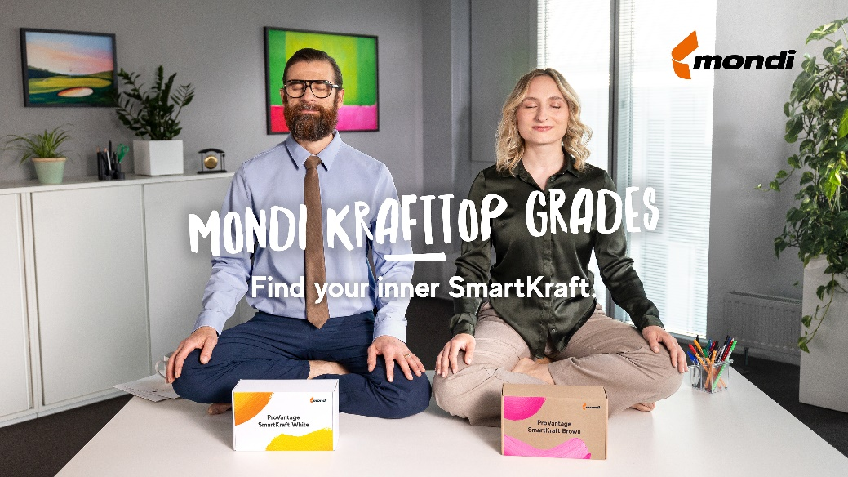

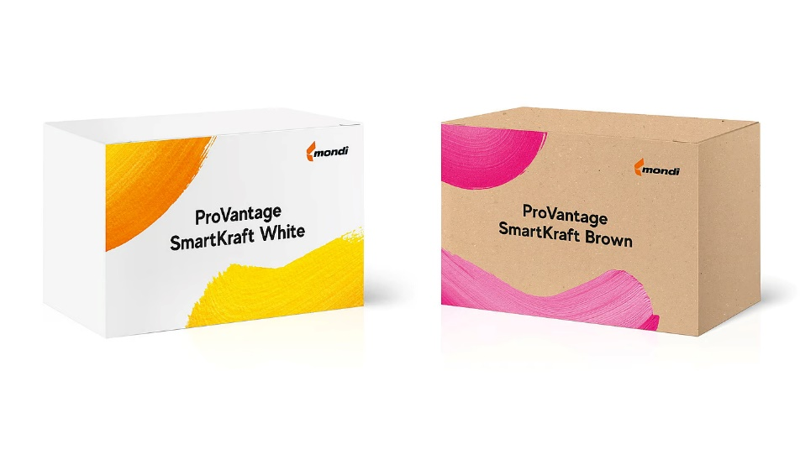

Find your packaging zen: Mondi's ProVantage SmartKraft brings peace of mind to packaging decisions. (Photos: Mondi, PR287)

This press release and relevant photography can be downloaded from

[www.PressReleaseFinder.com](http://www.PressReleaseFinder.com).

Alternatively for very high resolution pictures please contact Kim Lommaert ([klommaert@emg-marcom.com](mailto:klommaert@emg-marcom.com), +31 164 317 021).