PRESS RELEASE

**Mondi and traceless team up to develop a ground-breaking coating solution from agricultural by-products**

* *Mondi and traceless announce long-term partnership to develop bio-circular coating solution.*
* *The two experts work together to meet consumers' demands for an alternative to plastic coating for packaging.*
* *The ground-breaking coating solution is based on natural polymers, saving up to 95% of GHG emissions in production and disposal compared to virgin plastics.*

**18 June 2024** – Mondi, a global leader in sustainable packaging and paper, is partnering with advanced biomaterial engineers traceless to develop a new coating solution based on by-products from the agricultural industry. This innovative bio-circular coating solution is the first of its kind and will be able to replace traditionally used plastic coating.

There is an increasing demand for plastic alternatives in packaging solutions, and this new coating will respond to the demand directly: made from renewable plant-based materials, namely residues from the agricultural industry, it eliminates the need for fossil raw materials. traceless' consequential life-cycle assessment showed that the provision of traceless® material to the market leads to overall greenhouse gas savings of 76% from sourcing to disposal, if the material is used as a replacement for virgin PET. If only the production and disposal phase is considered, these savings add up to 95%. Also, the material is certified home compostable by DIN CERTCO according to NF T51-800.

The joint work of Mondi and traceless on this product started in 2021 and brought world-leading expertise together: Mondi’s knowledge in paper coating and packaging solutions, and traceless’ expertise for material solutions based on natural polymers. The coating granulates are produced in traceless' pilot plant and are applied to Mondi's kraft paper in Mondi's R&D centre for further testing of the coated paper in the company’s laboratories. Later production on industrial scale will take place in a designated plant in Hamburg.

Varying products require different barriers in their packaging and the coated kraft paper solution is tested thoroughly for different packaging purposes, to ensure it can be used across different end-markets: the in-depth trials have confirmed that kraft paper coated with traceless® can resist water, oxygen and fat, while offering good printing abilities for different customers. At the same time, the goal is to develop a solution that is also recyclable in existing recycling streams throughout Europe. Currently, the properties of the bio-based coating are further optimised, fine-tuning the solution to make it fit for different packaging applications for various end-markets such as eCommerce, frozen food, fatty and non-fatty food. The goal is to achieve a packaging solution which can be scaled for a range of different industries and significantly reducing the greenhouse gas emissions throughout the packaging life cycle. 1

Marko Schuster, COO Functional Paper and Films at Mondi, says: “We are always looking at what the next steps are in creating truly circular packaging, following our customers’ demands as well as our own innovative spirit. This is a fantastic example of how we can combine our R&D forces to be one step ahead in the sustainable packaging game, contributing to a circular economy.”

Anne Lamp, CEO and co-founder traceless adds: “Our mission is to make pollution and waste history by using materials that impact positively. The journey so far has been exciting and insightful, teaching us valuable lessons to ensure our packaging delivers excellent protection. By working with Mondi - its team, its machines and its products and processes - we are adapting our existing expertise in innovative biomaterials to reduce plastic barrier coatings in packaging. The goal is to create a truly fit-for-purpose product, that works for as wide a range of applications and industries as possible.”

/ends

**About Mondi**

Mondi is a global leader in packaging and paper, contributing to a better world by producing products that are sustainable by design. We employ 22,000 people in more than 30 countries and operate an integrated business with expertise spanning the entire value chain, enabling us to offer our customers a broad range of innovative solutions for consumer and industrial end-use applications. Sustainability is at the centre of our strategy, with our ambitious commitments to 2030 focused on circular driven solutions, created by empowered people, taking action on climate.

In 2023, Mondi had revenues of €7.3 billion and underlying EBITDA of €1.2 billion. Mondi has a premium listing on the London Stock Exchange (MNDI), where the Group is a FTSE100 constituent, and also has a secondary listing on the JSE Limited (MNP).

[www.mondigroup.com](http://www.mondigroup.com)

**About traceless**

Founded in Hamburg by Anne Lamp and Johanna Baare, traceless materials is a circular bioeconomy startup that has developed traceless®, a sustainable plastic alternative made from plant leftovers. Committed to addressing global challenges like plastic pollution, climate change, and biodiversity loss, traceless has launched its first pilot products across various sectors. The company is rapidly advancing its technology with the introduction of a large-scale production plant, realized through secured financing and support from the German Federal Ministry for the Environment and investors. As it expands production capacities, traceless continues to be recognized as an award-winning innovator in the biocircular sector.

**Contact:**

Judith Wronn

Head of Communication, Mondi Flexible Packaging

Tel: +49 151 1771 4692

Email: [Judith.Wronn@mondigroup.com](mailto:Judith.Wronn@mondigroup.com)

Kim Lommaert

EMG

Tel: +31 164 317 021

Email: [klommaert@emg-marcom.com](mailto:klommaert@emg-marcom.com)

**Photos:**

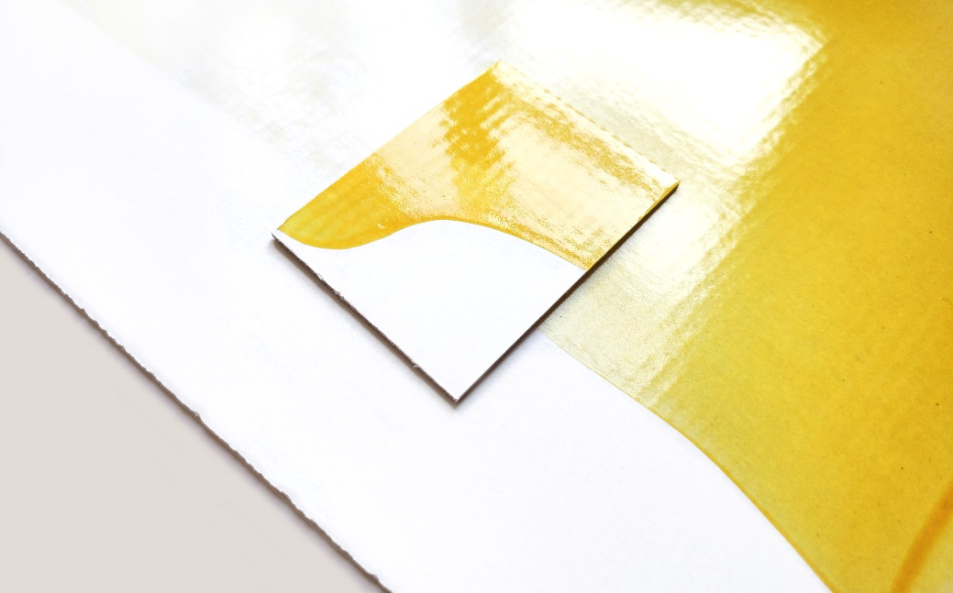



Mondi and traceless team up to develop a ground-breaking coating solution from agricultural by-products. (Photos: traceless, PR291)

This press release and relevant photography can be downloaded from

[www.PressReleaseFinder.com](http://www.PressReleaseFinder.com).

Alternatively for very high resolution pictures please contact Kim Lommaert ([klommaert@emg-marcom.com](mailto:klommaert@emg-marcom.com), +31 164 317 021).