PRESS RELEASE

**Unveiling FlexiBag Reinforced – Mondi’s cost-effective next generation of recyclable packaging**

* *Mondi is launching FlexiBag Reinforced, a new range of recyclable and cost-effective PE-based mono-material packaging.*
* *The new solutions are ideal to protect a wide range of products thanks to their high barrier protection, improved mechanical properties, and customisability.*
* *German pet food producer mera is using a new FlexiBag Reinforced created with 35% PCR (post-consumer recycled) content to pack its 'pure green' dry pet food range.*

**3 July 2024** – Mondi, a global leader in sustainable packaging and paper, is launching the latest addition to its popular portfolio of sustainable pre-made plastic bags - FlexiBag Reinforced: a range of innovative mono-PE-based, recyclable packaging solutions with improved mechanical properties.

Contributing to a circular economy, the FlexiBag Reinforced range is **recyclable** where collection facilities and recycling systems for PE films are in place. The bags have been created in-house by Mondi, leveraging its integrated value chain. This means the solutions can be **tailored to different customers’ specific needs more cost-effectively**.

**Improved mechanical properties** make the bag superior to previous versions – better puncture resistance, stiffness and sealability are guaranteed. The **level of barrier protection** can be adjusted, providing medium to high barriers against fat, oxygen and moisture while keeping the content fresh - making it ideal for the pet food industry.

With FlexiBag Reinforced, Mondi proactively meets future regulative requirements: a customised percentage of **post-consumer recycled (PCR) content** can be added (based on mass-balance), significantly reducing the use of virgin plastics and promoting material efficiency by keeping materials in circulation.

Dirk Gabriel, COO Consumer Flexibles at Mondi, says: “Mondi recognises the increasing emphasis on PCR materials driven by future regulative requirements and as a market leader in sustainable pet food packaging, we are taking every effort to secure sufficient upstream supply of PCR material for our customers. By working closely with our partners along the value chain we can understand the unique requirements of each customer and adapt accordingly to material efficiency and recyclability. With FlexiBag Reinforced, we are able to offer a solution that comes close to the material costs of conventional multi-material laminates for certain structures and at the same time offers recyclable packaging that gives our customers a competitive advantage in the market.”

**mera’s ‘pure green’ dry pet food range**

mera, a family-owned German pet food producer has successfully introduced FlexiBag Reinforced containing 35% PCR content for its 10kg packs of vegan dry dog food. The implementation process was smooth to manage as the FlexiBag Reinforced was suitable for mera’s existing machinery.

Enes Tajic, Purchasing Manager at mera, says: “We firmly believe that in nature, everything is inter-related. We are passionate about animal welfare - and part of that is a commitment to sustainability. Working with our long-term, trusted partner Mondi meant that these new dog food products will be packed in a way that enables us to continue to create harmony between our furry friends and their environment.”

/ends

**About Mondi**

Mondi is a global leader in packaging and paper, contributing to a better world by producing products that are sustainable by design. We employ 22,000 people in more than 30 countries and operate an integrated business with expertise spanning the entire value chain, enabling us to offer our customers a broad range of innovative solutions for consumer and industrial end-use applications. Sustainability is at the centre of our strategy, with our ambitious commitments to 2030 focused on circular driven solutions, created by empowered people, taking action on climate.

In 2023, Mondi had revenues of €7.3 billion and underlying EBITDA of €1.2 billion. Mondi has a premium listing on the London Stock Exchange (MNDI), where the Group is a FTSE100 constituent, and also has a secondary listing on the JSE Limited (MNP).

[www.mondigroup.com](http://www.mondigroup.com)

**Contact:**

Judith Wronn

Head of Communication, Mondi Flexible Packaging

Tel: +49 151 1771 4692

Email: [Judith.Wronn@mondigroup.com](mailto:Judith.Wronn@mondigroup.com)

Kim Lommaert

EMG

Tel: +31 164 317 021

Email: [klommaert@emg-marcom.com](mailto:klommaert@emg-marcom.com)

**Photos:**

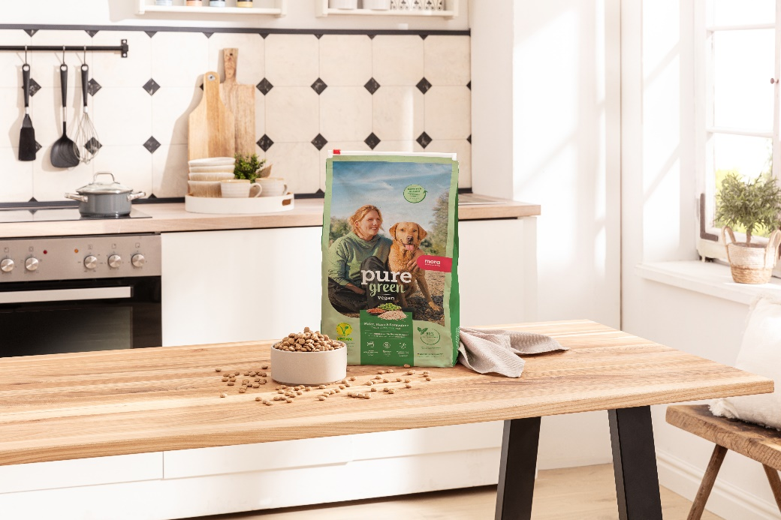

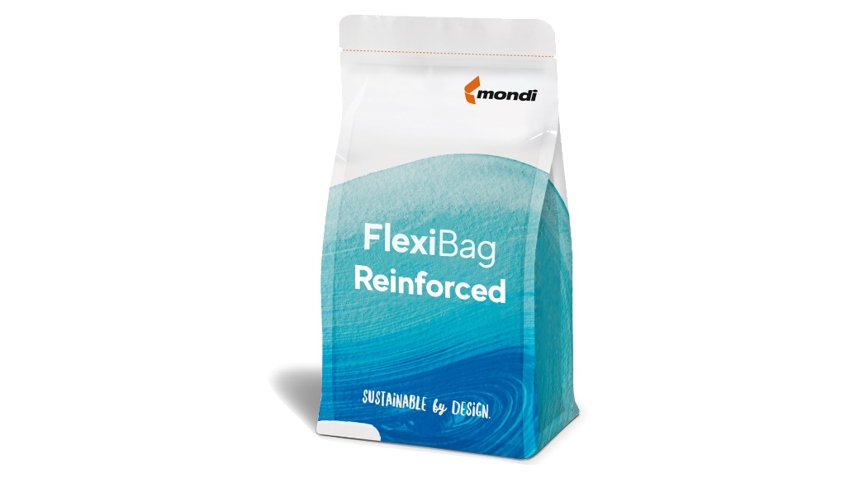

Unveiling FlexiBag Reinforced – Mondi’s cost-effective next generation of recyclable packaging. (Photos: Mondi, PR293)

This press release and relevant photography can be downloaded from

[www.PressReleaseFinder.com](http://www.PressReleaseFinder.com).

Alternatively for very high resolution pictures please contact Kim Lommaert ([klommaert@emg-marcom.com](mailto:klommaert@emg-marcom.com), +31 164 317 021).