PRESS RELEASE

**Mondi completes €95 million investment to boost efficiency and sustainability at Świecie containerboard mill**

* *As previously announced, upgrade increases Kraftliner production capacity by 55,000 tonnes per annum.*
* *Improvements in product quality and environmental performance strengthen the mill's sustainability profile.*

**14 October 2024** – Mondi, a global leader in sustainable packaging and paper, has recently completed a €95 million investment at its Świecie containerboard mill, which will increase kraftliner capacity by 55,000 tonnes. The upgrade comprises an extensive rebuild of paper machines PM2 and PM5, a new anaerobic treatment plant including an integrated cooling system, and upgrades to the pulp mill, the recycled fibre line and the energy recovery system.

These improvements will allow the mill to meet growing customer demand for heavy-duty packaging for large and heavy products, enhance product quality, and bolster its environmental performance by decreasing water consumption and wastewater emissions and increasing energy efficiency.

Since the project’s completion in June, Mondi Świecie has also expanded its ProVantage SmartKraft Brown portfolio with a broader range of grammage options. Offering exceptional strength and enhanced runnability, the brown Kraftliner product meets diverse packaging demands while championing environmental responsibility.

“The completion of this project marks a milestone for Mondi Świecie, enabling us to advance our operations and deliver even higher-quality paper to our customers. I am proud of our team’s exceptional skills and commitment, which were crucial in achieving these goals,” said Tomasz Katewicz, Managing Director of Mondi Świecie.

The completion of the investment further underscores Mondi’s commitment to operating efficiently and its progress in fulfilling the commitments set out in its Mondi Action Plan 2030 (MAP 2030) sustainability framework. It also reflects the Group’s strong commitment to the region, by providing competitive, high-quality employment and potential to further contribute to the area's economic prosperity.

/ends

**About Mondi**

Mondi is a global leader in packaging and paper, contributing to a better world by producing products that are sustainable by design. We employ 22,000 people in more than 30 countries and operate an integrated business with expertise spanning the entire value chain, enabling us to offer our customers a broad range of innovative solutions for consumer and industrial end-use applications. Sustainability is at the centre of our strategy, with our ambitious commitments to 2030 focused on circular driven solutions, created by empowered people, taking action on climate.

In 2023, Mondi had revenues of €7.3 billion and underlying EBITDA of €1.2 billion. Mondi has a premium listing on the London Stock Exchange (MNDI), where the Group is a FTSE100 constituent, and also has a secondary listing on the JSE Limited (MNP).

[www.mondigroup.com](http://www.mondigroup.com)

**Contact:**

Bettina Pokorny

Senior Communication & Marketing Manager, Mondi Corrugated Packaging

Tel: +43 1 79013 4347

Email: [Bettina.Pokorny@mondigroup.com](mailto:Bettina.Pokorny@mondigroup.com)

Kim Lommaert

EMG

Tel: +31 164 317 021

Email: [klommaert@emg-marcom.com](mailto:klommaert@emg-marcom.com)

**Photos:**

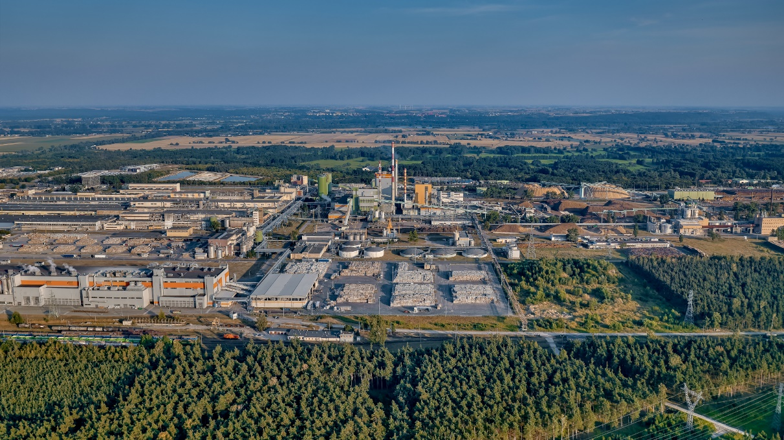

Mondi Świecie containerboard mill from above. (Photo: Mondi, PR302)

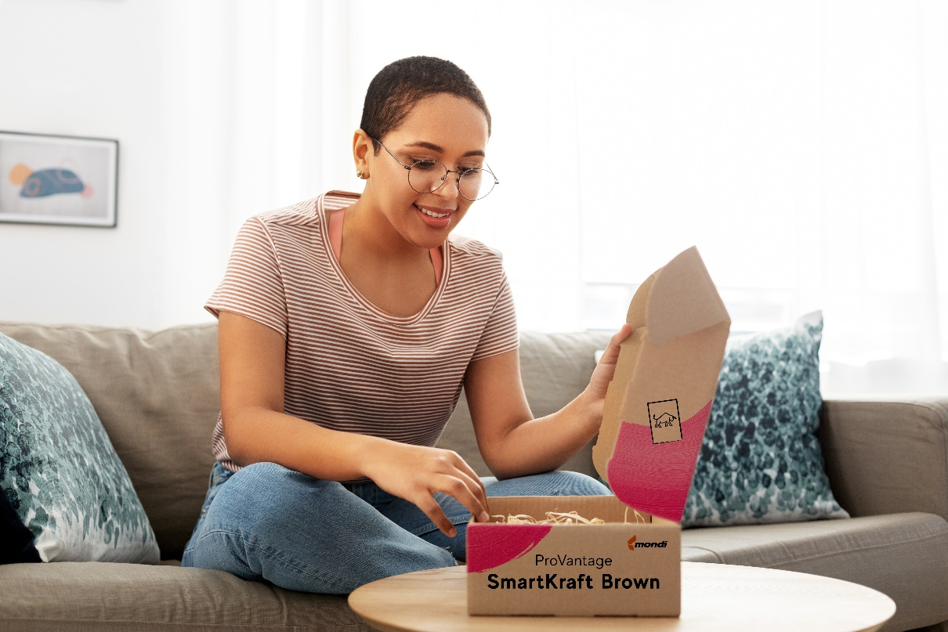

ProVantage SmartKraft Brown paper grade used in a corrugated box. (Photo: Mondi, PR302)

This press release and relevant photography can be downloaded from

[www.PressReleaseFinder.com](http://www.PressReleaseFinder.com).

Alternatively for very high resolution pictures please contact Kim Lommaert ([klommaert@emg-marcom.com](mailto:klommaert@emg-marcom.com), +31 164 317 021).