Press-Info

Meraxis and Fortum cooperate in Europe-wide distribution of recyclates

Muri near Bern/Switzerland January 23, 2024 – The Swiss trading group Meraxis and the Finnish company Fortum Recycling & Waste (Fortum) are deepening their existing cooperation with a strategic partnership. Meraxis will distribute Fortum recyclates throughout Europe. The offer includes PP, HDPE and LDPE recyclates as well as customized re-compounds. Through this cooperation, Meraxis is expanding its product range of recyclates and can thus offer its customers an even larger portfolio of sustainable material alternatives to prime material.

Fortum recyclates are made from post-consumer waste in Northern Europe. They are of high quality, durable,versatile as well as reliably available. Meraxis customers can also obtain customized re-compounds from Fortum Circo® that are specifically tailored to their applications and products. Product development in the Fortum-laboratory tailors technical properties such as strength, processability, and color to individual customer requirements. Fortum Circo® materials are suitable for the manufacture of a wide range of products such as household goods, parts for the automotive and furniture industries, and garden tools. Special grades meet the EU toy standard.

“With Fortum Circo®, we are expanding our range of high-quality recyclates. Our customers will also benefit from the Finnish company’s strong expertise in recycling and material development. Together, we are pursuing the goal of offering polymer processors tailor-made sustainable material alternatives. After all, switching from conventional to recycled plastics is one of the most important levers for reducing CO2 emissions,” says Eddy Khatib, Product Manager Recycling at Meraxis.

”We are pleased to continue and deepen our collaboration with Meraxis. This offers us full-service solutions and access to European converters and brand owners. Through this strategic partnership we are expanding our distribution network in Europe. This will help us to drive the circular economy and promote wider acceptance of recycled plastic materials,” says Anniina Rasmus, Commercial Manager, BL Plastics, Fortum Recycling & Waste.

In addition to recyclates, Meraxis also offers biopolymers, prime materials, additives, masterbatches, trade parts, and investment goods for the polymer processing industry in its one-stop shop. The portfolio further includes services relating to procurement, logistics, development, and processing. Plastics processors get everything they need from one company.

About the Meraxis Group
With a turnover of over 2 billion euros, Meraxis is one of the world's leading plastics distributors. The trading company with a global sales and logistics network is headquartered in Muri near Bern (Switzerland). As a full-service provider, the Meraxis Group offers its customers targeted support in strategic procurement: the one-stop shop supplies companies from numerous industries with polymers and polymer-related products for various production processes – from the automotive industry to the construction sector and packaging companies. The Meraxis Group combines its in-depth knowledge of materials and products with its global network of partners and suppliers. The company has extensive experience in the development and processing of high-quality polymers as well as in the management of complex logistics processes.
The group's portfolio includes standard plastics (such as PE, PP, PET, or PVC), engineering plastics, masterbatches (color granules), recyclates, and biopolymers. In addition to materials, Meraxis also procures capital goods such as injection molding machines, systems, and tools for various plastics processing techniques. The one-stop shop also offers equipment for upstream and downstream production processes (including metal profiles, films, injection molded parts, and gauges). Meraxis actively supports plastics processors on their way to becoming more sustainable. For example, the company supports its customers in the selection and procurement of sustainable materials and in switching from virgin materials to recyclates. Together with partners and customers, Meraxis develops digital solutions to promote the circular economy and transparency in the value chain. For example, a CO₂ footprint tool facilitates the selection of the lowest-emission material by showing alternative material options. Meraxis sees itself as an active partner in the digital transformation of the plastics industry.
Website: https://www.meraxis-group.com/
LinkedIn: https://www.linkedin.com/company/meraxis-group/

About Fortum Recycling & Waste
Fortum Recycling & Waste is rethinking recycling and leading the way towards a material revolution. Solving problems is in our DNA and our mission is to transform waste streams back to essential raw materials. Our role is to find solutions for our customers’ most challenging environmental waste problems, to save natural resources and support circular economy. Fortum Recycling & Waste has operations in the Nordics and the UK consisting of environmental waste management services, hazardous waste treatment and O&M expertise as well as material recycling services including solutions for batteries, plastics, metals, and ash and slag waste streams across Europe.
Fortum Circo® Recycled Plastics
Fortum Circo is a plastic recyclate produced from post-consumer plastic waste. With consistent and high quality, versatility and solid availability, Fortum Circo recycled plastic can be used in a wide variety of products and also customized into compounds to meet the specific needs and requirements. Fortum Circo is made with no compromises: it is a safe and reliable solution for sustainable plastics production.
Website: https://www.fortum.com/circo
LinkedIn: https://www.linkedin.com/showcase/fortum-recycling-waste
Press contact
Julia Hisge
möller pr GmbH
Tel: +49 (0)221 80 10 87-90
E-mail: jh@moeller-pr.de
www.moeller-pr.de

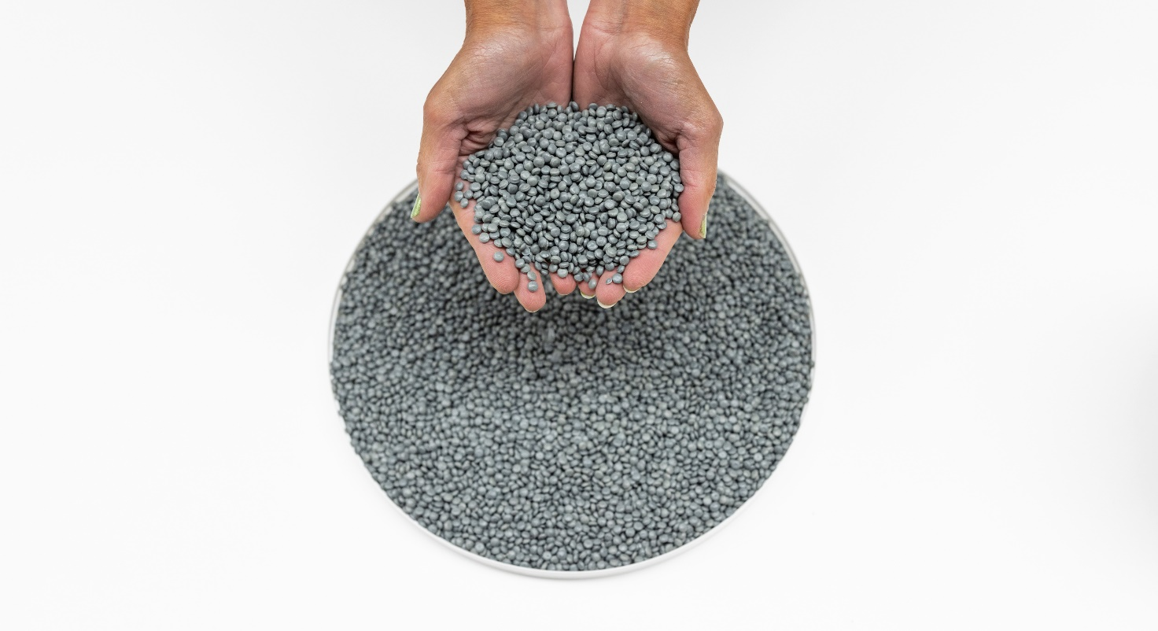
Copyright: Fortum Waste Solutions Oy

