Press release

New Anti-fouling additive for the PP and PE polymerisation process – Palsgaard introduces Einar® 981 to replace existing regulatory compromised chemistry

Einar® 981 is an unquestionably safe and efficient alternative that has worldwide regulatory approval. With its origin in food-grade renewable raw materials, it is the ideal candidate to maintain the highest possible efficiency and eliminate any regulatory concerns.

JUELSMINDE, Denmark, 28 June 2022

Palsgaard has announced the introduction of an efficient new plant-based, food-grade anti-fouling additive for the polypropylene and polyethylene polymerisation process. The new product, Einar® 981, has been developed to remove severe concerns about the ethoxylated amine chemistry currently used. Einar® 981 will officially be introduced to the market at K 2022 in Düsseldorf, Germany.

Einar® 981 is supplied as a clear and easily pumpable liquid for use in existing dosing systems. It eliminates static build-up during polymerisation and prevents fouling of the reactor wall, thus helping PP and PE producers maintain the cooling efficiency of the reactor. Building on Palsgaard’s proven chemistry of renewable anti-static polymer additives, it provides high anti-fouling efficiency at low concentration (100-300 ppm) without any negative effects on catalyst mileage, productivity or final polymer performance.

The active compound of Einar® 981 is a polyglycerol ester (PGE) blend of fatty acids derived from RSPO certified sustainable palm oil. As a non-toxic and food-contact approved anti-fouling additive, the product offers a drop-in regulatory compliant solution to replace incumbent ethoxylated amines and can also be used as a more efficient alternative to sorbitan monooleates. This makes it an ideal process additive in the polymerisation of PP and PE materials for sensitive applications, including e.g. medical devices and baby food containers.

“Polyolefin producers are under growing pressure from converters and brand owners to abandon the use of ethoxylated amines in their polymerisation processes and switch to safer products without any regulatory concerns,” says Ulrik Aunskjær, Global Business Director, Bio Specialty Additives at Palsgaard. “Einar® 981 is our answer to meet this challenge with a highly sustainable, renewable and food-grade anti-fouling process aid that demonstrates our expertise in customer and market focused renewable polymer additives.”

Einar® 981 is produced in CO₂-neutral facilities and will be commercially available worldwide.
Visit Palsgaard at K 2022 in Düsseldorf from October 19 through 26 in Hall 7, Level 1, Booth D20 to meet the company’s product and market specialists and discuss the sustainable benefits and superior performance of Einar® plant-based polymer additives.

<Release ends>

About Palsgaard A/S

Palsgaard is a world leader in plant-based emulsifiers and polymer additives for the global food, packaging and plastics industries. Since its founder Einar Viggo Schou invented the modern plant-based food emulsifier in 1917, the company has provided advanced industry know-how and innovation to an increasingly diversified customer base. From application centres around the world, Palsgaard’s experienced technologists support brand owners and manufacturers in optimising their sustainability by the use of natural, renewable ingredients and additives to mitigate their carbon footprint.

Palsgaard helps manufacturers grow and protect their brands by meeting consumer and regulatory demands for greater responsibility. The company is currently the world’s only commercial source of fully sustainable emulsifiers and additives based on RSPO SG-certified palm oil as well as rapeseed, sunflower, and other vegetable oils. All products are non-GMO, have full EU and FDA food contact approvals, and also meet halal and kosher requirements.

The company’s food emulsifiers and emulsifier/stabiliser systems have a long history of adding to the quality and shelf-life of bakery, confectionery, condiments, dairy, ice cream, and margarine products. At the same time, they can significantly improve the taste, mouthfeel and texture while using fewer resources. Palsgaard’s plant-based polymer additives, including anti-fog and anti-static formulations for food and other packaging, build on this expertise and are rapidly emerging as highly effective and sustainable alternatives to conventional petrol-based additives.

Palsgaard, with headquarters in Juelsminde, Denmark, is owned by the Schou Foundation and has 653 employees across 17 countries. The company operates plants, sales offices and warehouses across four continents. All of their six production sites in Denmark, the Netherlands, Mexico, Brazil, China and Malaysia are carbon-neutral. In 2021, Palsgaard achieved a turnover of USD 260 million (DKK 1.7 billion) with products sold to customers worldwide in more than 120 countries.

Learn more about the company’s product and service portfolio at www.palsgaard.com/polymers.

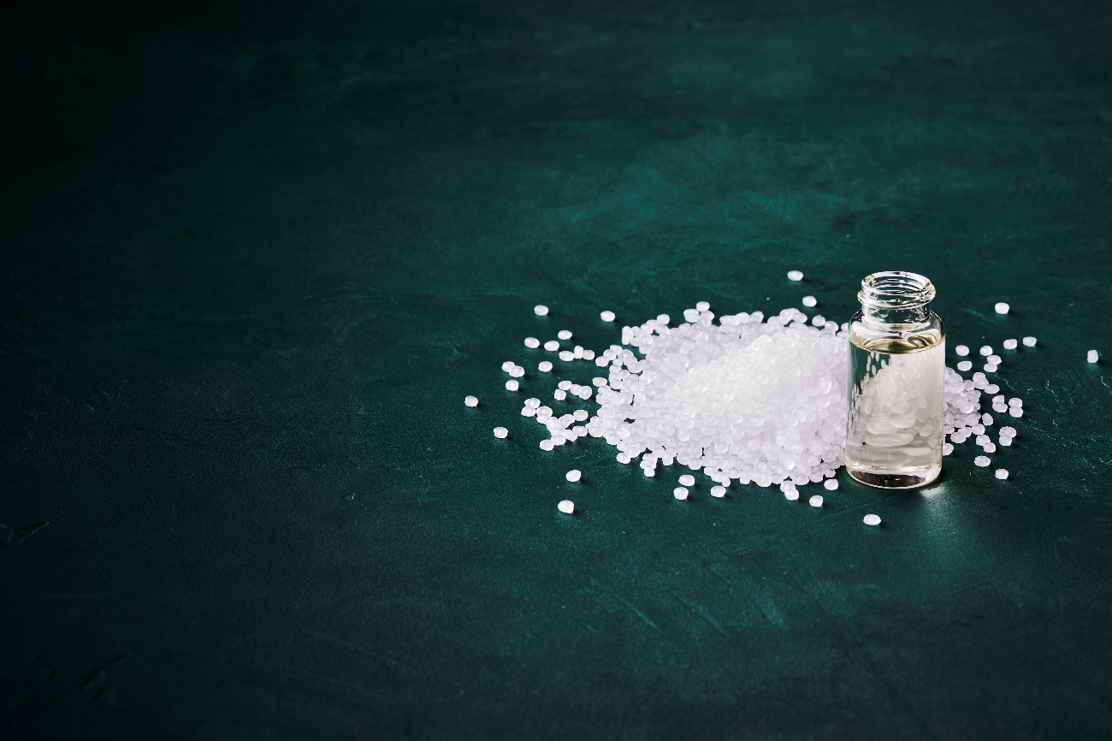
Einar® 981 is a plant-based, food-grade anti-fouling additive for the polypropylene and polyethylene polymerisation process. (Photo: Palsgaard A/S)

For more information please contact:
Mette Dal Steffensen, Senior Brand Communications Specialist, Palsgaard A/S
mds@palsgaard.dk | +45 2073 4534

Stephanie Wakkee, EMG
swakkee@emg-marcom.com | +31 164 317 038

This press release and relevant photography can be downloaded from www.PressReleaseFinder.com.
Alternatively for very high resolution pictures please contact Stephanie Wakkee
(swakkee@emg-marcom.com, +31 164 317 038).

Roundtable on Sustainable Palm Oil, www.rspo.org.

