**Press Release**

July 18, 2024

**US premiere at IMTS - FOBA presents new compact UV laser**

**Selmsdorf/Wood Dale, July 2024 - FOBA will be exhibiting three laser marking systems at the International Manufacturing Technology Show IMTS in Chicago/USA (9 to 14 September 2024). The main focus will be on the lightweight and space-saving integration of the new UV laser head into a FOBA M1000.**

At IMTS, FOBA will be showcasing a full range of laser marking solutions, from the largest laser marking workstation, the M3000, to the compact M1000 manual workstation and the world's smallest laser marking head, Titus™. Each laser system shows different application areas and functions for efficient industrial product marking, from metals to plastics.

The latest product in the FOBA product family is the optimised V series, which, with the 4 watt UV and 10 watt green marking laser, offers higher performance and better precision than its predecessor models, but at a fraction of the size. The laser head is so compact that it can be integrated into the FOBA M1000 manual workstation. The smaller size makes it easier to integrate into existing production environments.

"The new V-Series shows its strength above all in the marking of plastics and composites," says Philipp Febel, Director Product Strategy & Customer Experience at FOBA, "and is a sustainable alternative to other marking technologies such as continuous inkjet or pad printing." In contrast to these technologies, the marking lasers require hardly any consumables and therefore minimize waste and operating costs.

In live demonstrations on the M3000 laser marking machine, visitors will see the deep black marking of stainless steel in combination with the MOSAIC feature, which automatically aligns the marking - even on parts that are randomly placed in the marking field. With the Titus™ fibre laser marker, FOBA is showcasing the smallest laser marking head available on the market at the trade fair. It is predestined for fast marking in production lines and offers maximum flexibility in terms of integration. All three systems will be available for live demonstrations at the trade fair stand.

**Further Information:**

IMTS | International Manufacturing Technology Show  
September 9-14, 2024 | McCormick Place, Chicago IL [https://www.imts.com/](https://www.mdmwest.com/en/home.html)

**FOBA Laser Marking + Engraving**

[**https://www.fobalaser.com/de/**](https://www.fobalaser.com/de/)

**Images for editorial use**

**Images can be downloaded free of charge for editorial use at:**

<https://www.fobalaser.com/newsroom-events/news-press/us-premiere-at-imts-foba-presents-new-compact-uv-laser>

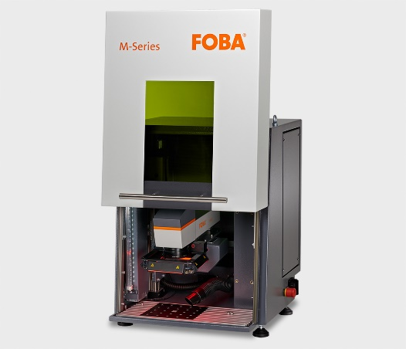

Compact laser marking workstation FOBA M1000, into which the V-series (UV or green laser) can be integrated. (Copyright: FOBA)

Ein Bild, das Gerät, Design enthält.

FOBA laser marking head with UV laser for marking plastics. (Copyright: FOBA)

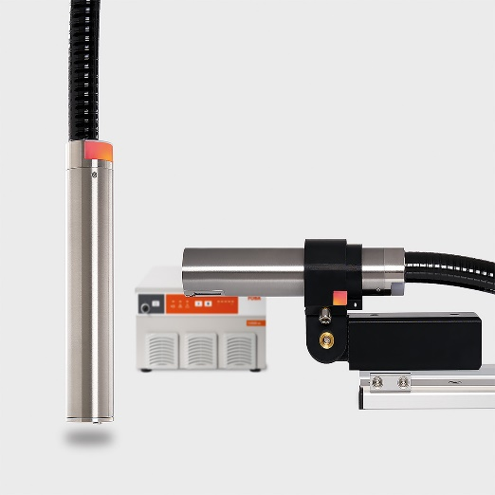

FOBA Titus™, the smallest marking head on the market for fast marking in production lines.

(Copyright: FOBA)

For additional information and images for editorial use please contact:

**Kathrin Urban |** Campaign & Event Manager

**ALLTEC Angewandte Laserlicht Technologie GmbH** | FOBA Laser Marking + Engraving  
An der Trave 27 – 31 | 23923 Selmsdorf

Tel.: +49 (0)38823 55-440

[kathrin.urban@fobalaser.com](mailto:kathrin.urban@fobalaser.com) | [www.fobalaser.com](http://www.fobalaser.com)

**About FOBA** [**www.fobalaser.com**](http://www.fobalaser.com)

FOBA Laser Marking + Engraving (brand of ALLTEC Angewandte Laserlicht Technologie GmbH) is one of the leading suppliers of advanced laser marking systems. FOBA develops and manufactures marking lasers for integration as well as laser marking workstations with vision assisted marking workflows. FOBA technology is being applied for the direct part marking of any kind of metals, plastics, or other materials in industries like automotive, medical, electronics, plastics or tool, metal and mold making. With its worldwide sales and service branches and its headquarters near Lübeck/Hamburg (Germany) ALLTEC/FOBA is part of the Veralto Corporation.