January 2023
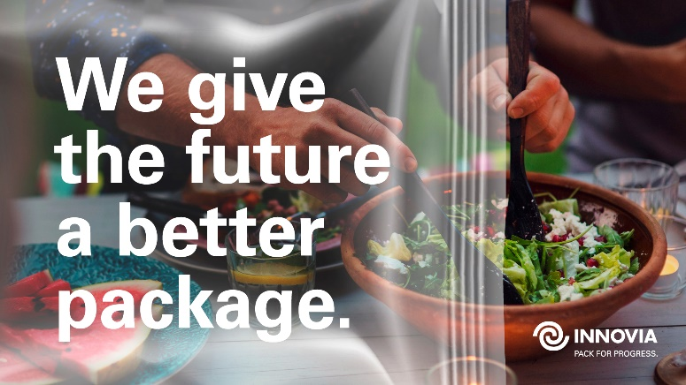
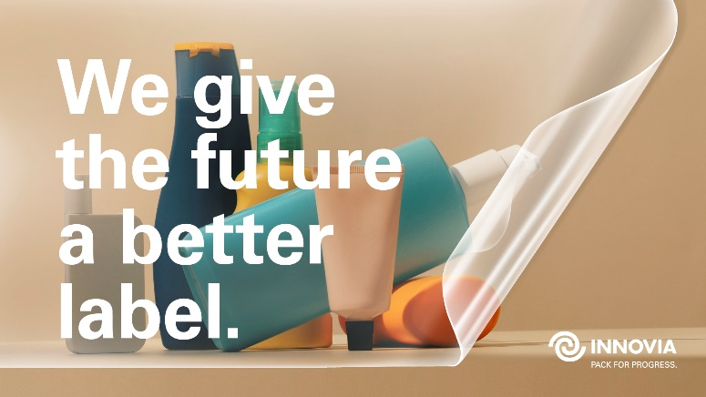
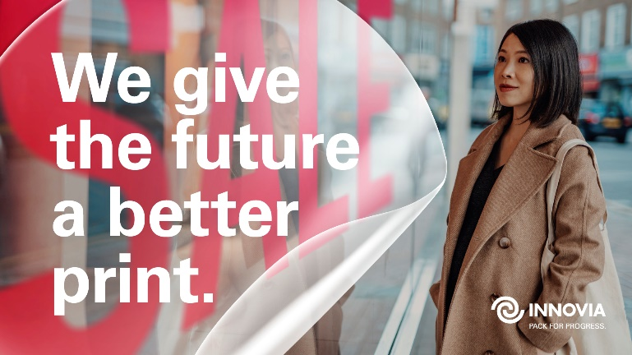

“BETTER FUTURE”: INNOVIA FILMS UNVEILS NEW COMMUNICATION CAMPAIGN

- Campaign underpins the importance of material science in creating more sustainable packages for consumers
- Highlighting 90 years of Innovia being dedicated to innovation and progress

Innovia Films just announced the launch of their new communication campaign “Better Future”. The campaign underpins Innovia‘s role in creating better and more sustainable and recyclable materials for the future, which are used in consumer packaging, labels and for graphic films. Their long history in being a global innovator – and the leading manufacturer of BOPP (polypropylene) film.

As the name Innovia suggests, it's all about innovation, the future and progress. Innovia attaches great importance to further developing its products in such a way that they meet future requirements, both from the customer's point of view and in a sustainable sense. Hence the new claim: ‘Pack for progress’ and the headline mechanics: ‘We give the future a better label/package/print’, when developing

sustainable and recyclable packaging that will benefit our environment using the base materials are essential.

Innovia Films has been a global player for the past 90 years and continues to play an enormous role in material science. “That is at the heart of what we do. We wanted this reflected in our internal and external communication,” says Guenther Birkner, President of Innovia. “The development of sustainable packaging solutions and the implementation on a larger scale is in full swing,” explains Simon Huber, Managing Director Innovia Films Europe. “We have many exciting new developments to offer for applications such as polypropylene film for mono-material pouches and also polyolefin films that are used for low density shrink sleeves that automatically detach from PET bottles and float in the recycling process…all of these examples illustrate how we see a better future for packaging without risking food waste.”

The new campaign “Better Future” will be rolled out globally within the next weeks and months and will be the center piece of the communication activities in the media, at trade fairs, internally and all the Innovia Films media channels. “We chose a very clean and modern design to reflect how current our work and film portfolio is for many industries. As we are a global company with customers in many countries, we wanted the campaign to be a universal one – we are proud to have achieved this and that the ‘look and feel’ of the campaign works in all regions,” says Marika Knorr, Head of Sustainability & Communications. “The design of the campaign is very flexible so we can introduce new key visuals for various occasions.”
Ends (Words: 424)

PICTURE CAPTIONS:
- “Better Future”. The campaign underpins Innovia‘s role in creating better and more sustainable and recyclable materials for the future, which are used in consumer packaging, labels and for graphic films.
- As the name Innovia suggests, it's all about innovation, the future and progress.
- Innovia offers PVC-free graphic films for advertisement and promotions for example – this is reflected in the new campaign

For further information contact:

Marika Knorr, Head of Sustainability & Communications / Charlotte Robinson, Assistant Communications Manager
Innovia Films Ltd, Lowther R&D Centre, Wigton, Cumbria, CA7 9XX, UK
Tel: +44 (0) 16973 42281 Fax: +44 (0) 16973 41452
Email: mknorr@cclind.com
www.linkedin.com/company/innovia-films
Watch our Videos on You Tube: www.youtube.com/innoviafilms
www.innoviafilms.com
Innovia Films is a major producer of highly differentiated specialty Biaxially Oriented Polypropylene (BOPP) films using proprietary ‘Bubble’, Stenter Technology and Cast manufacturing processes.

The company holds a leading global position in the markets for high performance coated films, tobacco overwrap, labels and security films. Innovia employs >1400 people worldwide and has production sites in Australia, Belgium, Germany, Mexico, Poland and the UK. The company is focused on high-quality value-added products, strong customer relationship, R&D and excellent service.

