March 14, 2023

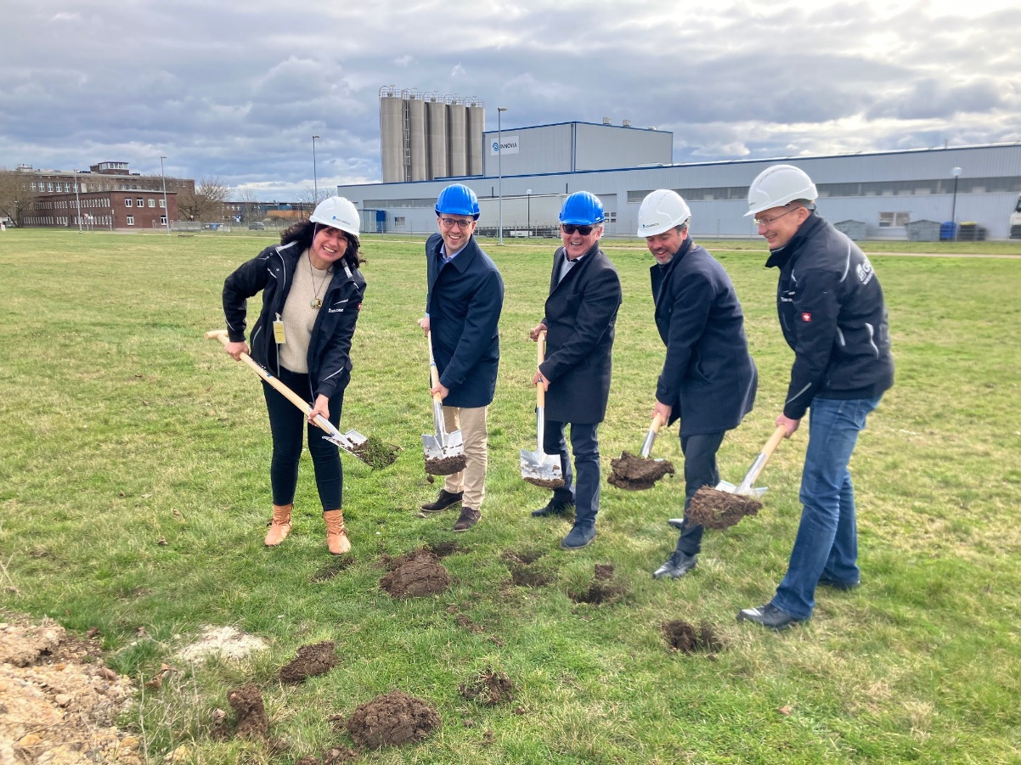

INNOVIA FILMS ANNOUNCES GROUNDBREAKING FOR EXPANSION AT GERMAN SITE FOR PRODUCTION OF SUSTAINABLE LABEL MATERIAL

- New 8.8 meters wide multi-layer co-extrusion line will produce highly engineered thin gauge label films
- Innovative technology is unique for label films, with 36,000 tons of annual capacity designed for best-in-class energy efficiency
- Polypropylene is a widely recycled material that has an established recycling stream
Innovia Films, a science material leader and major producer of highly differentiated speciality Biaxially Oriented Polypropylene (BOPP), Bubble and Tenter technologies and Cast Polypropylene (CPP) films, announces the groundbreaking for a significant expansion at its Innovia business unit near Leipzig in Germany at the Dow ValuePark Schkopau.

A new 8.8 meters wide multi-layer co-extrusion line will produce highly engineered thin gauge label films to support the growing, sustainability driven demand for lower resin content materials. The new technology is unique for label films, with 36,000 tons of annual capacity designed for best-in-class energy efficiency. Production will commence in the second half of 2024.

Simon Huber, Managing Director Innovia Films Europe, commented: „The intended introduction of the BOPP - film on a production scale represents an innovation for the application as uncoated and printable label film that does not exist yet. The new line in Germany will supply thinner films for the label market, close to where many customers are located. Polypropylene is a widely recycled material that has an established recycling stream and that supports a circular economy of plastics“.

Giuseppe Ronzoni, General Manager at Innovia Films in Schkopau, Germany, concluded, “This technology offers clear advantages over the state of the art, especially for the life cycle assessment with regard to product-specific CO2 emissions. Further developments, retrofitting and the more sustainable change in the German electricity mix can lead to a further improvement in the environmental impact.”
The investment is part of the company strategy to focus on providing more sustainable material for the label industry as part of their “Better Future” material science strategy. Thinner materials equal more material efficiency and a lower carbon footprint of the end product, which supports the carbon reduction strategy of many major brands that are looking to introduce more sustainable packaging into the market.

Ends (Words: 425)

PICTURE CAPTION: Groundbreaking for new multi-layer co-extrusion line.
Left to right:
Kerstin Dittmann, Sales Engineer, Goldbeck
Giuseppe Ronzoni, General Manager
Simon Huber, Managing Director Innovia Films Europe
Jörg Bechmann, Branch Manager, Authorised Signatory, Goldbeck
Stefan Strobel, Project Manager, Goldbeck

For further information contact:

Marika Knorr, Head of Sustainability & Communications / Charlotte Robinson, Assistant Communications Manager
Innovia Films Ltd, Lowther R&D Centre, Wigton, Cumbria, CA7 9XX, UK
Tel: +44 (0) 16973 42281 Fax: +44 (0) 16973 41452
Email: mknorr@cclind.com
www.linkedin.com/company/innovia-films
Watch our Videos on You Tube: www.youtube.com/innoviafilms
www.innoviafilms.com
Innovia Films is a major producer of highly differentiated specialty Biaxially Oriented Polypropylene (BOPP) films using proprietary ‘Bubble’, Stenter Technology and Cast manufacturing processes.

The company holds a leading global position in the markets for high performance coated films, tobacco overwrap, labels and security films. Innovia employs >1400 people worldwide and has production sites in Australia, Belgium, Germany, Mexico, Poland and the UK. The company is focused on high-quality value-added products, strong customer relationship, R&D and excellent service.

