Press Release

UFlex Showcases Pioneering Packaging Solutions for the Food and Beverage Industry at Indusfood Tech 2024
January 8, 2024, Noida, National Capital Region: India’s largest multinational flexible packaging and solutions company, will showcase its diverse range of flexible packaging solutions and machinery tailored for the Food and Beverage industry at Booth No. J 32, Hall 5, at the Indusfood Tech 2024, scheduled to be held at India Exposition Mart, Greater Noida from January 8-10, 2024.
UFlex’s flexible packaging business will showcase its wide range of innovative, packaging solutions that have been the game changers for packing large quantities of products. The showcased offerings include 3D and 4D pouches, anti-counterfeiting solutions through VDP (Variable Data Printing), URC (Unique Random Coding), and laser scoring for enhanced consumer convenience. Additionally, the exhibit features high-impact resistance bags, various handle options designed for consumer ease, and a range of sustainable packaging solutions.
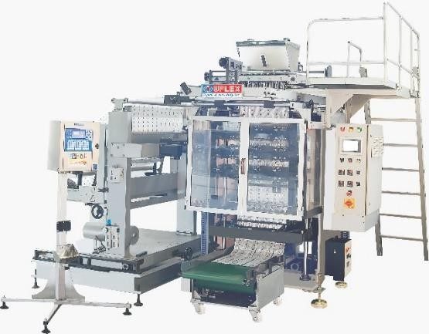
At the show, UFlex’s engineering business will feature two of its highly acclaimed machines. Be sure to stop by and witness a live demonstration of the Multi-Track 1200 3 Side Machine (MT1200 3S) and our Pick-Fill-Seal Machine (PFS).

MT1200 3S is a high-speed continuous motion multi- track machine for three-sided sealed pouches. It is used for filling powder, liquid, and granules.

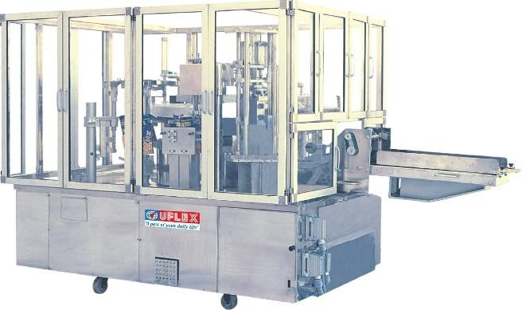
Pick-Fill-Seal (PFS) Machine is a revolutionary packaging solution that combines the essential steps of picking, filling, and sealing into a seamless and efficient process. It provides a fully automated solution for packing products in a preformed pouch.

Join the UFlex team at Booth No. J 32, Hall 5, India Exposition Mart, Greater Noida, to delve into the future of packaging technology. Our team will be available for live demonstrations and discussions, showcasing how these innovative packaging solutions can enhance packaging processes, taking efficiency and sustainability to new heights.
For queries: corpcomm@uflexltd.com

About UFlex Limited:
UFlex is India’s largest multinational flexible packaging and solutions company. Since its inception in 1985, UFlex has grown from strength to strength and has built a strong presence across all verticals of the packaging value chain — packaging films, chemicals, aseptic packaging, flexible packaging, holography, engineering, and printing cylinders.
With a 10,000+ strong multicultural workforce across global regions that works toward developing innovative, value-added, and sustainable packaging solutions, the company has earned an irreproachable reputation for defining the contours of the ‘Packaging Industry’ in India and overseas. It provides end-to-end solutions to numerous Fortune 500 clients across various sectors such as FMCG, consumer product goods, pharmaceuticals, building materials, automobiles, and more, in more than 150 countries. Headquartered in Noida, the National Capital Region, India, UFlex enjoys a global reach with advanced manufacturing facilities in India, the UAE, Mexico, Egypt, the USA, Poland, Russia, Nigeria, and Hungary.
A winner of various marquee global awards for product excellence, innovation, and sustainability, UFlex is the first company in the world to earn recognition at the Davos Recycle Forum in 1995 for conceptualizing the recycling of mixed plastic waste. For more details, please visit: www.uflexltd.com

