Press Release

FOR IMMEDIATE RELEASE

**Title: Zeus Packaging Nominated for Nine Awards at The Packaging Awards 2024**

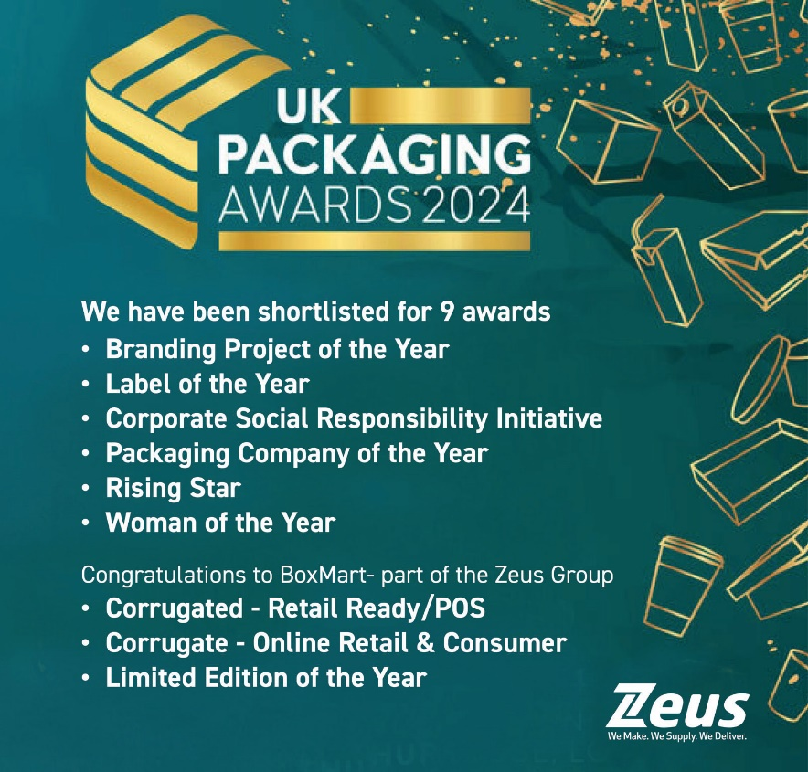

[Zeus Packaging](https://global.zeuspackaging.com/), leader of sustainable packaging solutions, are thrilled to announce its nomination within a huge nine categories at The Packaging Awards 2024, underscoring the company's commitment to innovation, sustainability, and excellence in the packaging industry. Last year they took home the title of ‘Entrepreneurial Company of the Year’ at the same awards. The awards ceremony, which celebrates the best in packaging design and technology, will take place on the 10th October in London.

The Packaging Awards is a highly respected event that honours outstanding achievements across the packaging sector, recognising companies and individuals who have made significant contributions through creativity, technological advancements, and sustainability efforts. This year, Zeus Packaging's nominations span across multiple categories, reflecting the company's diverse expertise and industry leadership.

**Zeus Packaging's Shortlisted Awards:**

* **Packaging Company of the Year:** Zeus Packaging
* **Corporate Social Responsibility Initiative of the Year:** Apollo
* **Label of the Year:** Jester Rum Label
* **Branding Project of the Year:** Sustainable Exhibition Stands
* **Rising Star Award:** Jade Gurr
* **Woman of the Year:** Pip Gorringe
* **Corrugated: Online Retail and Consumer Goods:** Thornbridge Brewery Refillable Advent Calendar (Boxmart, Part of The Zeus Group)
* **Corrugated: Retail Ready and Point of Sale:** Dipping Sauce Dispenser CDU for Chopstix (Boxmart, Part of The Zeus Group)
* **Limited Edition of the Year:** Mother's Day Advent Calendar for Lush (Boxmart, Part of The Zeus Group)

"We are incredibly proud and honoured to be shortlisted for nine awards at The Packaging Awards 2024," said Keith Ockenden, CEO of Zeus Packaging. "These nominations reflect our team's hard work, dedication, and passion for driving innovation and sustainability in the packaging industry. We look forward to the awards ceremony and celebrating the achievements of all the nominees and projects."

From humble beginnings to a global supply chain solutions provider, the Zeus journey is nothing short of inspiring. Watch the transformation from one man, one product, and one van into a $600 million industry leader with over 1350 dedicated employees worldwide on the [Zeus Growth Story.](https://www.youtube.com/watch?v=vpWjW2fWEqA&t=66s) Led by visionary Brian O'Sullivan, the 2021 EY Entrepreneur of the Year, Zeus has cultivated a passionate and resilient team that continues to drive the company forward. With a strong focus on innovation, sustainability, and customer-centric solutions, Zeus is building a brand that customers trust and depend upon. Join Zeus on this remarkable journey and see why Zeus is set to become the first single-shareholder Irish company with revenue exceeding $1 billion!

For media inquiries or further information, please contact:

Pip Gorringe

Director of Marketing

Zeus Packaging

[Pip.Gorringe@zeuspackaging.co.uk](mailto:Pip.Gorringe@zeuspackaging.co.uk)

07809737871

About Zeus Packaging

Zeus Packaging is a leading provider of sustainable packaging solutions, committed to innovation and excellence in serving a diverse range of industries, including retail, food and beverage, pharmacy, luxury and transit packaging. With a focus on sustainability and customer satisfaction, Zeus Packaging delivers high-quality, eco-friendly packaging products to clients worldwide. Serving in 38 countries and with 61 locations, Zeus truly is a global packaging solutions provider.

End of Release